Style Sheet for DigitalLearn.org Public Courses

Screenshot/Image | Description
Storyline Player Specifications | - Published size should be 720 x 540  - Browser size: Display at user's current browser size  - Player size: Scale player to fill browser window
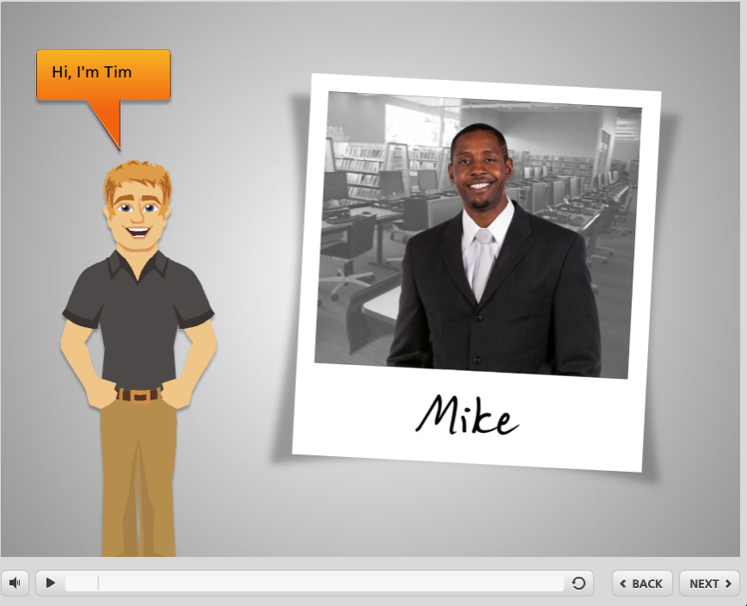 | - Use of instructor avatar and learner photo  - Use in course introductions  - Font: Helena’s Hand  - Image: Polaroid Template
- White projection screen.
- Used as backdrop for images with instructor.
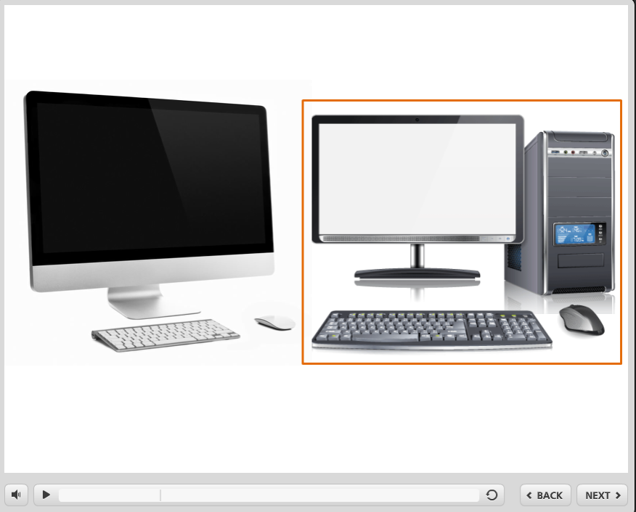 | - Highlight box  - Used to highlight a specific element or object on the screen  - Orange rectangular outline  - Other colors or shapes may be used to provide high contrast to background
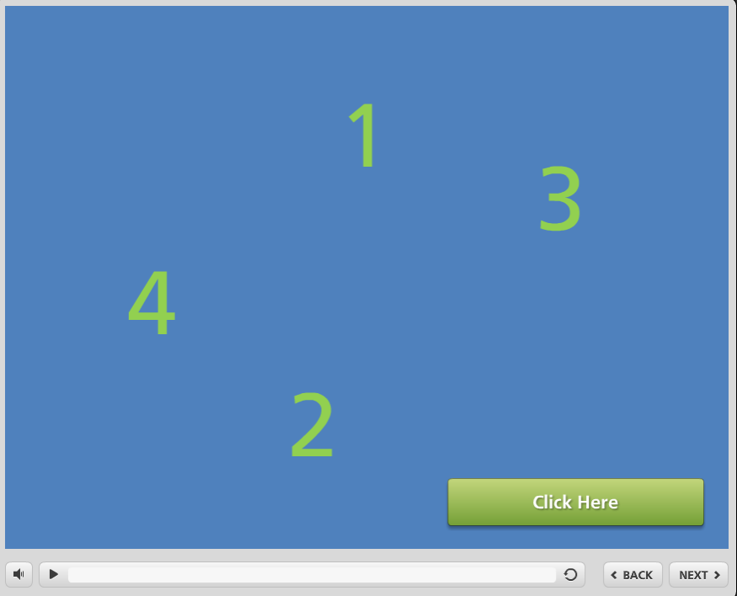 | - Practice exercise example  - Provide clear instructions and hints
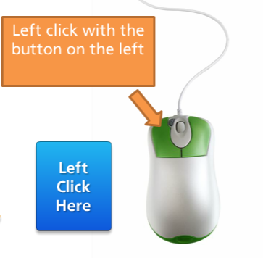 | - Text box style examples  - Use color scheme  - Use high contrast between text and background color
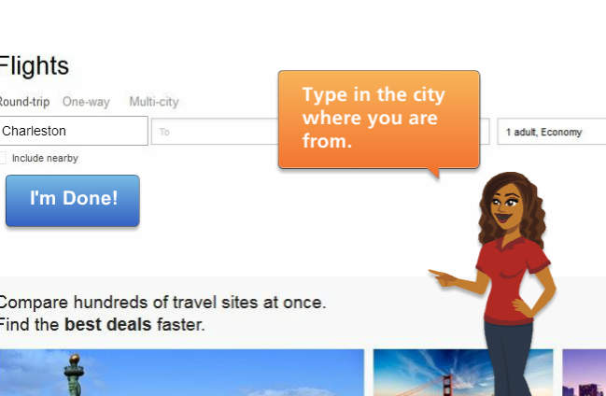 | - Interaction with instructor and “I’m Done” button  - Uses on-screen button mentioned in narration to “Submit” interaction
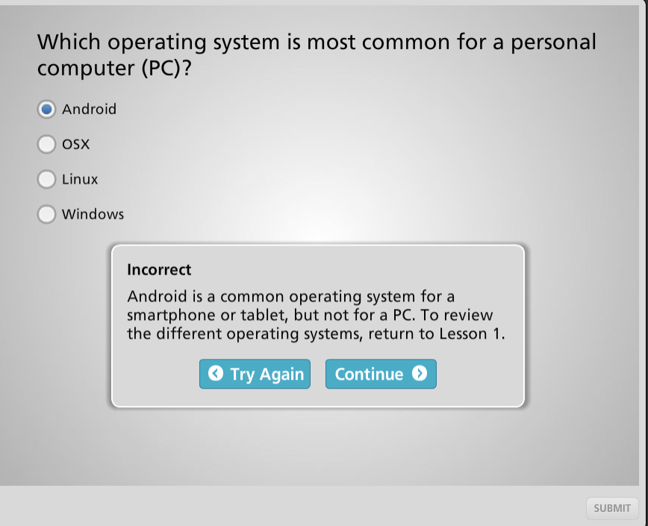 | - Quiz feedback example  - Allow user to try again  - Give feedback to help them determine the correct answer  - Quizzes should reinforce and review course content
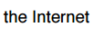 | - Use Internet (with a capital “I”) when referring to the Internet
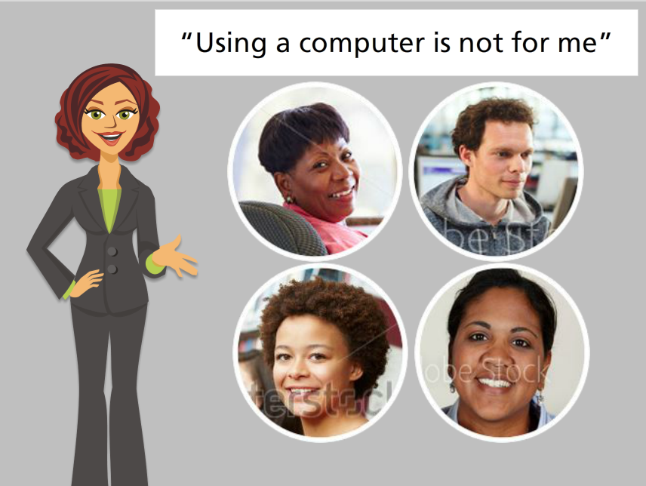 | - Give user relatable stories based on user characters or personas
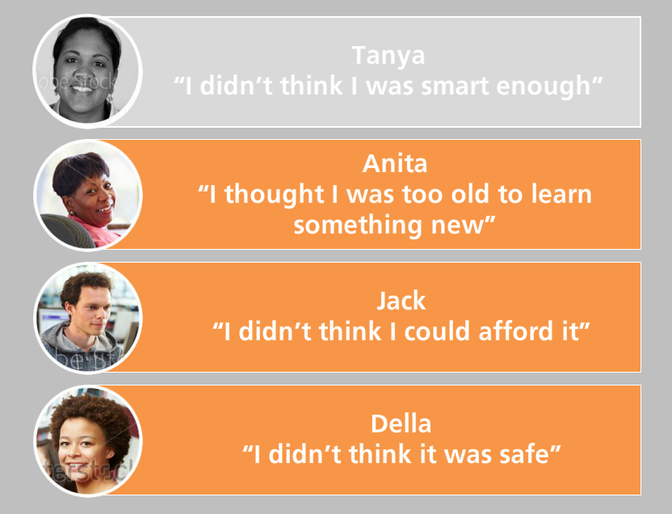 | - Give users choice in which order to view examples  - Here, user can click on each row to jump to that person’s story, visited state is shown at the top
Color scheme for DigitalLearn
- Orange- F46719
- Purple- 86449F
- Blue- 009EC5

Publishing Notes

Last Slide of Each Lesson:
Add this trigger to execute javascript when the timeline ends on each lesson (or when the user clicks the final “continue” or “finish course” button:
window.parent.sendLessonCompletedEvent();

Publishing in Storyline 3:
- Click “Publish”
- Enter the title of the course (which may differ from your filename)
- Add yourself as an author by clicking “...”
- Select a destination to save the file, then click publish
- Choose “ZIP”
- Confirm the filename and click Save

Publishing in Storyline 2:
Follow the steps above, and note the following settings:
HTML5 Output checked, Articulate mobile player turned off

Process for Adding Captions using Camtasia Studio
- Open Camtasia
- Click on Import Media. Select all audio tracks from the lesson and click Open.
- Generate the caption files (.srt) by repeating this process for each slide:
  - Drag the audio file to the beginning of the Tracks area on the bottom half of the screen.
  - Open the Captions tab to the far right of the clip bin (you may have to click on “More”)
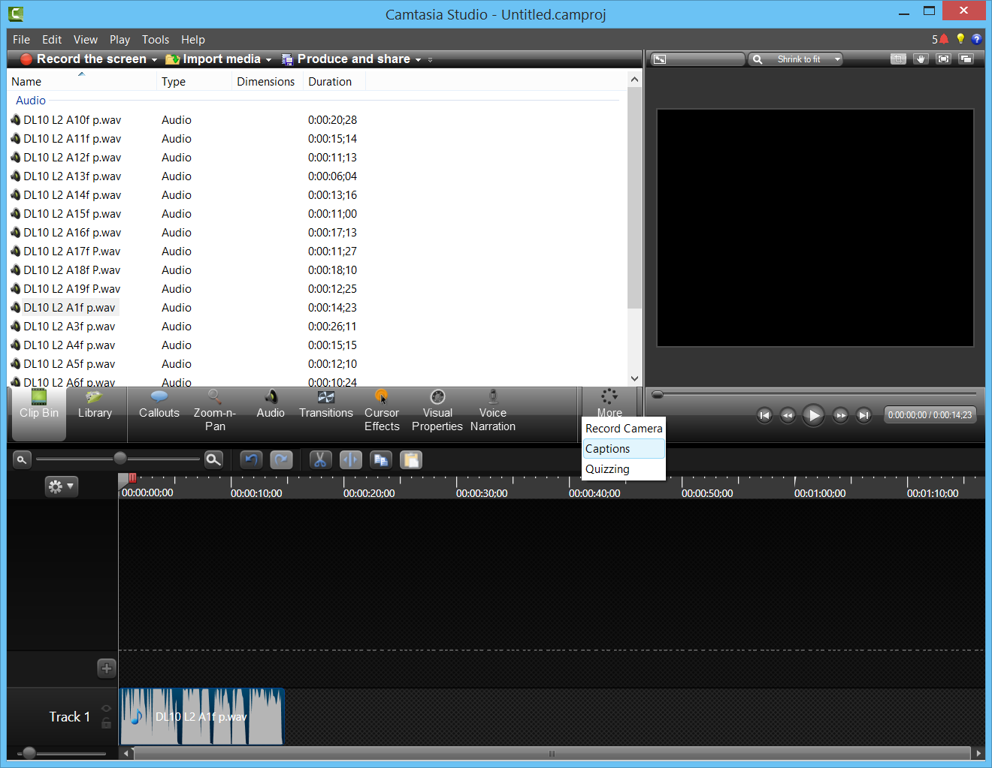

Process for Adding Captions using Camtasia Studio (cont.)

  - Paste in the script for the current slide. Remove any line breaks, extra spaces, or animation notes
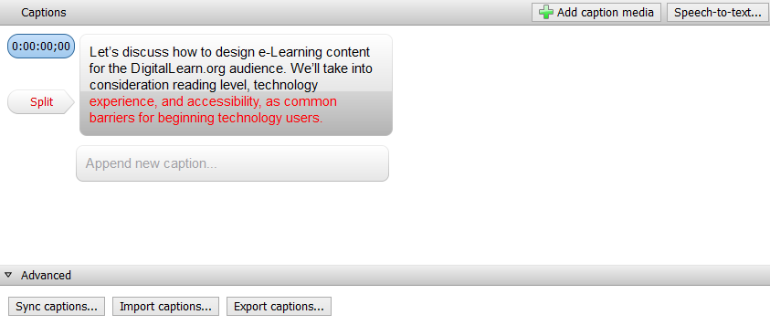
  - Click “Sync Captions.” As the audio plays, click on the text at the points where the captions should split.

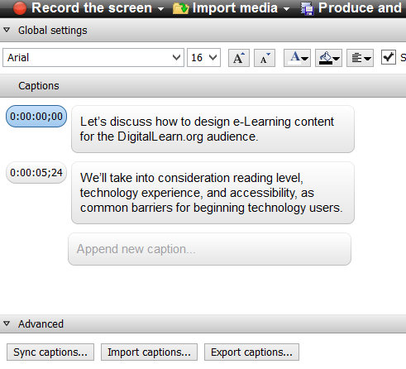

Process for Adding Captions using Camtasia Studio (cont.)

  - Click “Export Captions” and enter a file name (referencing the lesson and slide number) to save the caption file.
  - Delete the tracks in the bottom half of Camtasia to begin the process for the next slide. (You can delete the tracks by pressing CTRL+A then Delete.)

- Add the captions in Articulate Storyline by repeating this process on each slide or layer with an audio track:
  - Click the audio icon in the slide to open the Audio Tools tab.
  - In the Accessibility Group, click the plus sign next to Captions.
  - Select the caption file generated in Camtasia.

- Preview the course with the CC button turned on to ensure captions were added correctly.

