Designing Effective eLearning Content: Recommended Practices

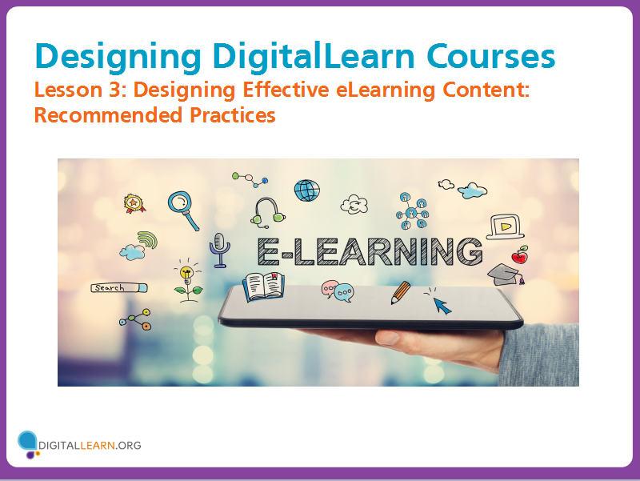
Let’s look at some techniques for designing effective eLearning content.
These practices are based on proven instructional design principles and adult learning theories. You can find a source for these practices in the resources tab.

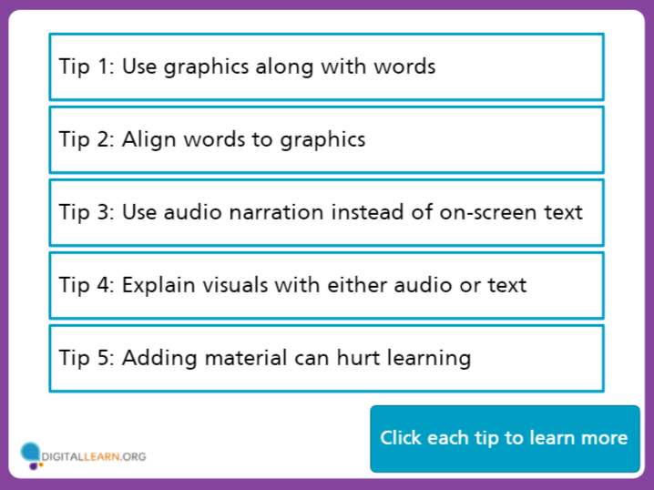

Click on each tip to learn more.

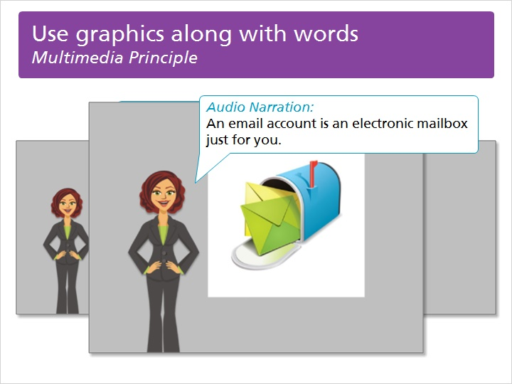
Use graphics along with words
Multimedia Principle
It’s best to use both words and graphics in eLearning content, rather than just words alone. This is because our brains make deeper connections when processing both visuals and words together, as long as they are working together to communicate the same message. In this example, the instructor is narrating the words, and the image is showing a graphic representation of the idea.
Text Box:
Audio Narration: an email account is an electronic mailbox just for you.

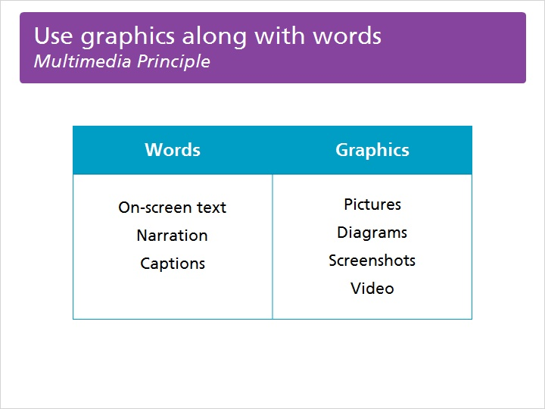

Words may be represented by on-screen text, audio narration, or captions. Graphics may be in the form of pictures, diagrams, screenshots, or video.
Table:
Words Graphics
On-screen text Pictures
Narration Diagrams
Captions Screenshots
Video

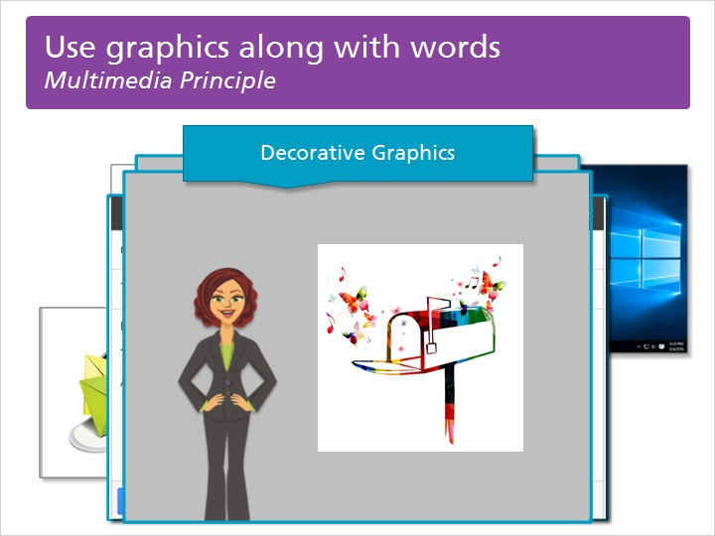

Select the right graphic type to support learning, based on the goal of the lesson. You may want to choose a representational graphic, one that shows an example of an item being described. Or you may want to choose a series of transformational graphics, showing the sequence of events that occur when using a particular technology.
Be careful not to use graphics that are merely decorative when they do not add anything to the learning material. Selecting the right graphic helps the learner’s brain make connections to the information, which helps them remember it and recall it later.

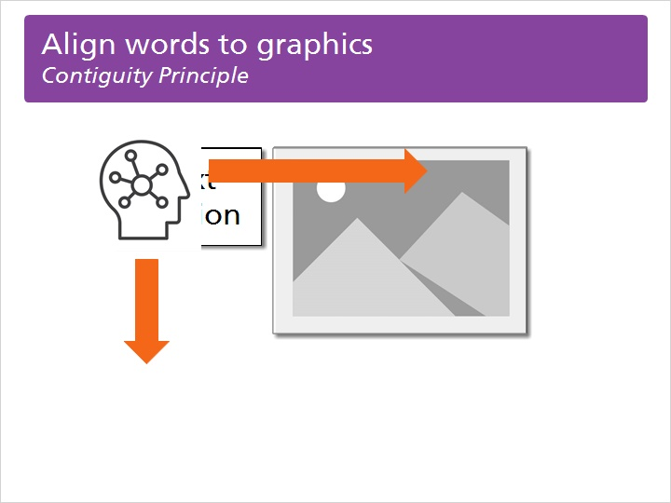
Align words to graphics
Contiguity Principle
You should always align your words and graphics in your eLearning content, both visually and aurally. This is because when we separate words from related graphics we create extraneous processing in the brain. This creates cognitive load and makes it harder for learners to comprehend the information being presented.

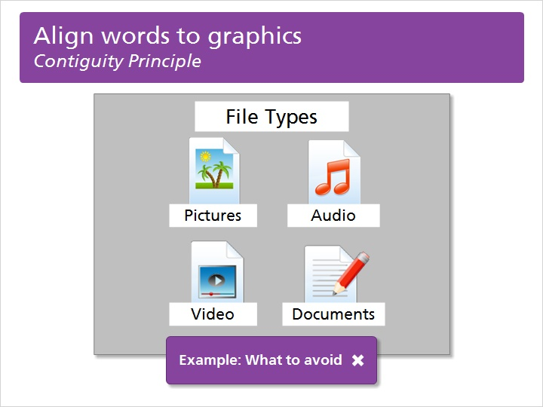

When dealing with printed words, be careful to place the printed words near the related graphics, like this. Click to view an example of what you should avoid doing.
Text Labels:
File Types: Pictures, Audio, Video, Documents

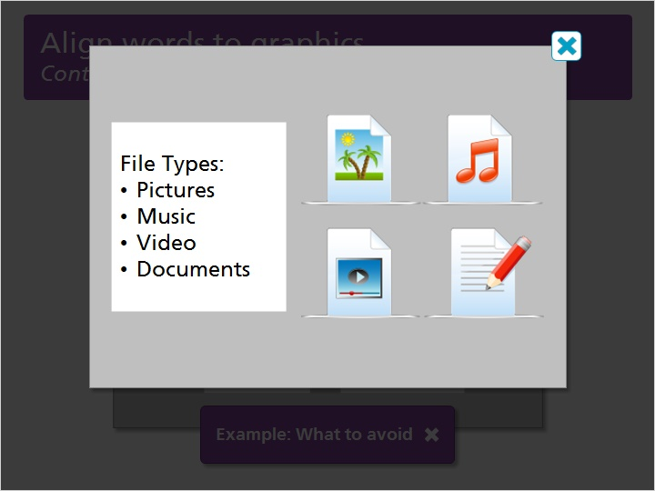
Example: What to Avoid
Text Box:
File Types: Pictures, Music, Video, Documents

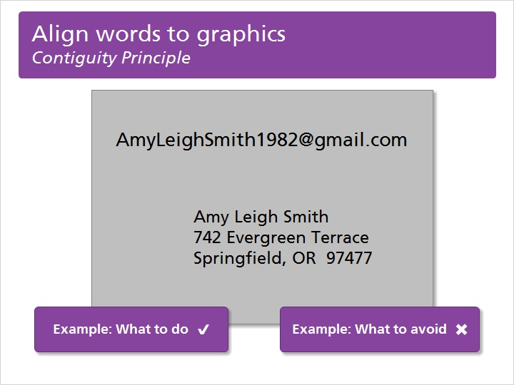

When dealing with narration, synchronize the spoken words with the corresponding graphics and animation. Review and compare these examples of what you should do and what you should avoid doing.

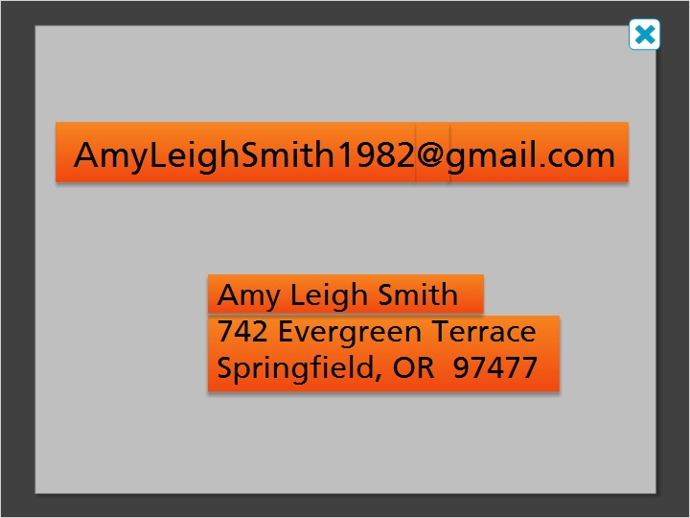
Example: What to do
Text Box:
AmyLeighSmith1982@gmail.com
Amy Leigh Smith
742 Evergreen Terrace
Springfield, OR 97477
Audio Narration:
An email address is made up of who you are sending the email to, the @ symbol, and the location for their email, just like a regular address is made up of who and where.

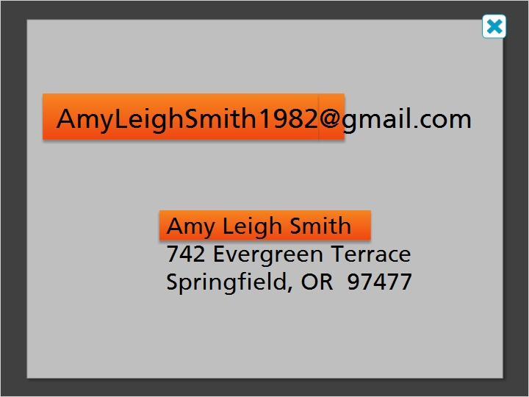
Example: What to Avoid

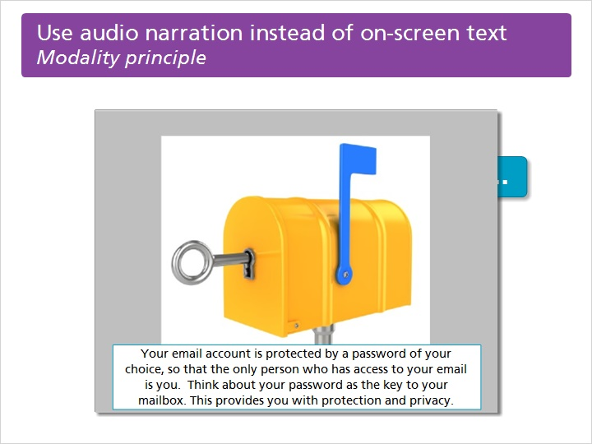
Use audio narration instead of on-screen text
Modality principle
In most instances, you should present words as audio narration, rather than displaying it as on-screen text. This is especially true with long explanations or descriptions. This is because putting lengthy text on-screen increases the cognitive load of the learner.

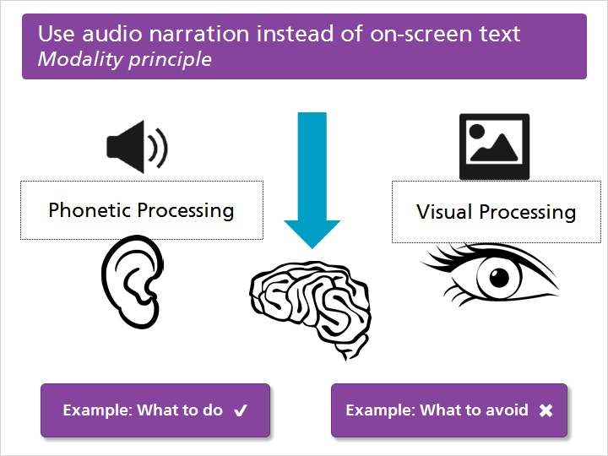

Presenting words as audio narration accompanied by graphics allows learners to process information through two complementary channels simultaneously. The learner hears the words spoken and processes them phonetically in the brain. The learner sees the graphics and processes them visually. Click to compare an example of what you should do and what you should avoid.

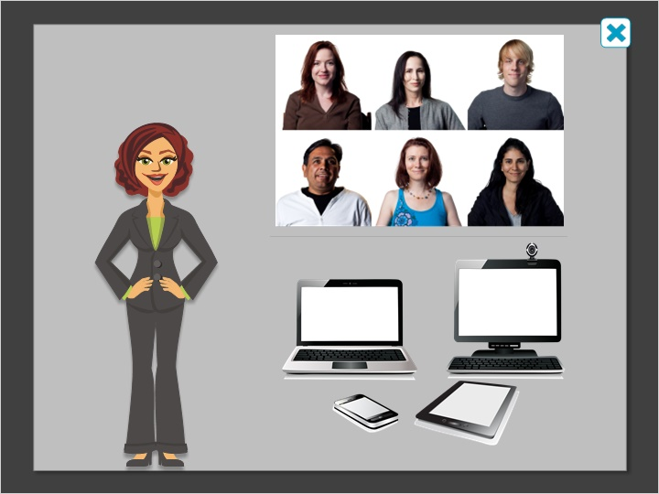
Example: What to do
Audio Narration:
You can send an email to multiple people at the same time and you can access your email on any device that has the Internet, like your computer or your mobile phone.

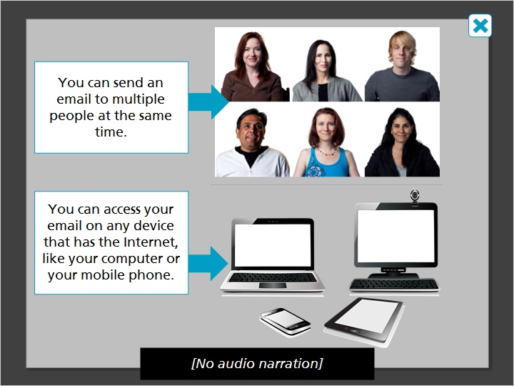
Example: What to Avoid
No audio narration

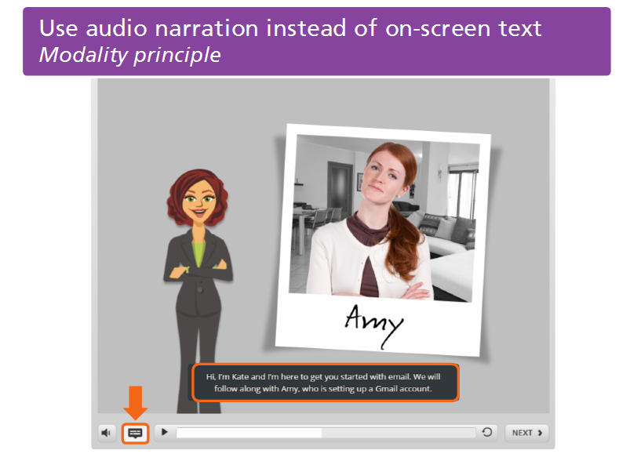
One exception to this principle is individuals who have hearing loss or are deaf. Another exception is with English Language Learners. These learners may have difficulty hearing the audio narration or processing spoken words.
To meet the needs of these learners, using some type of captioning is recommended. Captioning that can be turned on or off by the learner is the best option, if you have a choice of style.
Text Box:
Exceptions:
Individuals with hearing loss
English Language Learners

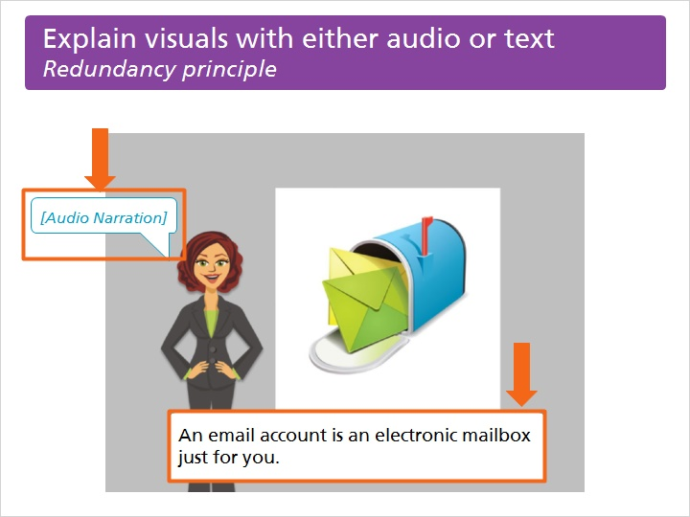
Explain visuals with either audio or text
Redundancy principle
When explaining visuals, do so with audio or with on-screen text, but not both. Avoid redundancy through duplication of words. When words are duplicated in audio and on-screen text, this increases cognitive load and makes it more difficult for the learner to understand.

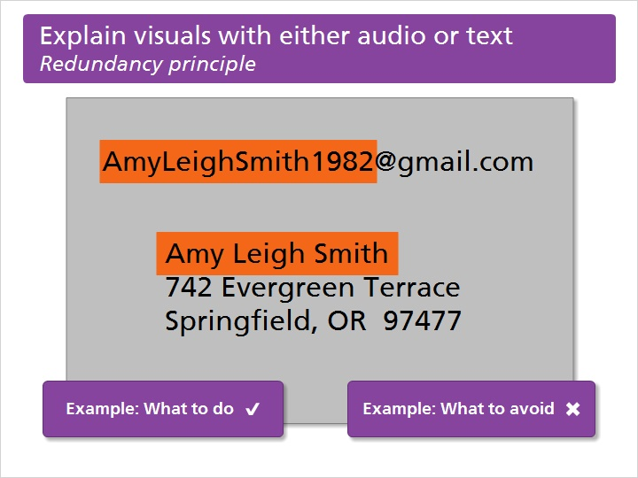
With complex visuals it is natural to want to offer some visual explanation. Try to do this by using short text labels or visual indicators such as arrows or highlight boxes.

Example: What to do

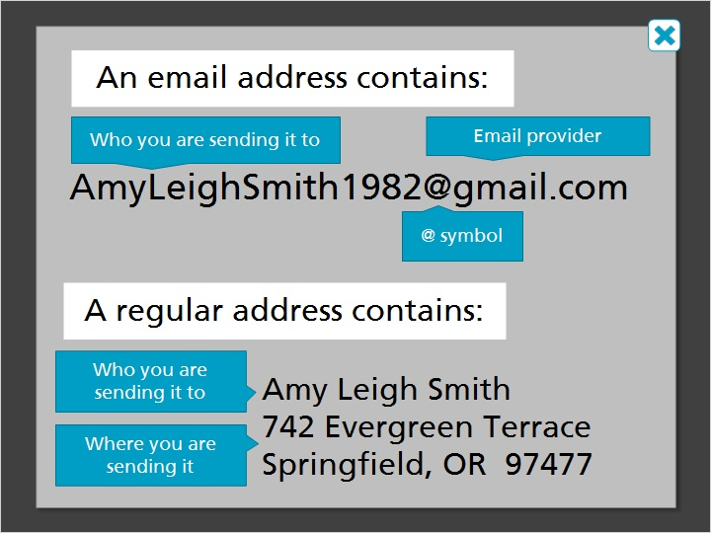
Example: What to Avoid

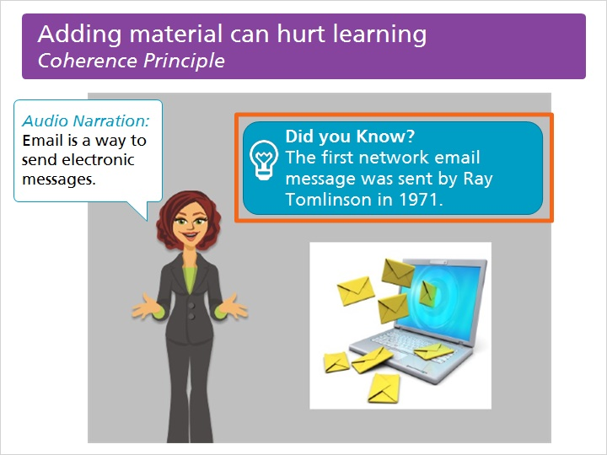
Adding material can hurt learning
Coherence Principle
Avoid adding extraneous material to your eLearning. Extraneous material is anything that does not directly relate to achieving the course objectives. Adding extraneous material is distracting to the learner and increases cognitive load.
Text Box:
Audio Narration: Email is a way to send electronic messages.
Did you Know? The first network email message was sent by Ray Tomlinson in 1971.

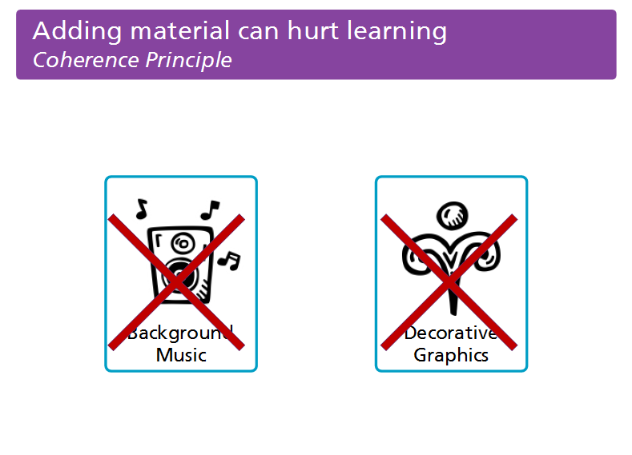

Extraneous material is anything that is unnecessary. Sometimes it might be background music or decorative graphics, or any other content that is considered to be entertaining or aesthetically enhancing. This material is not helpful to the learning process and should not be included in eLearning lessons.

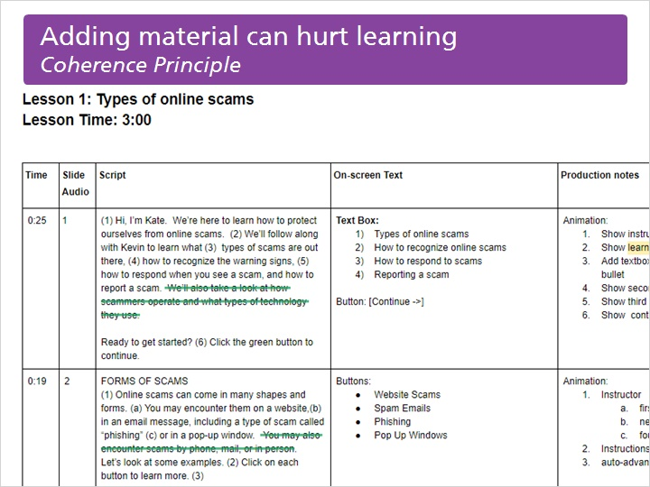
Extraneous materials can also be words, concepts, or ideas that don’t contribute to the course objectives. Adding too many ideas into a single lesson is one example. Similarly, providing descriptions that are more detailed than necessary can cause confusion. Have someone else review and edit your storyboard to give feedback on its clarity, which will help you avoid adding unnecessary concepts or ideas to your courses.

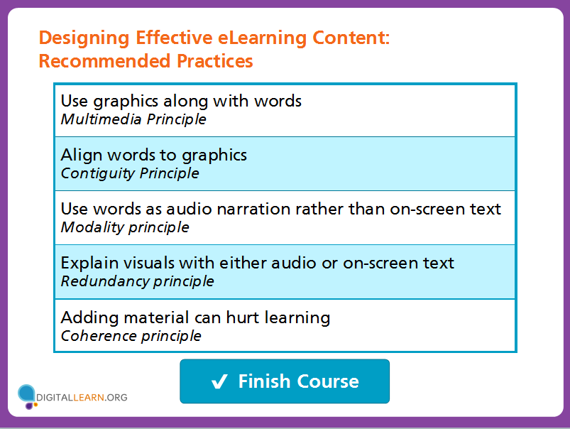

Designing effective eLearning involves the application of these principles based on cognitive science. Follow these tips to make your DigitalLearn courses more effective for learners of all types.

