Designing Content for the DigitalLearn.org Audience
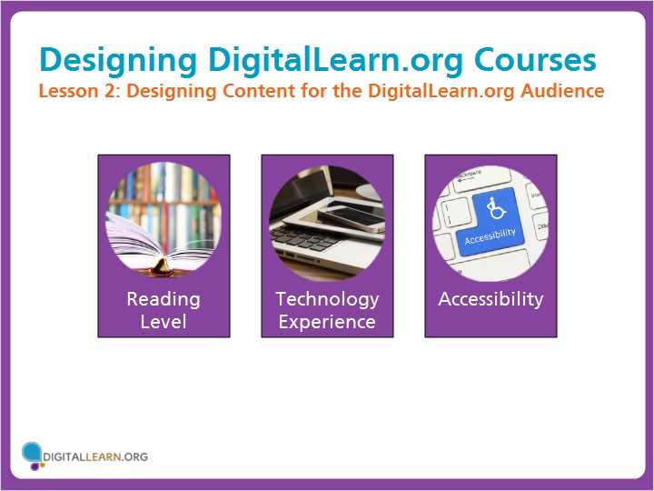

Let’s discuss how to design e-Learning content for the DigitalLearn.org audience. We’ll take into consideration reading level, technology experience, and accessibility, as common barriers for beginning technology users.

Reading Level
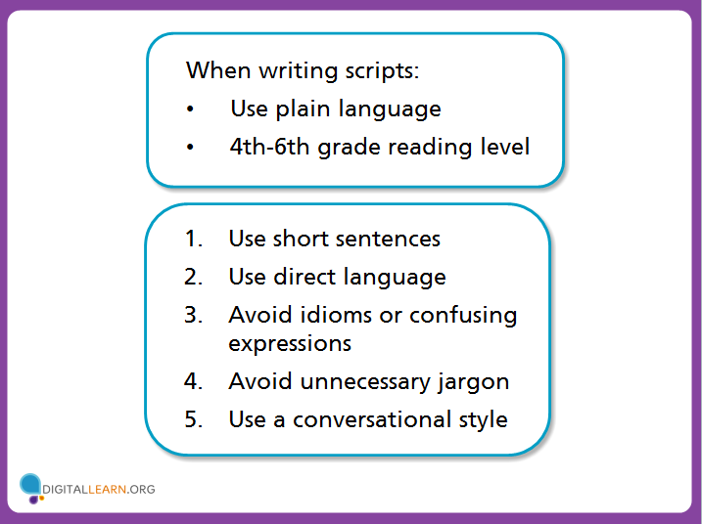

We recommend writing scripts using plain language, targeted at the 4th-6th grade reading level. This helps to keep courses accessible to a wide audience, including English language learners and those with low literacy levels.
I’ll go over these tips for using plain language, which will help keep the reading level low. I’ll share an example of what to do (and what not to do) for each tip.

When writing scripts:
- Use plain language
- 4th-6th grade reading level

- Use short sentences
- Use direct language
- Avoid idioms or confusing expressions
- Avoid unnecessary jargon
- Use a conversational style

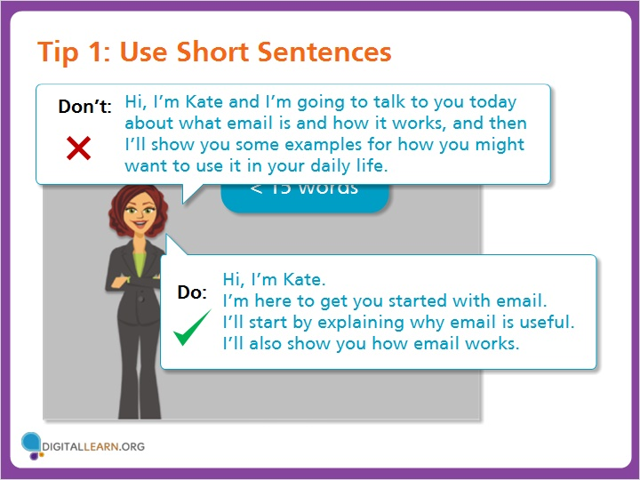
Use short sentences of 15 words or less, breaking up information into small chunks. Consider breaking compound sentences into individual sentences to improve clarity. Take a moment to compare these two examples.

Tip 1: Use Short Sentences

Do: Hi, I’m Kate.
I’m here to get you started with email.
I’ll start by explaining why email is useful.
I’ll also show you how email works.

Don’t: Hi, I’m Kate and I’m going to talk to you today about what email is and how it works, and then I’ll show you some examples for how you might want to use it in your daily life.

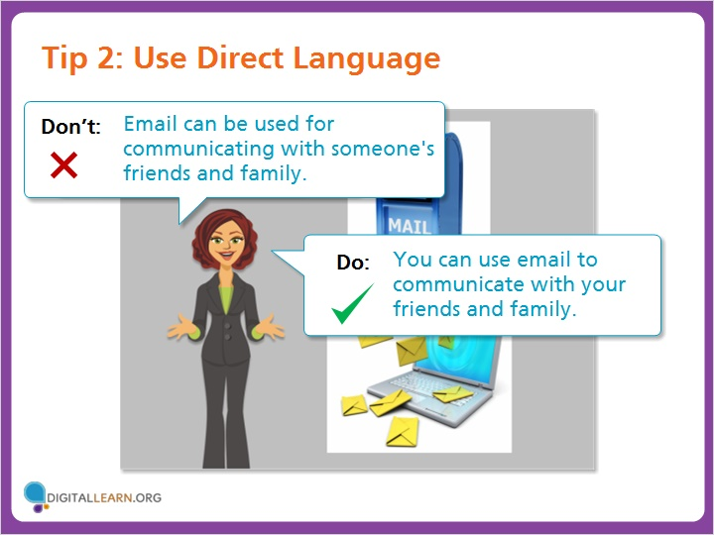

Use direct language and “active” voice instead of passive voice. Use personal pronouns such as you, I, or we. Keep the subject and verb close together.

Tip 2: Use Direct Language

Do: You can use email to communicate with your friends and family.
Don’t: Email can be used for communicating with someone's friends and family.
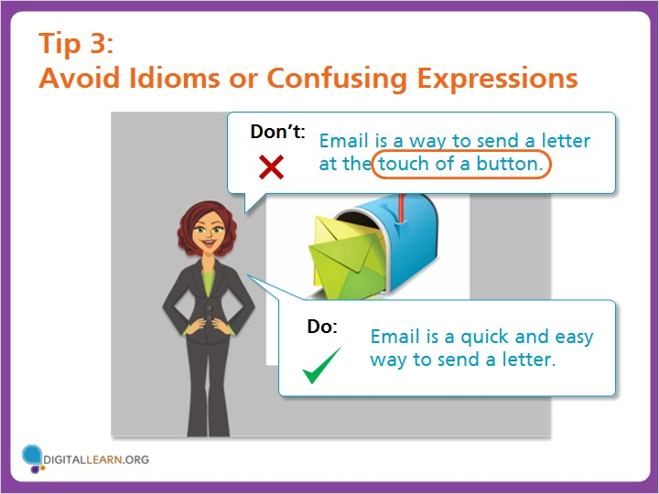

Avoid using idioms, slang, or confusing expressions. English language learners may not be familiar with casual expressions you use on a daily basis.

Tip 3: Avoid Idioms or Confusing Expressions

Do: Email is a quick and easy way to send a letter.

Don’t: Email is a way to send a letter at the touch of a button.

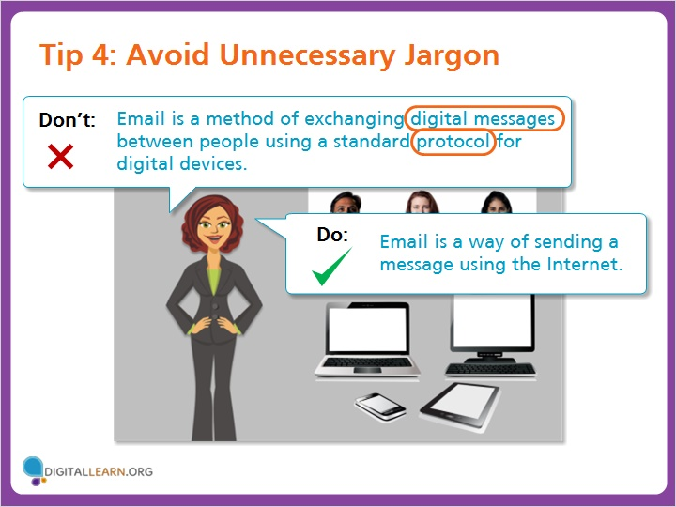

Don’t use unnecessary jargon. When you introduce a new term, explain what it means. Don’t make explanations unnecessarily complicated.

Tip 4: Avoid Unnecessary Jargon

Do: Email is a way of sending a message using the Internet.

Don’t: Email is a method of exchanging digital messages between people using a standard protocol for digital devices.

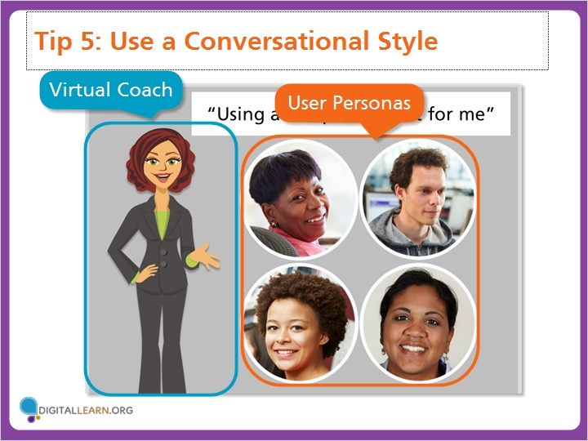

When writing scripts, we recommend using a conversational style. Write in first and second person, using the voice of a Virtual Coach. This makes the lesson more user friendly and personalized.
To make examples more relatable, incorporate a user persona or character and give a realistic example for the learner to follow along with.

Tip 5: Use a Conversational Style

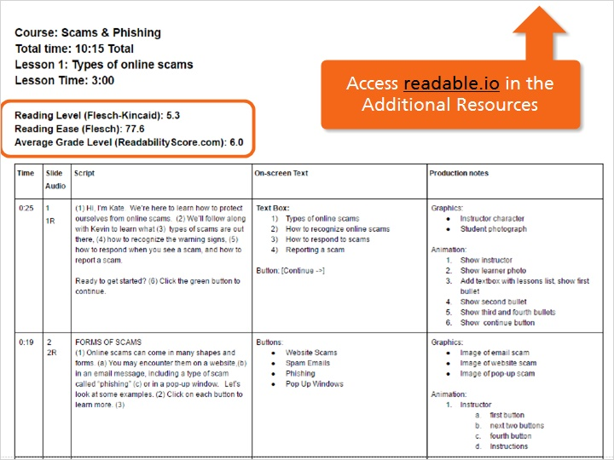

To test the reading level of your script, you can use a site such as readable.io which offers a range of scoring mechanisms to gauge the reading level.
We like to document the reading level in the storyboard for each lesson.
Some courses may include a number of computer and technology terms that will inflate the reading level. This is acceptable if you are defining the terms within the content of the course and using plain language guidelines.

Access readable.io in the Additional Resources

Technology Experience
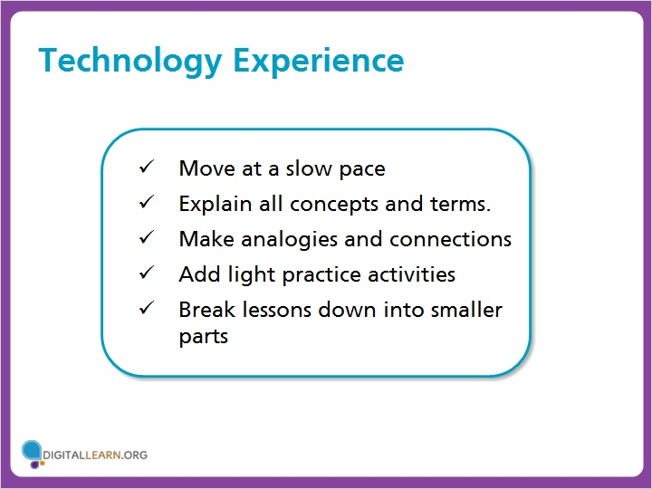

DigitalLearn.org courses are designed for those with limited technology experience. They may have never used a computer before, be confused about terminology, or have trouble controlling the mouse and keyboard.
To keep courses approachable to new technology users, we recommend these guidelines for developing course content.

- Move at a slow pace
- Explain all concepts and terms.
- Make analogies and connections
- Add light practice activities
- Break lessons down into smaller parts
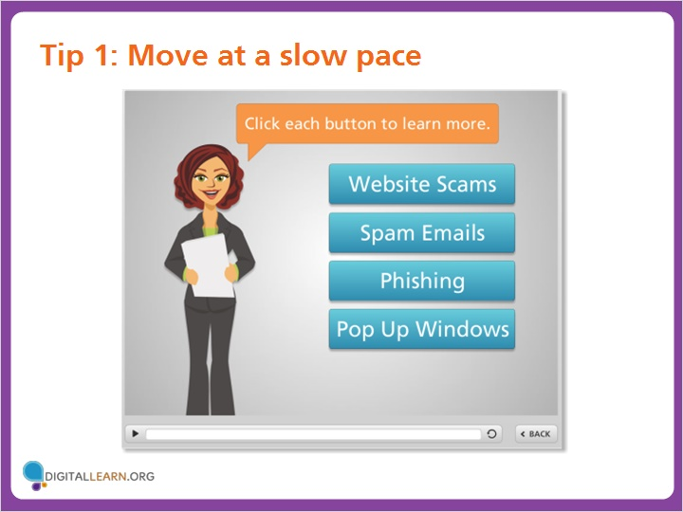

Tip 1: Move at a slow pace

Move at a slow pace. Beginning technology learners often need more time to absorb what they see on the screen. Allowing the learner to choose when to advance to the next point or concept gives them more control about how quickly the pace moves.

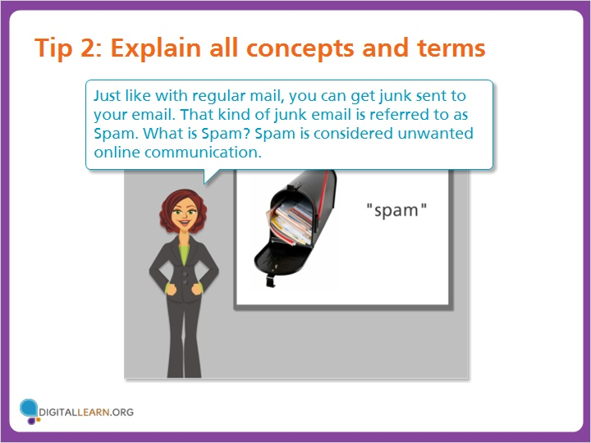

Tip 2: Explain all concepts and terms

Explain all concepts and define all terms used; don’t assume the learner already knows. Here is an example of narration from one of our existing DigitalLearn courses.

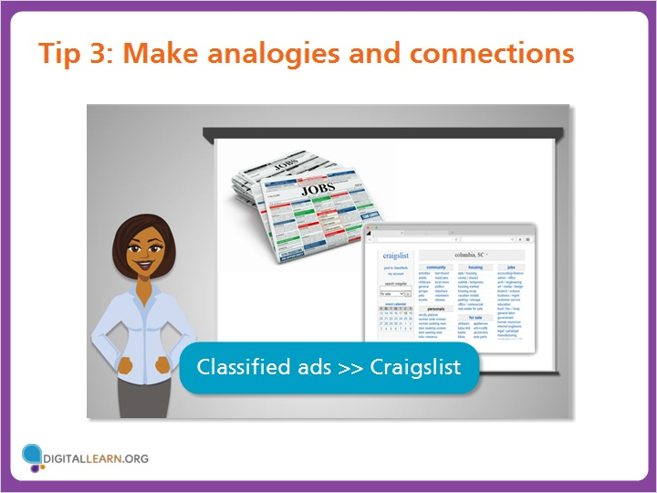

Tip 3: Make analogies and connections

Make analogies and connections to non-technology experiences that the learner can relate to.

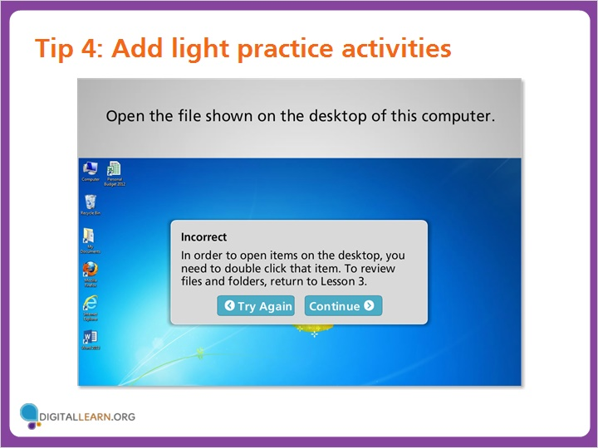
Tip 4: Add light practice activities

Add light practice activities, especially at the lowest levels. When including practice activities or quizzes, be sure to include hints so users don’t get “stuck” on something that is too difficult for them.

Tip 5: Break lessons down into smaller parts

Break lessons down into smaller parts, and allow the learner to control when to progress to the next level. This gives them time to digest content or repeat it if needed.

Accessibility
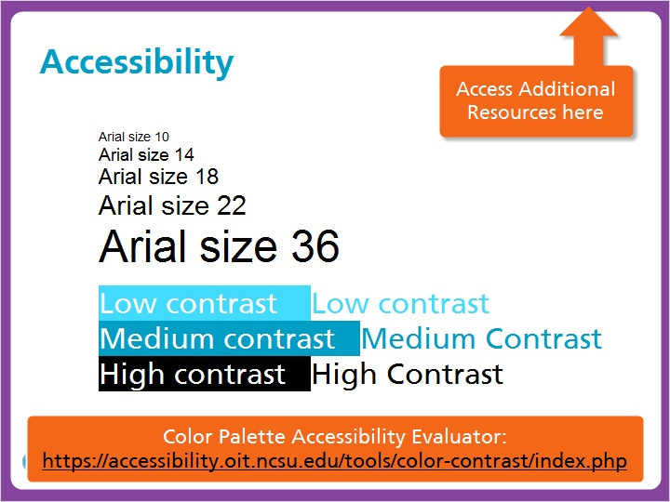

It’s important to take accessibility into account for DigitalLearn.org courses. On screen text should be easy to read with large font sizes and high contrast. You can test font sizes and colors using free online resources such as the one shown on your screen.

Color Palette Accessibility Evaluator:
https://accessibility.oit.ncsu.edu/tools/color-contrast/index.php

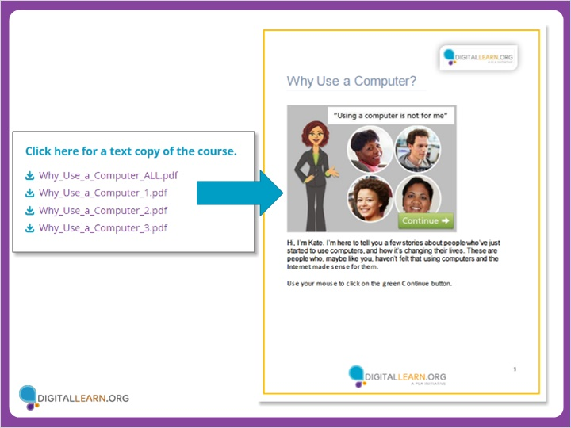

Provide a PDF transcript of all of the audio narration, and include still images from the course. This can be autogenerated in Storyline and then edited for consistency.

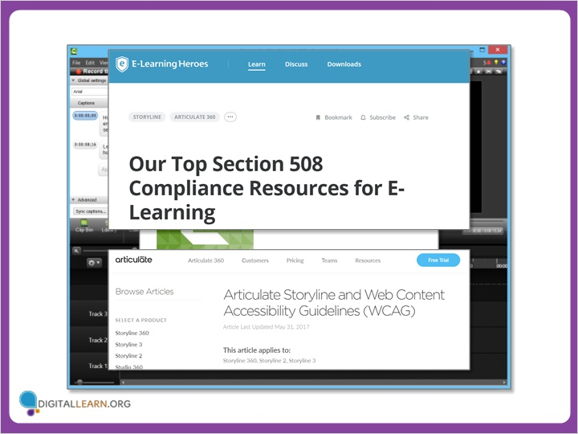

It is possible to add closed captioning in Storyline 3. To do this requires the use of another program, Camtasia, to create the caption file. We have included instructions in the style sheet, and you can also learn more on the Articulate website and E-Learning Heroes blog.

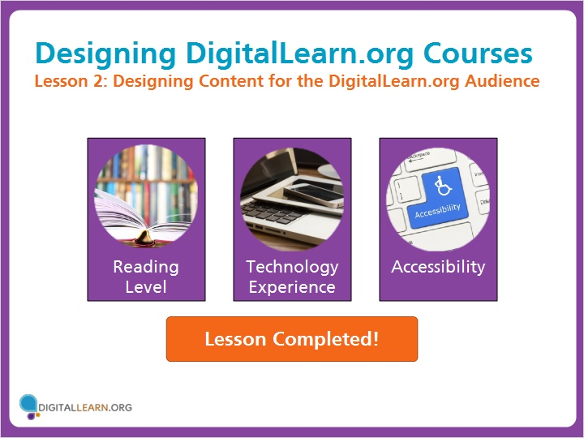

The DigitalLearn.org audience faces many barriers to using the computer. Follow the practices outlined in this lesson to keep DigitalLearn.org courses approachable and accessible to a broad audience.

Lesson Completed!

