
Youth Computer Take Apart
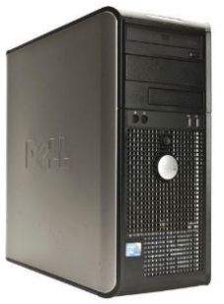
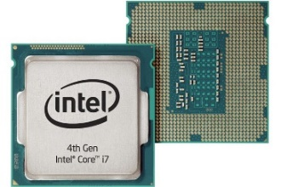
Computer Case
Also called a Tower; holds all the computer parts
CPU
Central Processing Unit;
the computer’s “brain”

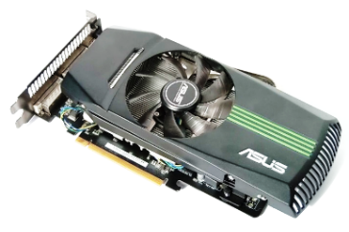
Motherboard
The circuit board that connects all the parts; like your Central Nervous System
GPU
Graphics Processing Unit; allows you to see images on the screen, like your eyes
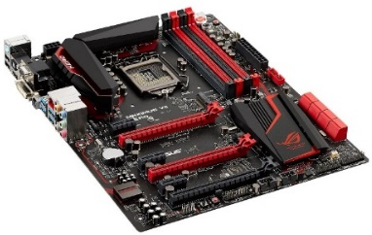

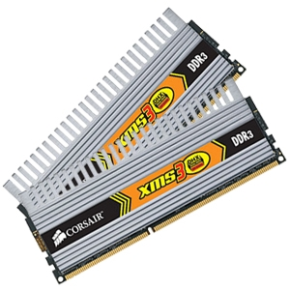
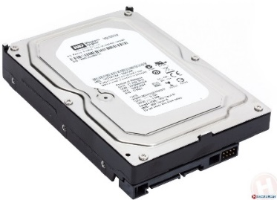
Hard Drive
Saves your files, programs, and apps; like your long-term memory
RAM
Random Access Memory; runs the programs, like your short-term memory

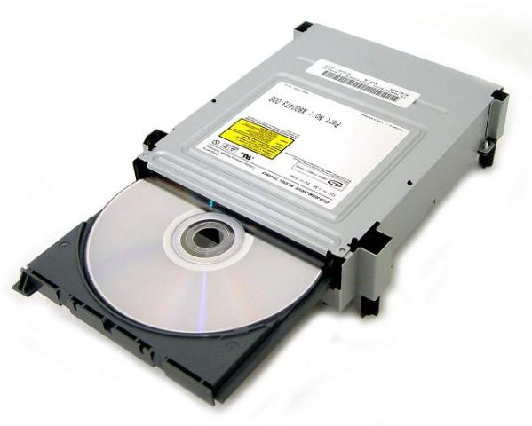
Cooling Fans
Like sweating! Keeps parts cool and prevents overheating/damage
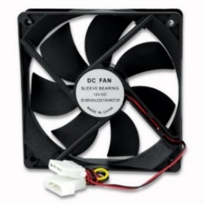
Optical Drive
Reads discs (CD’s, DVD’s, Blu-Rays); like your eyes and ears

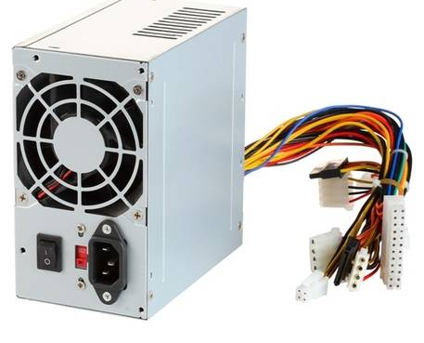
PSU
Power Supply Unit; powers the computer, like the heart

