Tablet Apps

Below is a list of popular apps and staff favorites. Have fun exploring!

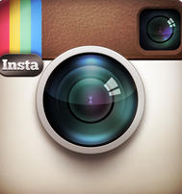 | 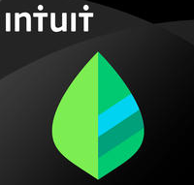
SOCIAL MEDIA | FINANCE | TRAVEL | COMMUNICATION
Facebook | Your Bank’s App | Uber | Yahoo, Gmail & Outlook
Pinterest | Mint | Lyft | The Weather Channel
Twitter | PayPal | Waze | CNN/ABC/NBC News
Flickr | Square | Airlines | Yahoo/Google/Bing News
Instagram | Expensify | Kayaak | Chicago Tribune
SnapChat |  | Travelocity | Sun-Times
LinkedIn |  | TripAdvisor | Tumblr
Skype |  | Priceline | Blogger
 |  |  | TEDTalks
HEALTH & WELLNESS | MOVIES, TV & VIDEO | MUSIC & SHOPPING | PRODUCTIVITY
MyFitnessPal | Netflix | Pandora | Evernote
Fitbit | Crackle | Spotify | Google Docs
MapMyRun/Walk/Ride | Hulu | Shazam | Google Drive/Calendar/Maps
Yoga.com | VUDU | iHeartRadio | Dropbox
7 Minute Workout | Cable TV | Living Social | Microsoft Office
HealthTap | Amazon Instant Video | eBay | Trello
First Aid  (The American Red Cross) | Watch ESPN  Fandango | Amazon  Retail/Department Stores | Tiny Scanner  Cozi Family Calendar
Luminosity | IMDb | ScanLife | Genius Scan
Relax & Rest Guided Meditation | YouTube | Red Laser  ShopAdvisor
SparkRecipes |  | Groupon  Zillow Real Estate

