
WordPress: Designing Your Website
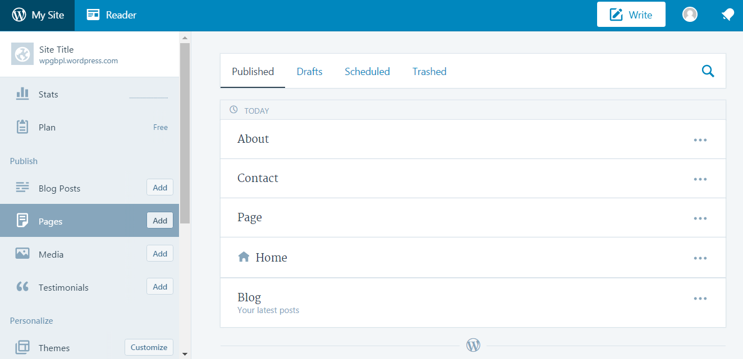
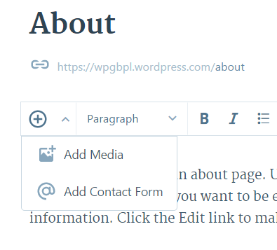
Adding an Image to your Page/Post
- Click Pages located in the left menu
- Choose any page
- Click on the Plus icon
- Click on the blue Add New button
- Choose an image file from your computer
- Confirm your choice
- Click on the blue Insert button

Adding an image from the web using a URL
- Click Pages located in the left menu
- Choose any page
- Click on the Plus icon
- Click on the Add via URL button
- Copy URL link
- Paste link into box
- Click the blue Upload button
- Click the blue Insert button

Linking Social Media Profiles to your Site
Note: You’ll need an existing social media account
  - Click Menus located in the left menu
  - Using the dropdown at the top choose Social Menu
  - Click the Pencil icon next to the desired social media site
  - Click on the Link tab
  - Paste a link to the account in the link address box
  - Click the blue OK button
  - Click the blue Save button

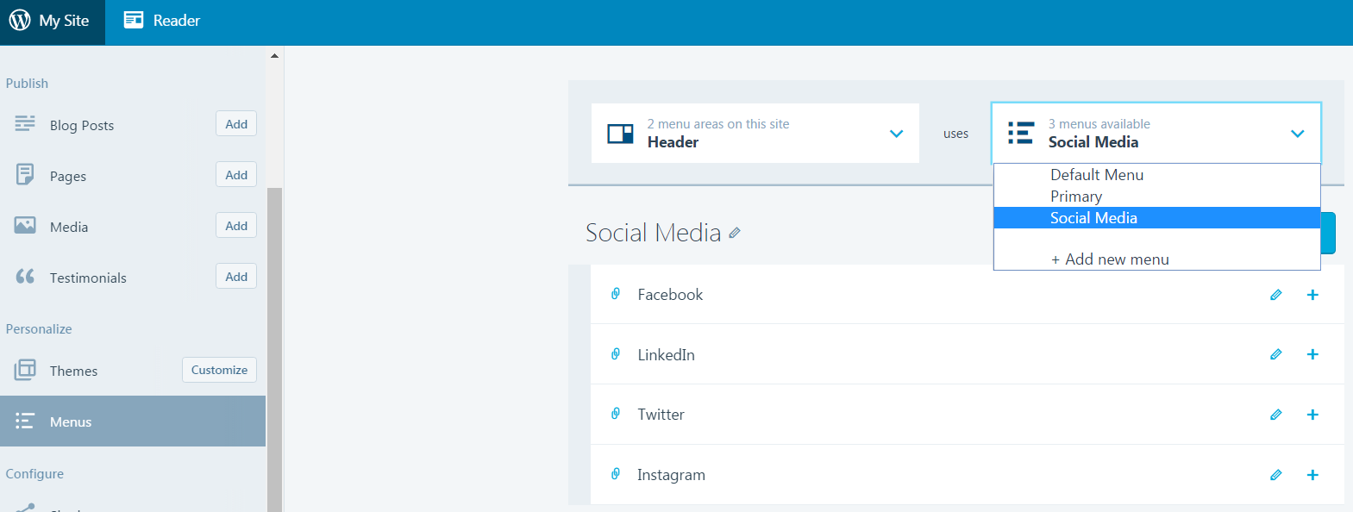

Removing Social Media Links from the Social Media menu
  - Click Menus located in the left menu
  - Using the dropdown menu near the top choose Social Links Menu
  - Click on the Pencil icon to the left of Instagram
  - Click on the Trash icon button to remove Instagram from the social media menu
  - Click on the blue Delete Item button to delete Instagram from the list of options

Editing the List of Social Sharing Buttons
- Click Sharing located in the left menu
- Click Sharing Buttons tab located near the top of the page
- Click on Edit sharing buttons located below the preview box
- Click any of the “light grey” social buttons to remove them from the list of choices
- Click Save Changes

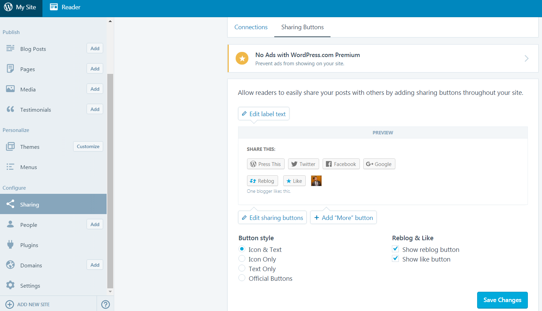
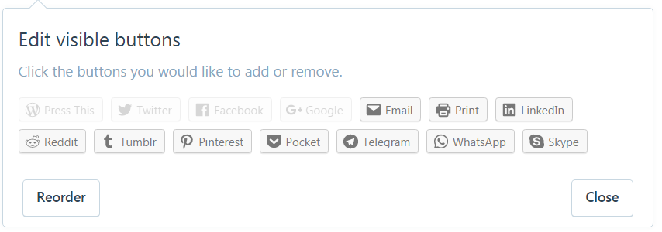
Bonus: Removing the Social Sharing Buttons from your Pages
- With the Sharing Button window, still open - uncheck Pages located under Options
- Click Save Changes

