
WordPress: Creating Your Website
Logging in to your Wordpress.com Account

Step 1
Type WordPress.com in your browser. Then click Log In located in the upper right corner.

Step 2
Enter in your Username or Email and Password then click on the blue Log In button.

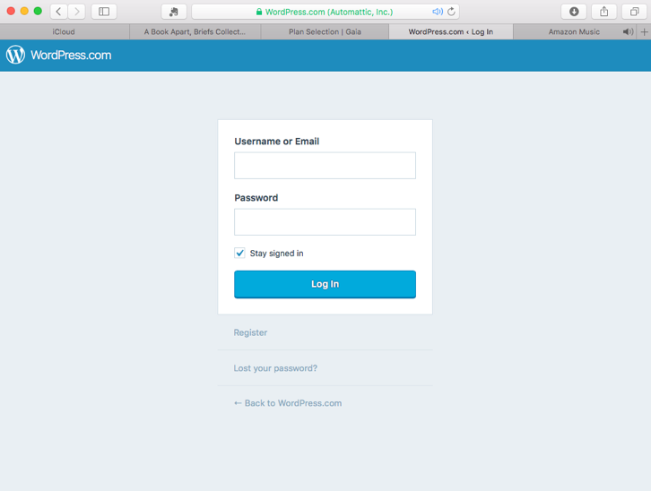
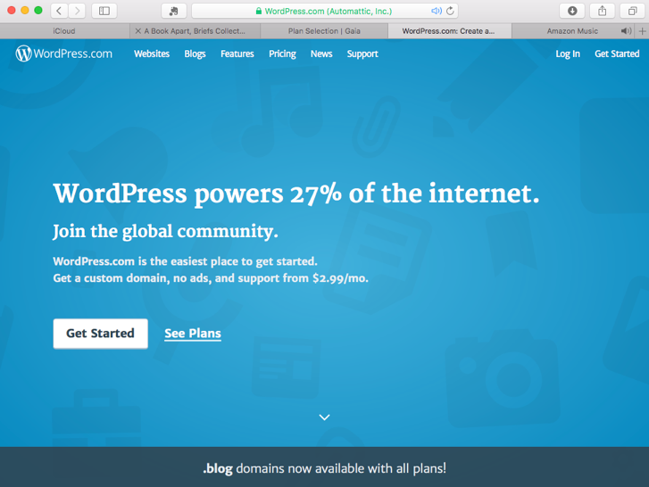
Step 3
Click on My Sites in the upper left corner to view your WordPress.com account.

Step 4
Congratulations! You are now ready to edit your website!

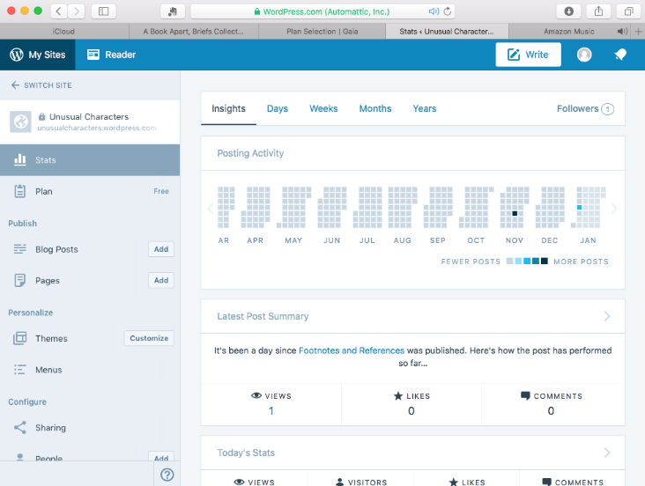
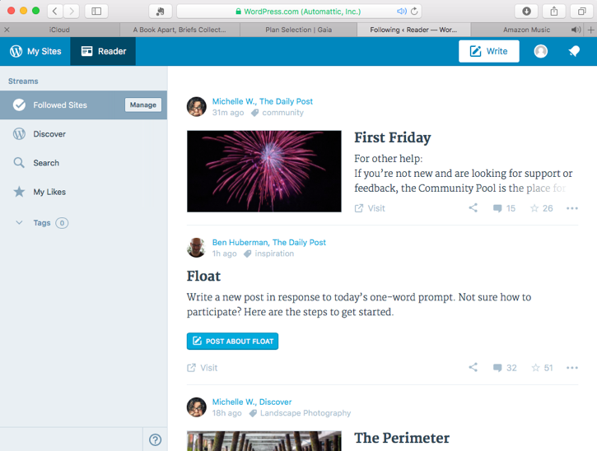

Editing the Menu (NOTE: Two pages may exist by default. You may have an About and Contact page created for you by WordPress.com.)
- Click Menus located in the left menu
- Click Primary from drop down menu in the upper corner
- Click the Plus icon located to the right of the page name
- Choose Add menu item below
- Click on Create a new page for this menu item
- Enter a page name and click the blue Add Item button
- Click Save
Bonus: Creating a Sub-Menu Item
- Click the Plus icon located to the right of any page name
- Choose Add menu item to children
- Click on Create a new page for this menu item
- Enter a page name and click the blue Add Item button
- Click Save
Adding a Page
- Click Add located next to Pages in the left menu
- Enter text in the title and body area
- Click Publish
- Click View Page located in the green toolbar
Bonus: With the view page still open, set static home page
- Click Customize located in the lower corner to return to the editor
- Click Static Front Page in the left menu
- Choose A static page
- Choose a Front page using the drop-down menu (This can be edited at any time.)
- Choose a Post page using the drop-down menu (This can be edited at any time.)
- Click the blue Save & Publish button near the top
Selecting a Theme
- Click Themes located in the left menu
- Click the All dropdown menu near the upper right corner and choose Free
- Scroll down to view the choices
- Click on the ellipsis icon in the lower right corner of the theme thumbnail image
- Choose Activate from the pop-up menu
Bonus: You can preview themes and try them before activating them
- Click on the ellipsis icon again and choose Live Demo to view the features of the theme
- Click on the “X” in the upper corner of the window to close the view
- Click on the ellipsis icon again and choose Try & Customize
- Click on the “X” in the upper corner of the window to close the view

