WordPress: Adding Function to Your Site

Adding a Widget

Step 1  Click the grey Customize button located to the right of Themes.  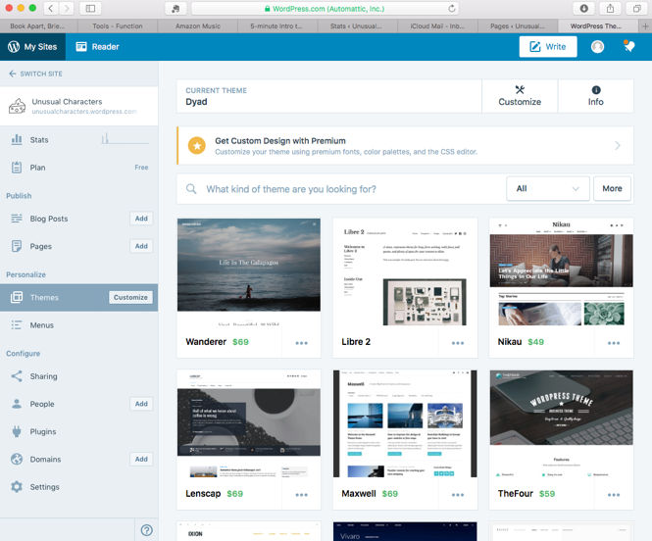 | Step 2  Click on Widgets from the left menu.  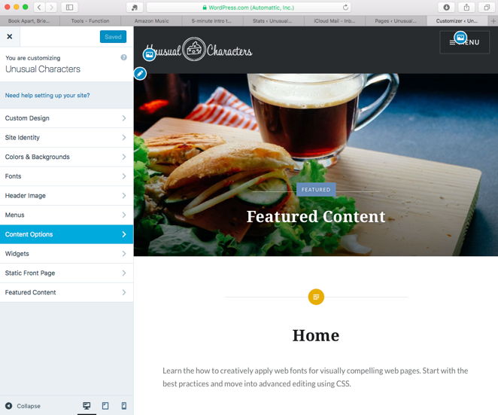
Step 3  Click on Footer from the left menu.  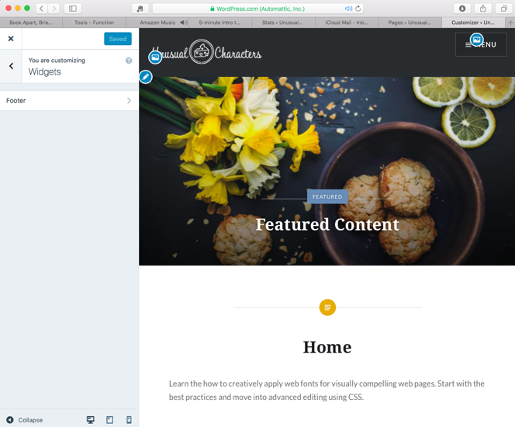 | Step 4  Click on the Add a Widget button.  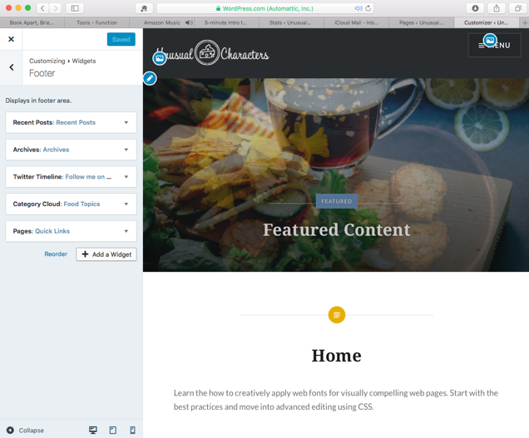
Step 5  Choose Pages from the fly out menu.  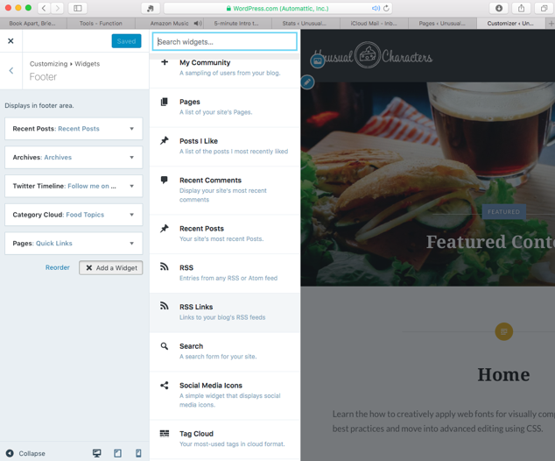 | Step 6  Click the blue Save & Publish button.  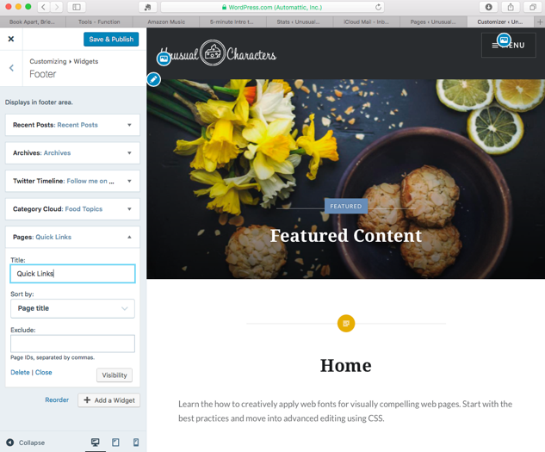

List of User Profile Roles

- Subscriber
    - If allowed, visitors can set up their own user profile
    - This role is limited to managing their own profile
    - If you set Comments to require users to be registered, this is the role they would be assigned
- Contributor
    - This role comes with the capability to create, edit and delete their own unpublished posts
    - Its limitations are the inability to upload media, publish posts and editing or deleting a post once it is published
    - When submitting a post, the publishing button is replaced with a submit for review button
- Author
    - This role comes with the capability to create, edit, publish and delete their own published posts plus add media
- Editor
    - This role has the same capabilities of an Author plus the ability to delete post from other users, moderate comments and manage categories
- Administrator
    - Full control over the entire site
    - Capable of editing user profiles and deleting user profiles

