
Windows 11 Basics
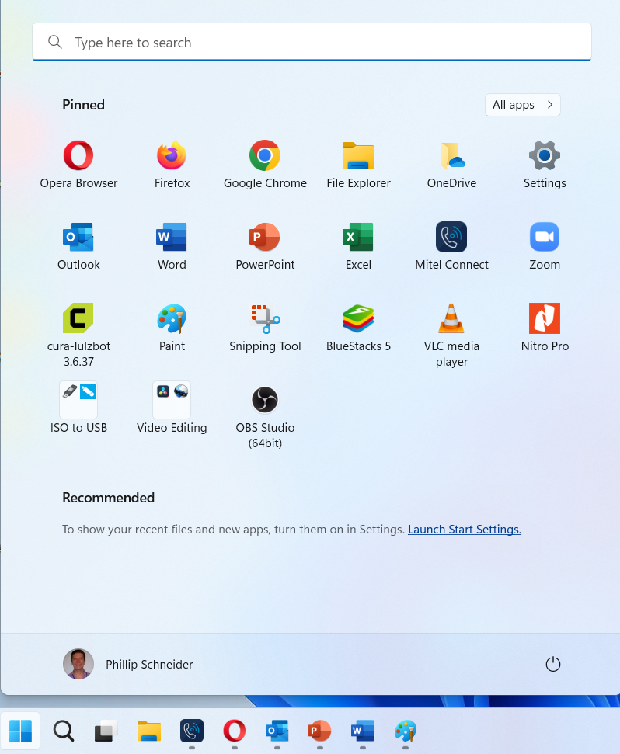
New Start Menu
- Search Bar at the top
- Tiles gone and replaced with icons
- Can still create folders by dragging an icon on top of another one
- Recommended items are located at the bottom of the start menu unless turned off
- Your Profile
- Power icon now in bottom right corner

1

2

3

4

1 2 3 4 5
5
6

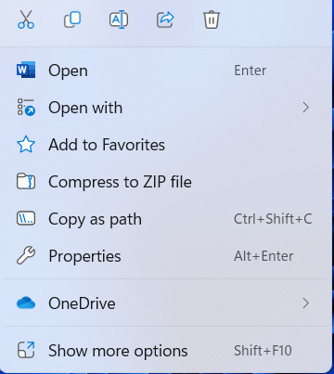
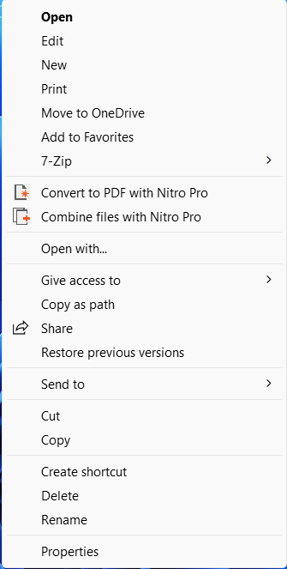
New Right Click Menu
- Cut
- Copy
- Rename
- Share
- Delete

Original Menu with full options

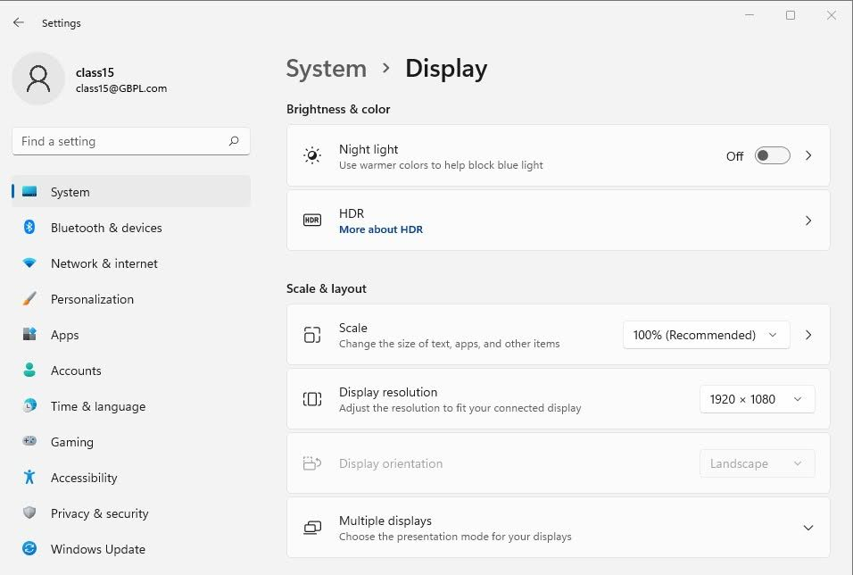
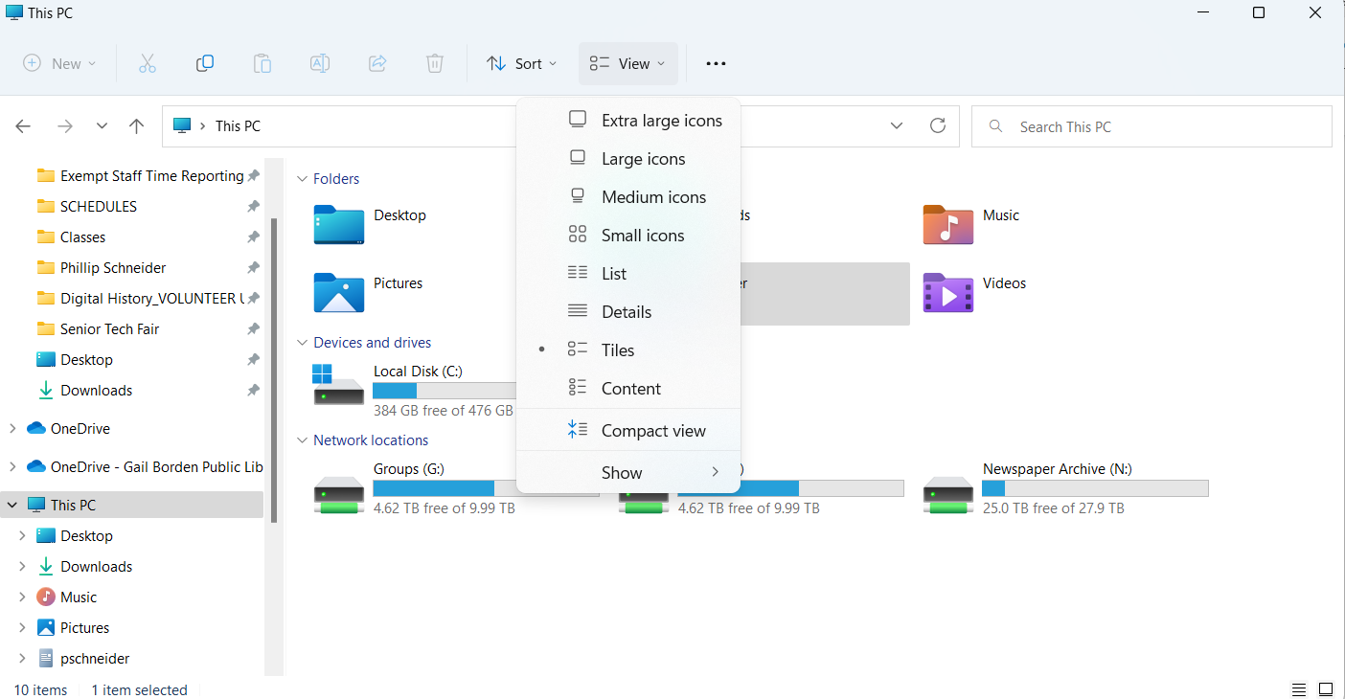
Settings
- System: Make all icons larger, Night light, HDR and Multiple monitors
- Bluetooth & Devices: Bluetooth connection and settings for printers, Scanners and your mouse.
- Networking & Internet: Wi-Fi connections and settings
- Personalization: Change desktop and lock screen pictures
- Apps: Deleting apps/programs and setting default programs
- Accounts: User account settings
- Time & Language: Set date and time
- Accessibility: Change the size of your text, mouse pointer, text cursor, and magnification options.
- Privacy & Security: Privacy options and Windows security (Defender)
- Basic functions: cut, paste, rename, etc.
- Navigation menu
- Quick Access Items
- All files
- Change icon size with view
- File search bar
6
5
4
3
1
2

