Windows 10 Intermediate

**Tips for Installing Apps/Programs**

1. Only download/install programs from official company websites, CDs or the Windows Store
2. Read through instillation agreements carefully to avoid installing unwanted add-ons
3. Some programs require your computer to restart prior to the first use

**Creating Desktop Shortcuts**

1. Minimize or close all programs so you can see the desktop
2. Open the Start Menu
3. In the list of apps, find the program you want to create a shortcut for
4. Left-click and hold on the app tile, then drag it out to the desired location on the desktop

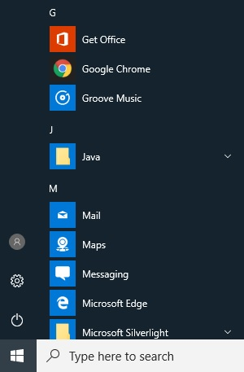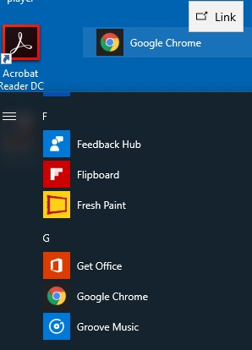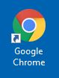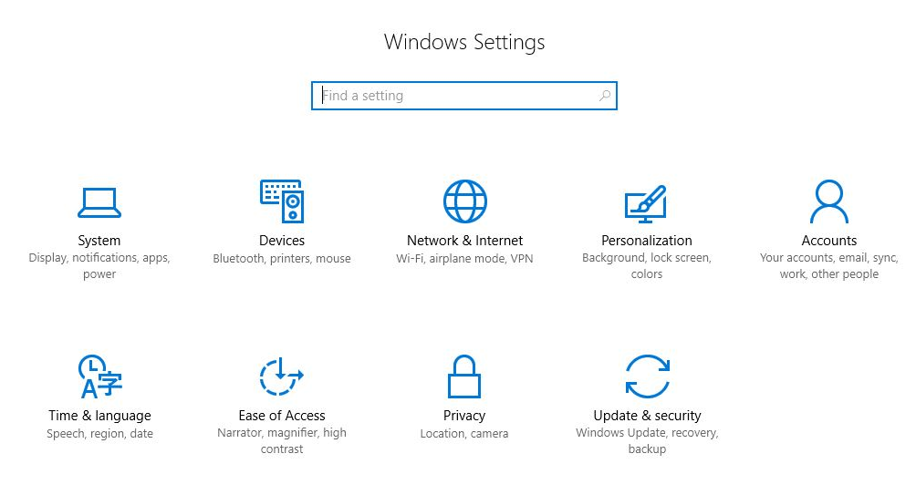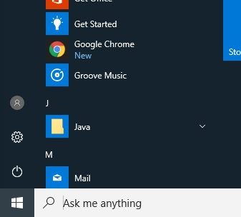

**Accessing Settings**

The Settings screen has changed in Windows 10. Explore the options to discover where items have moved. Prefer to use the Control Panel? Type *Control Panel* in the search box to access it.

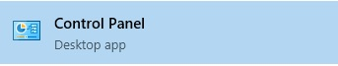

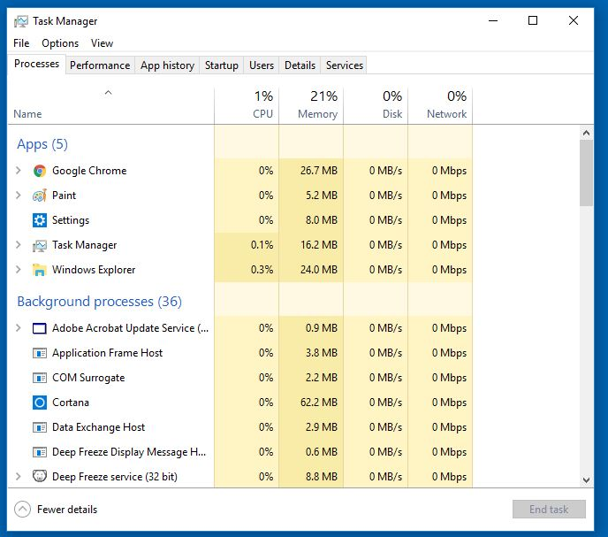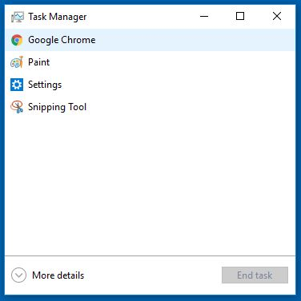

**Task Manager**

Open Task Manager by pressing **Ctr + Alt +Del** on your keyboard at the same time, and then click **Task Manager**

* Use the **Processes** tab to close unresponsive programs
* Use the **Startup** tab to adjust programs that open automatically upon booting Windows

**Uninstalling Programs**

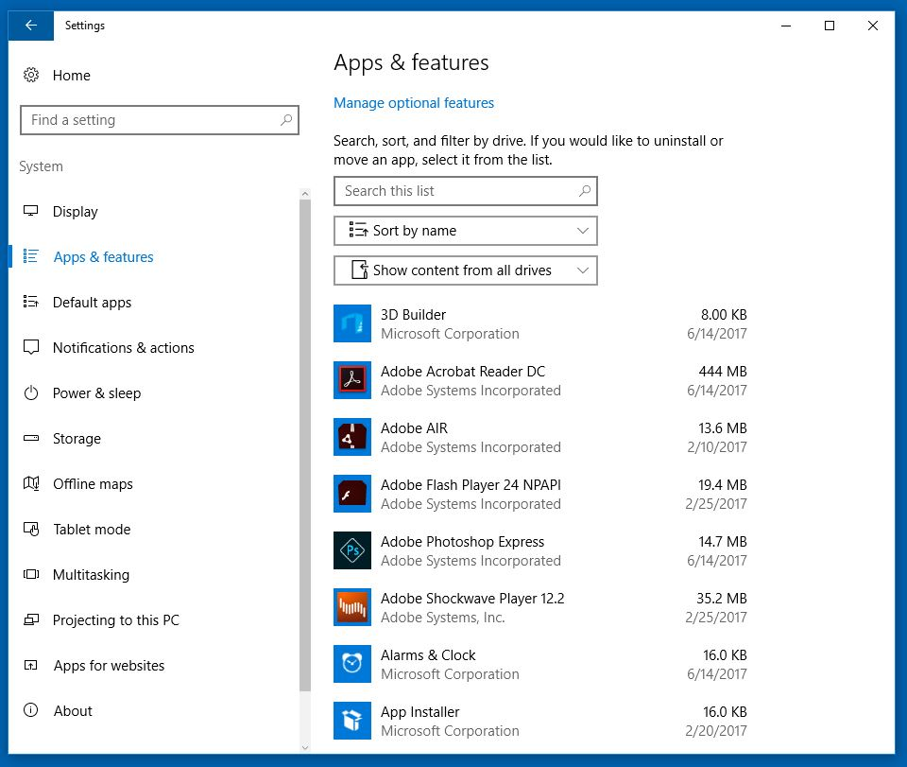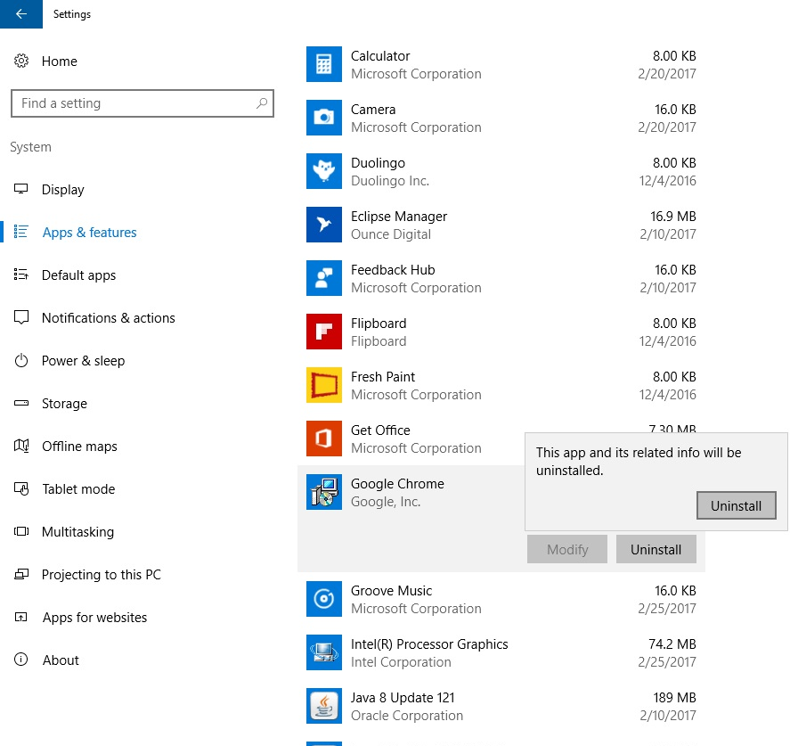

The **Windows Store** allows you to purchase and download apps, music, Movies, TV shows, and Video games

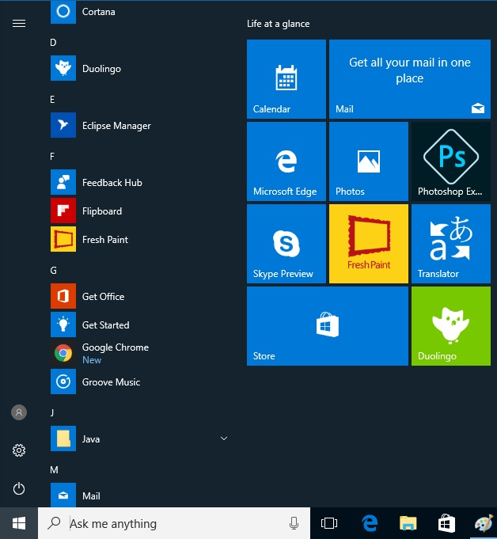

**Windows Defender** is a free, built in antivirus program with Windows 10. Paid antivirus software will offer more robust options, but Defender provides basic coverage.

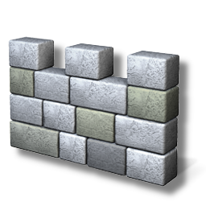

1. Open **Settings**
2. Click **System**
3. Click **Apps & Features**
4. Select the app you wish to delete
5. Click **Uninstall** and follow any prompts