
Windows 10 Basics
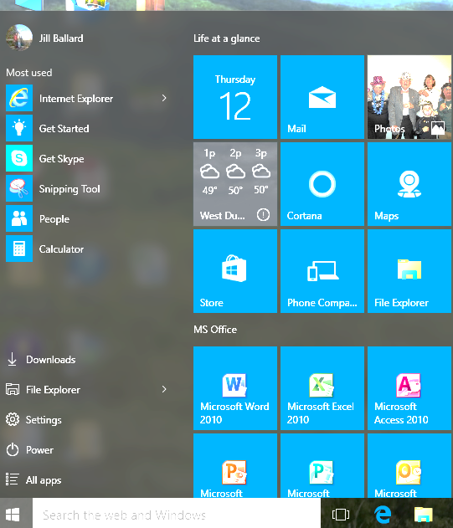
App
Tiles
Search Web & Windows
All Apps
Sign Out
Power Button

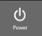
Logging Off/ Restarting/ Shutting Down
To Log off, click your name at the top left of the menu, then click Sign Out
To Restart or Shut Down the computer, click the Power button then select the desired option

Windows 10 Start Menu
Use the Start Menu to access programs (also called Apps) and controls via these options:
- Click the App Tiles on the right-hand side. Scroll to view more.
- Click All Apps to scroll through an alphabetical list of programs.
- Begin typing a program name in the Search the Web & Windows box to search.

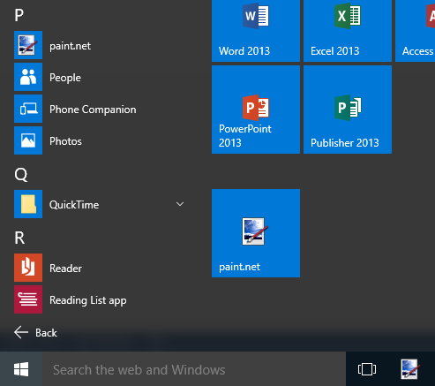
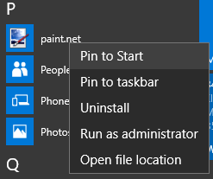

Customizing the Start Menu
Pin apps you use often
- Find an App you use frequently
- Right-click on the app’s icon
- Click Pin to Start and/or Pin to Taskbar
Start
Taskbar

Live tile apps display up-to-date information. By default, they are on but can be turned off by right-clicking on the tile and selecting Turn live tile off.




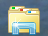
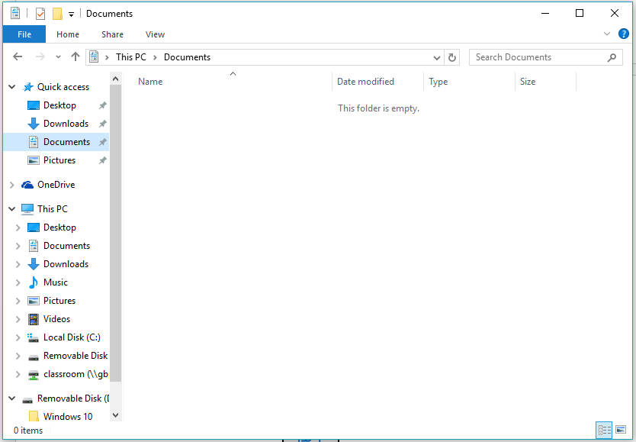

Using File Explorer
- Click the File Explorer icon on the Taskbar
  - Single-click a folder in the Navigation Pane to see its contents
  - Double-click a file or folder in the Content area to open it
- To return to a previous screen, click the Back button
Navigation Pane
Content Area

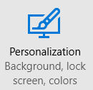

Windows 10 Settings
Personalizing your Desktop Background/Lock Screen
- Access Settings using the Start Menu
- Select Personalization
- Choose between a single Photo, Solid Color, or Slideshow
- To change the accent color, click Color on the left

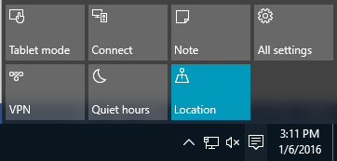
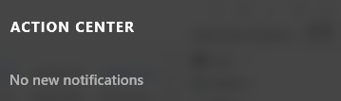
The Notifications/Action Center posts updates about ongoing tasks or issues encountered. Access it by clicking on the Notification button on the Taskbar. When a notification pops up, click on it to view details.
Within the Notification/Action Center, you can access other options and settings.


Microsoft Edge – A new browser option for Windows 10. Access it by clicking
Navigation Buttons
Reading View
Add to Favorites
Actions/Settings
The Hub

