
What Do I Read Next?

SOME “NOVEL” WAYS TO USE NOVELIST:
- Find another book like one you already enjoyed by searching for “read-alikes.”
- Browse genres and subgenres, like World War I historical fiction.
- Find books in a series by using the Series search option.
Note: You will need a valid Gail Borden Library card to use Novelist at home. Access by going to www.gailborden.info > Research > Databases > Novelist Plus

Search box and pull-down menu of search options

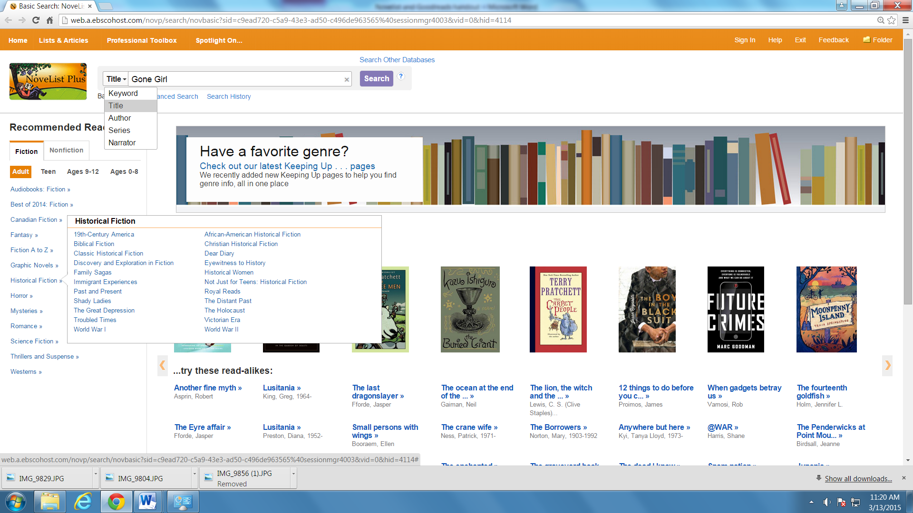
Browse genres—click on your favorite!
Hover over the covers of these bestsellers to learn about other books you may enjoy, or “read-alikes.”

LOOKING FOR YOUR NEXT GOOD READ?
- Use Goodreads to keep track of your personal reading by “shelving” your books onto shelves: Currently Reading, To Read, Read, and more.
- Follow what your friends are reading—make comments and recommendations!
Or, become friends with your favorite authors!
- www.goodreads.com – Create a free account if you want to save books to shelves, rate/review them, and follow friends.

The search box is found on every screen
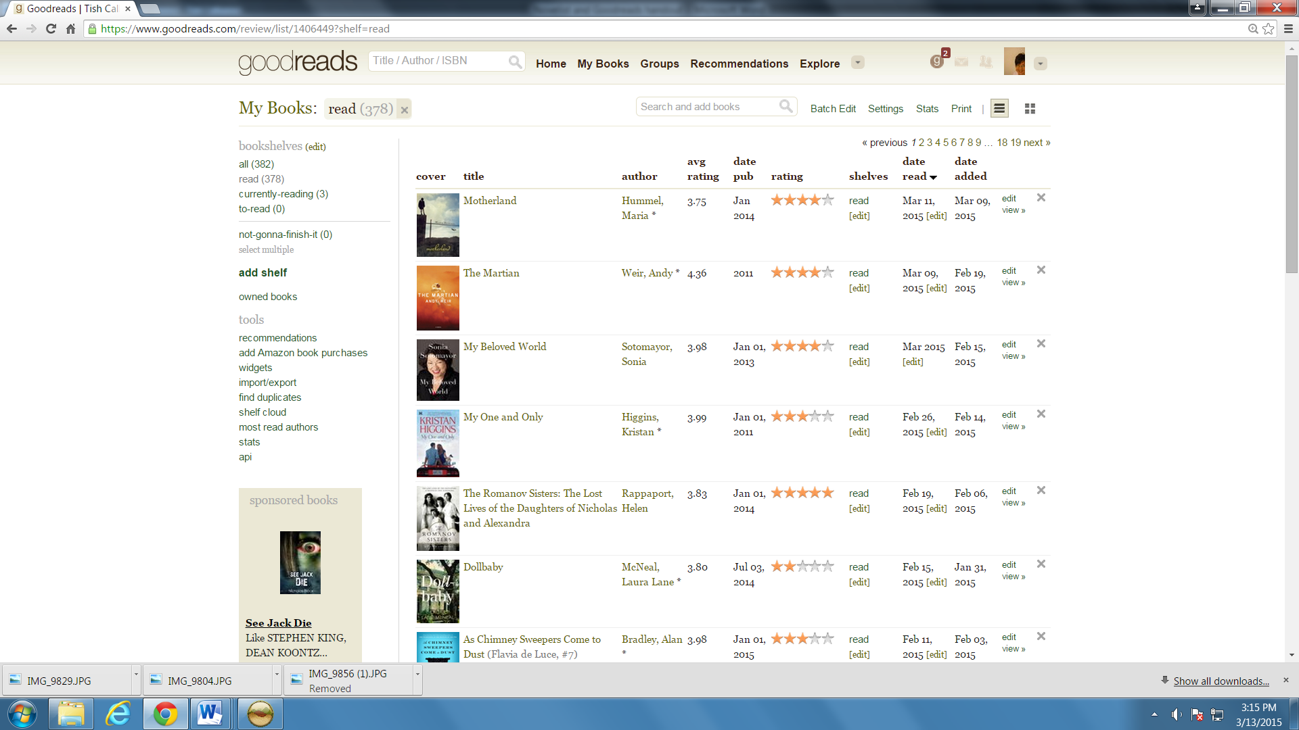
My Shelves
Star ratings
My Read Shelf (Can be sorted by date read, rating, etc.)

