
Weebly Basics

Access Weebly at www.weebly.com
Set Up
- Choose the focus of your site.
- Select a theme.
- Click on Preview.
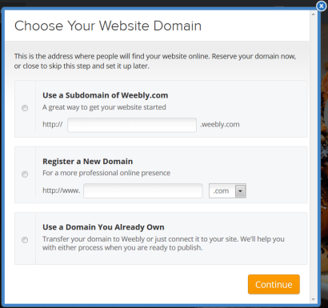
- Click on Start Editing. Note that themes can be changed at any time.
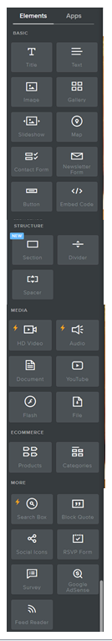
- The domain pop up box will appear. Your domain can be chosen any time before you publish.
- Click on the X in the upper right corner to choose later.
- Begin editing your site.
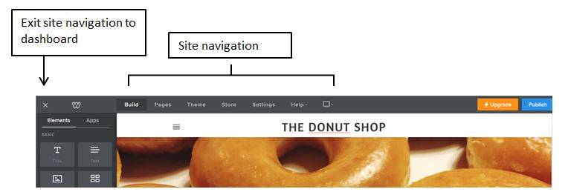
Editing your site - Elements

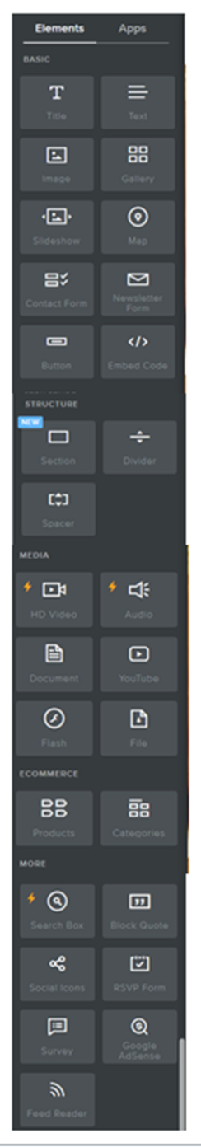
Add text
Add image
Weebly Elements can be used to add content and structure to your website.
- Elements can be quickly dragged and dropped into place.
- Elements stack on top of each other by default, but they can be placed side by side by dragging to the left/right until a blue line appears.
- Use the Spacer element to add space between content.
- Use the Divider element to create columns.
To add an Element to the page:
- Click on the Build tab.
- Drag and drop the Element into position on the page.
- After adding a Text element:
- Click inside the text box to begin inserting the text and begin typing.
- The text will be auto saved within the Element. There is no limit to text element size, it will auto fit to your type.
- After adding an Image Element:
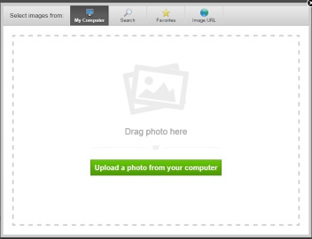
- Click the Upload Image box to add a picture.
- In the dialog box that appears, upload files from your computer, paste a link from a web-based image, or click the Search button to browse from Weebly’s free stock photos. There are higher quality photos available for a small fee.
- The chosen picture will drop into the page.
- To resize, click and drag on a corner of the image.
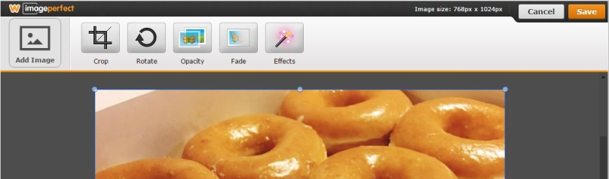
- To edit using additional picture controls, image perfect settings dialog box.
Resize
- Save changes

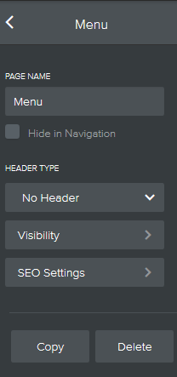
Pages
To add a Page:
- Click on the Pages tab.
- Click on the + sign.
To delete a page:
- Click on the page title bar to open the options
- Choose Delete
Reorder pages by clicking and dragging the page title bar.

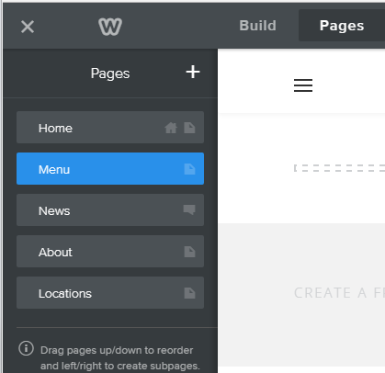
Page title bar

Dashboard
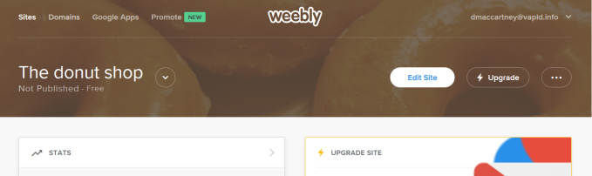
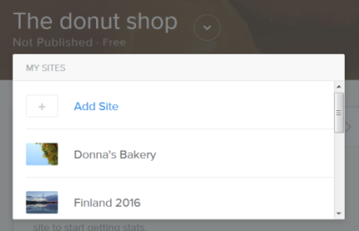
The Dashboard houses the behind the scenes activity for your websites. Here you can add, copy and delete websites, track visits to your sites, view comments and form entries, and third party apps.
View site activity and statistics

Delete or copy a site
Return to site editor
Add a new site or select a site to edit

