
Learner Activity Sheet: Video Conferencing Basics

ACTIVITY #1: Creating an Account
- Log on to the internet and go to https://zoom.us.
- Click on the orange button that says “Sign Up” on the upper right.
- Follow the prompts to verify your age.
- Enter your email address and click on the “Sign Up” button.
- Go to your email account, open the email sent from Zoom, and click on the confirmation link.
- Enter your name and create a password for your account.
  - My email address is: ___________________________________________
  - My password is: _______________________________________________
- Click on “Continue” to finish the registration process.
Note: Take this sheet home and store it in a safe place in case you forget your information.

ACTIVITY #2: Exploring Zoom Features
- Locate the Mute/Unmute icon. Click on the caret next to the button. Click on “Test Speaker and Microphone” and go through the steps.
- Locate the Video icon. Click on the caret next to the button. Click on “Video Settings.” Write down two features you can adjust in the Video Settings.
Feature 1 ____________________________________________________
Feature 2 ____________________________________________________
- Click on the Chat icon. Type a message in chat and send it. Bonus: add an emoji to your chat message.
- Click on the Reactions icon. Practice a) raising and lowering your hand and b) find and click your favorite animal emoji.
- Click on the Participants icon. Roll over your name and click on “More.” Select “Rename” and make a change to the way your name displays.

ACTIVITY #3: Scheduling a Meeting
Please follow along with the Instructor Demo as you complete this activity.
- Go to your account at https://zoom.us. Log in if you aren’t already logged in.
- Go to My Account.
- Click on Schedule a Meeting.
- Complete the meeting form to schedule a meeting:
- Topic: “Work Meeting” or “School Meeting” (or whatever else you would like).
- When: Next Friday at 11:00 am for 30 minutes.
- Scroll down and click on Save.
- Go to Meetings in the right-hand sidebar. Roll over the meeting you just scheduled, and click on Start to start the meeting.
- Once you’ve opened the meeting, click on the caret next to the Participants icon, then click on Invite.
- In the pop-up, click on “Copy Invitation.”
- Log in to your email, create a new message, and paste the invitation into the body of the email.
- Send the invitation to the instructor at the email address they give you.

ACTIVITY #4: Practice
Complete the Practice lesson for Basics of Video Conferencing. You can either open a web browser and complete the activity on your own or follow along with the instructor.
To complete the activity on your own:
- In the address bar of the web browser, enter digitallearn.org.
- Click on Basics of Video Conferencing.
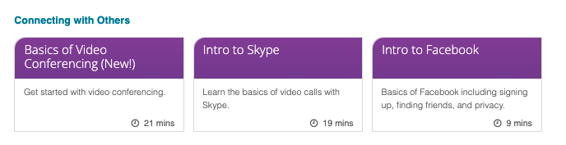
- Click on the Practice lesson.


