
Video Conferencing Basics Learner Handout

Joining a Meeting
For many of us, the first time we use a video conferencing tool is when someone else invites us to a meeting. We typically receive an invitation through email.

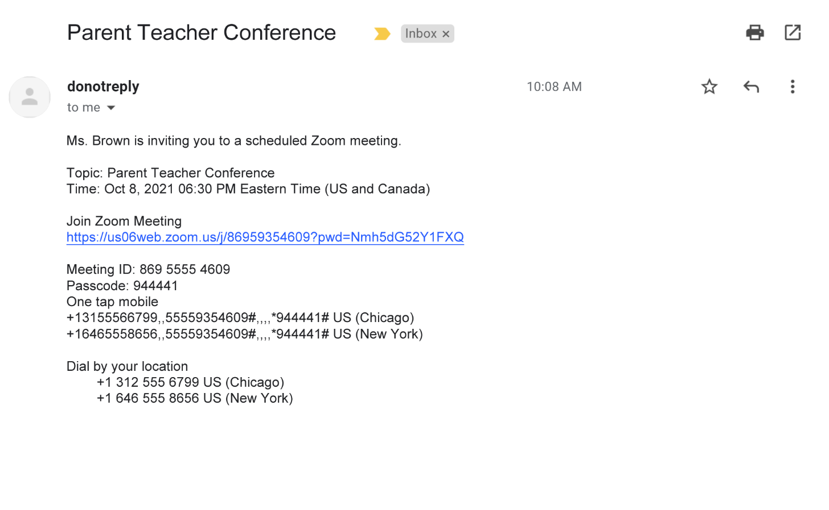
Phone numbers
Meeting ID and Passcode
Link to join
Date and Time
Topic
Who is inviting you

Common Participant Features
Common features you’ll use when you join a Zoom meeting include:
- Muting and unmuting your microphone.
- Turning your video camera on and off.
- Chatting with others in the meeting.
- Sharing your screen.
- Using reactions and raising your hand.
- Changing the view from gallery to speaker view.
- Viewing a list of other participants.
- Leaving the meeting.

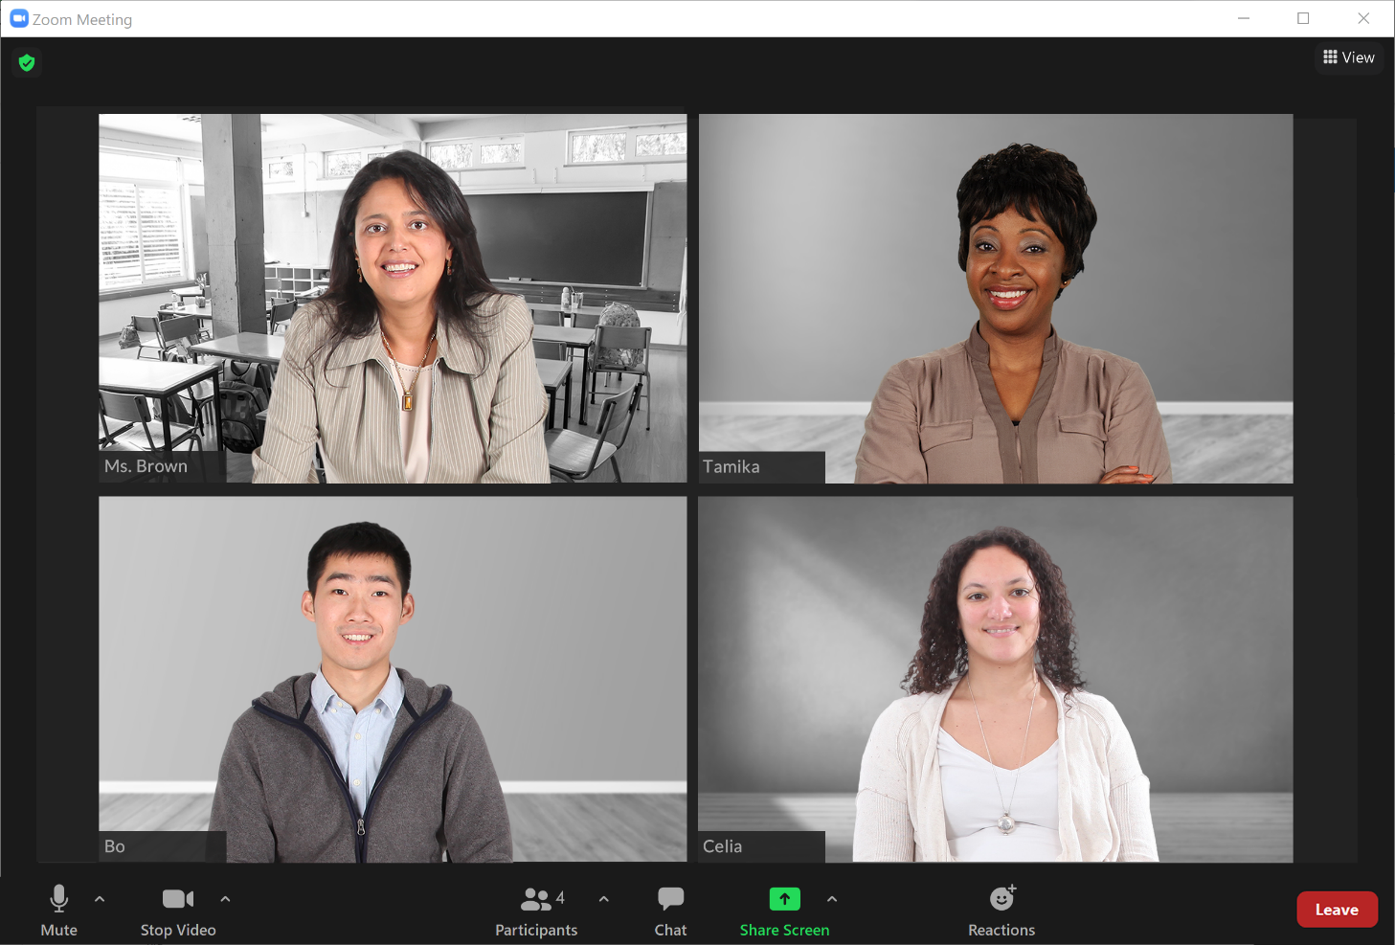
1. Mute and Unmute
2. Video Start and Stop
6. Change View
4. Share Screen
3. Chat

5. Reactions
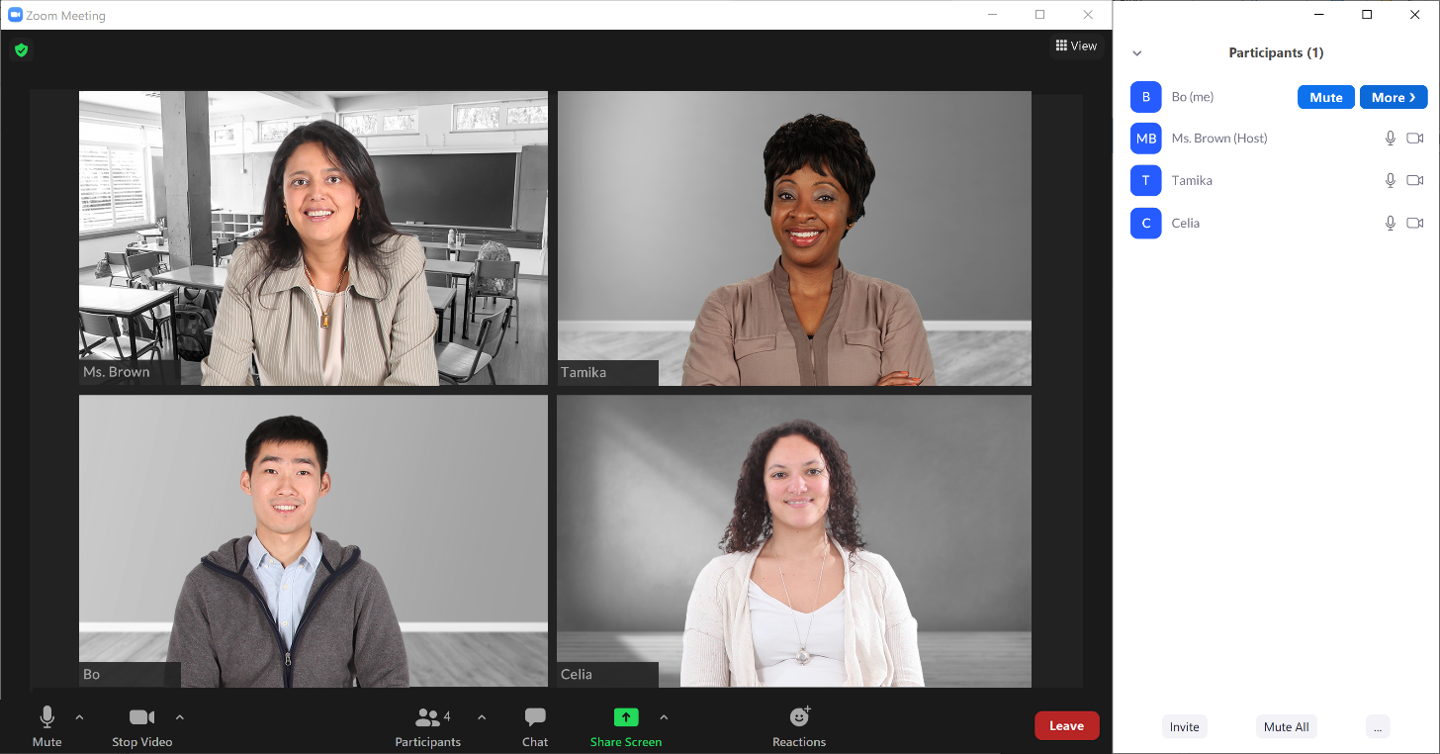
8. Leave Meeting
7. View Participants

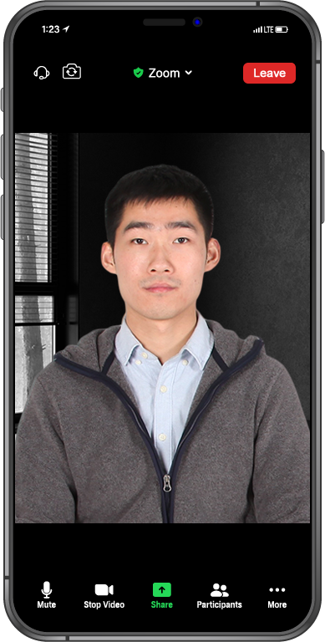
8. Leave Meeting
More features
7. View Participants
4. Share Screen
2. Video Start and Stop
1. Mute and Unmute
Tips for Hosting
Security
- Lock a meeting after it starts to keep anyone unwanted from entering the meeting.
- Enable the waiting room so you can let in only the people you want to attend the meeting.
- Consider what features you want participants to be able to do, such as unmute themselves, share their screen, or chat. You can adjust these features before the meeting begins, or you can do this during the meeting.
- If someone unwanted enters your meeting, you can use the Remove Participant feature to remove them. That person cannot rejoin the meeting until you allow it.
Participants Panel
- As the host, you also have more features available in the Participants panel. Here are a few more tips:
  - If someone will be making a presentation or speaking for a long time, you can mute everyone in a meeting using the Mute All button. This is helpful to keep background noise to a minimum.
  - If background sound is coming from a participant and they aren’t able to mute themselves, you can mute that person by clicking the Mute button next to their name.
Recording
If you want to keep a recording of the meeting, you can use the Record feature. This will save a recording of the video to your computer or online Zoom account.
- Always let people know when you plan to record a meeting. Zoom may also provide a pop-up message or audio alert to participants that the meeting is being recorded.
Ending
- As the host, it’s important for you to end the meeting when it’s over. To end the meeting, click End, and then select End Meeting for All. You will immediately end the meeting for all participants.

Learn More

Visit https://www.digitallearn.org/ for more courses and to help build skills and confidence using technology.

