

Selling on eBay
Selling Fees
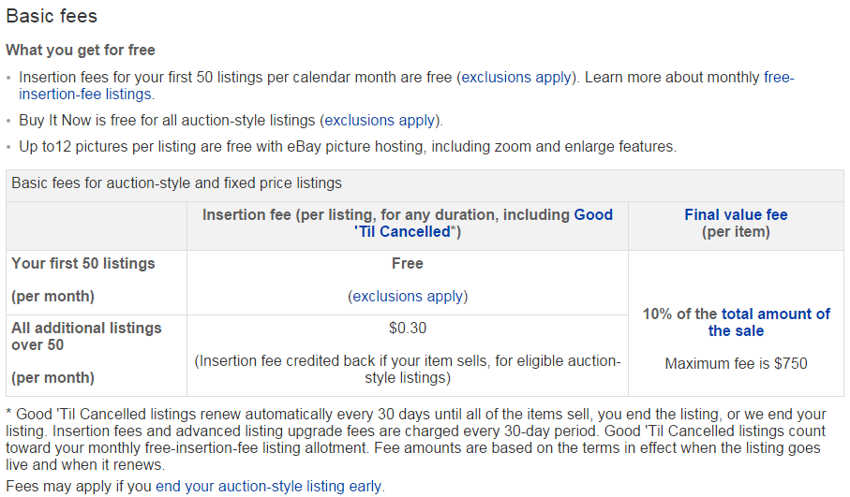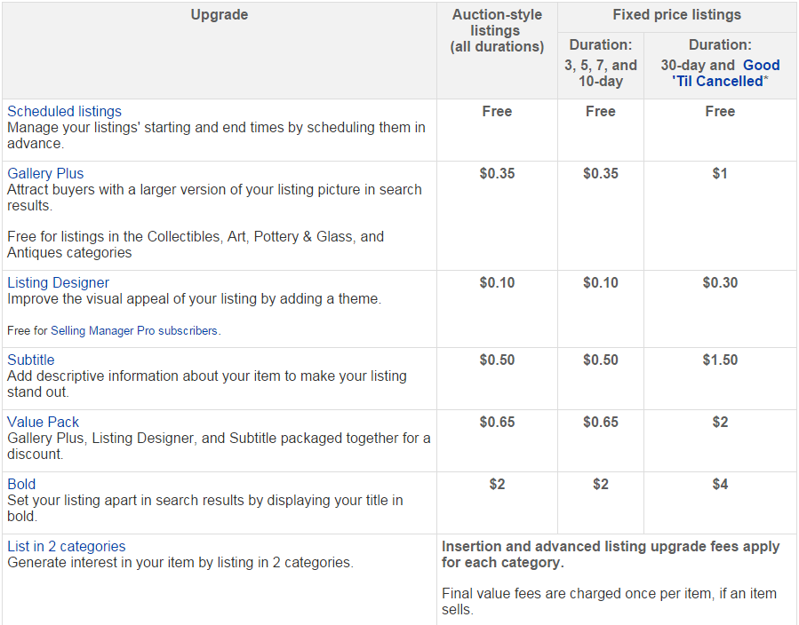
Create a Great Listing
- Before you list your item it can be helpful to see what other sellers are pricing their items at. This can help you price yours competitively.
- Be sure to put the exact name of the item in the title so it is easier for buyers to find when searching. This should include at least the brand and product name.
- If you are selling a used item, make sure to describe it with as much detail as possible. That way, buyers will know exactly what they are getting, you stand to make more money, and buyers are less likely to become angry and/or return the item.
- Upload the pictures of your item from every angle with the best camera you have. Make sure to highlight damage, or wear on an item to prevent returns.
- If you are not offering free shipping, be sure to use your preferred shipper’s website to estimate the shipping costs. Remember to account for packing material and travel costs in the amount you charge for shipping.
- After your listing is created stay attentive, quickly answer questions about your item and update your ad with new information if necessary.

Shipping Your Product
- After you have sold your item and received payment, ship it out as soon as possible, being careful to stay within the time frame specified in your listing. This will help you avoid getting a poor rating from the buyer.
- If there will be any delay in the shipment, notify the buyer. Most users are understanding and will not leave you negative feedback as long as you explain the situation to them.
- When shipping your item, size and padding are key. The larger the box, the larger the shipping costs, so try to use a box that is only an inch or two larger than the item. An inch of packaging material on all sides is usually more than enough to protect the item unless it is fragile.
- When you ship your item always get a tracking number to prove that the customer received the item. After shipping enter the tracking information into eBay and mark the item as “Shipped” so the customer can track their package

Helpful Web Links
- Prohibited eBay items: http://pages.ebay.com/help/policies/items-ov.html
- Ebay customer service: http://ocsnext.ebay.com/ocs/home
- eBay fee calculator: http://www.fees.ebay.com/feeweb/feecalculator

