
QuickBooks: Working with Items
Understanding Items in QuickBooks

- Service – Relates to services you provide or sometimes purchase. Service items are non-taxable.
- Inventory Part – Tracks products you make/buy/sell. Inventory increases with a received purchase order or bill and decreases on a customer invoice. This displays only when Inventory and Purchase Orders are active on the Company tab of the Items and Inventory preferences.
- Inventory Assembly - Assembles multiple inventory components, as in a Bill of Materials. When an inventory assembly is built, the individual items (components of the assembly) are deducted from inventory and the quantity of the finished product is increased. The assembly functionality is only available in QuickBooks Premier or Enterprise.
- Non-inventory Part – Used for products you purchase but do not track as inventory. This includes purchased products that are ordered for a specific customer and directly shipped to the customer, or for materials and supplies you purchase but do not sell to the customer.
- Other Charge – A multipurpose item type including freight, handling, and other miscellaneous charges. Using Other Charge makes it possible to see your services separate from the regular charge types such as revenue and expense.
- Subtotal – Adds the subtotal line items on sales and purchase forms. This item is useful if you want to calculate a specific discount on a group of items on an invoice form.
- Group – Quickly assigns a grouping to individual items on sales and purchase forms. Unlike assemblies, groups are not tracked as a separate finished unit. Groups can save you data entry time and enable you to print or not print the details on a customer’s invoice.
- Discount – This type facilitates dollar or percent deductions off what your customers owe on a sales form. This item type cannot be used on purchase forms.
- Payment – You create this item type if you record a payment directly on an invoice as a line item, such as with a Daily Sales Summary form. On typical customer invoices, you should not record payments in this manner because there is no tracking of the customer’s check or credit card number.
- Sales Tax Item – This type is available only if you enabled sales tax by selecting Yes to charging sales tax on the Company tab of the Sales Tax preferences. In most cases, QuickBooks automatically assigns this item to an invoice. In some states or industries where there are multiple sales tax rates for a given sale, you can also add this item to an invoice as a separate line item.
- Sales Tax Group – This type is used to group multiple tax district flat-rate sales tax items that are combined and charged as one sales tax rate.

Adding a New Item
Accessing the Item List
- Click New Item
- Select one of the previously mentioned Item Types
- Enter the appropriate information in the Name/Number and Description (optional) fields
- In the Rate box, enter the amount you are going to charge for this item
- Enter information in the Tax Code box, if necessary
- Select the Account that this item will be associated with
- Click Ok

- In the Company section, click the Items/Services Icon
- Click the Item tab
- Use the drop-down menu to select the appropriate option

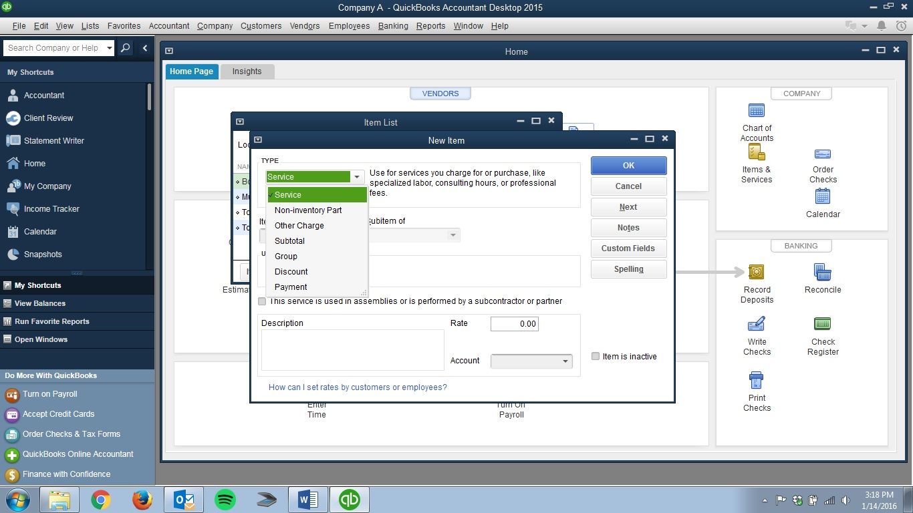
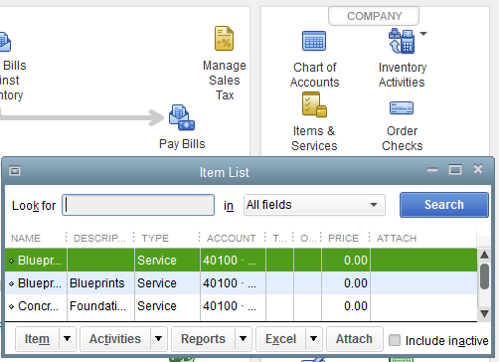

Organizing Your Items – Create a matrix, like the sample one below, to organize your Item List

 | Black | Brown | White
Small | BLSM | BRSM | WHSM
Medium | BLMD | BRMD | WHMD
Large | BLLG | BRLG | WHLG
X-Large | BLXL | BRXL | WHXL

