
Getting Started with QuickBooks
QuickBooks Set Up Checklist

Company data

___ Company legal name and address
___ Federal EIN or social security number
___ State employer ID number
___ Fiscal year end
___ QuickBooks start date
___ Type of business
___ Name of the income tax form the client files
___ Accounting basis (cash or accrual)

Chart of accounts

___ Names, numbers, and descriptions for the chart of accounts
___ Financial statements as of the end of the prior tax year
___ Trial balances as of the QuickBooks start date
___ Numbers and balances (from the start date through today) for the following types of accounts: bank, credit card, loan, and lines of credit

___ Value of assets (original cost and accumulated depreciation for fixed assets)
___ Equity information including all owner’s contributions & retained earnings for each year the company has been operating

. ___ Budget for the fiscal year, if any

Customer: Job list

___ Information to complete the Customer list: names, addresses, contact information, taxable status, etc.
___ Customer payment terms
___ Customer shipping methods
___ Customer types
___ Open balances/outstanding invoices as of the start date

Vendor list

___ Information to complete the Vendor list
___ List of 1099 vendors and their tax ID numbers
___ Vendor payment terms
___ Shipping methods
___ Vendor types
___ List of outstanding bills as of QuickBooks start date

Item list

___ List of all inventory, non -inventory, service and other items to complete the Item list
___ Price list for all items
___ Inventory and inventory assembly numbering scheme
___ Quantities on hand and values for inventory and inventory assemblies as of the start date
___ Desired reorder points for all inventory items __Taxable status for each item
___ List of states in which the company pays sales tax
___ Sales tax rates, sales tax agencies, and the sales tax liability as of the start date
___ Frequency of sales tax reporting (monthly, quarterly, annually)
___ Sales tax calculation basis (cash or accrual)
___ Types of sales (wholesale, retail, out of state)

Fixed Asset Item list

___ List of all fixed assets
___ Purchase information (purchase cost, date, vendor, etc.)
___ Asset account
___ Depreciation information Employee list
___ Information to complete the Employee list

Payroll information

___ Determine 941 deposits (monthly or each pay period), state withholding, local withholding and unemployment tax (FUTA, SUTA)

___ YTD information for each employee as of the start date
___ Accrued benefits including sick and vacation time for each employee as of the start date
___ Earnings, additions, and deductions for payroll processing (SEP, union benefits, 401(k), reported tips, etc.)

___ Employer federal, state and local tax identification numbers
___ YTD payroll liability payment
Preferences in QuickBooks – QuickBooks groups preferences into specific categories listed on the left-hand side of the pop up window. Click on a desired category to edit those preferences.
To Access Preferences
- Click the Edit button on the top toolbar
- Arrow down and select Preferences

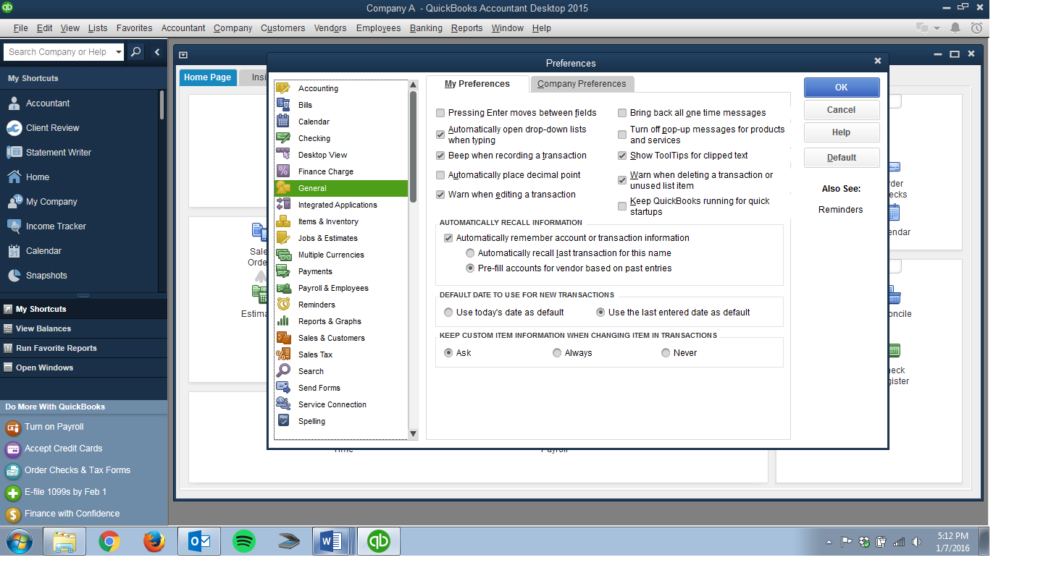
Edit
Categories

Within Preferences, two main tabs are available for each category. The My Preferences tab allows for settings specific to the individual user, while the Company Preferences tab hosts settings tied to the company data file.



