
QuickBooks Basics

THE HOME SCREEN
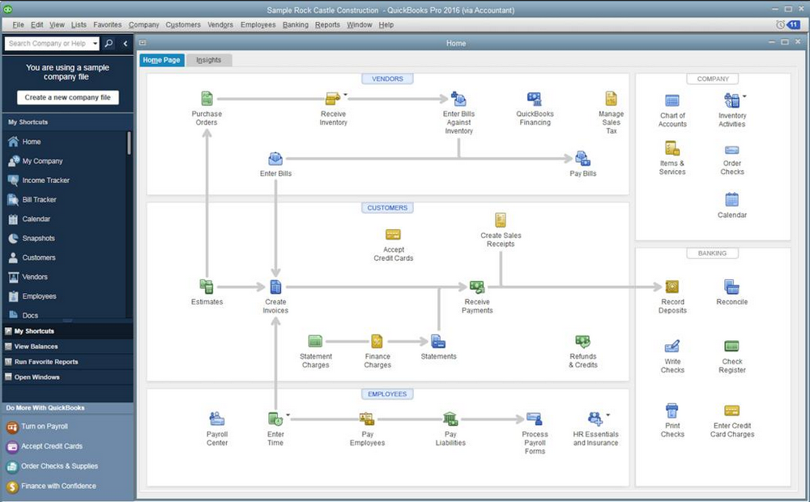
Main Menu Bar
Navigation Bar
Notifications
Vendors
Employees
Banking
Company
Customers
Features | Enterprise Version | Premier Version | Pro Version
# of Simultaneous Users | Up to 30 | Up to 5 | Up to 3
Data File Size | 1GB or more | 150-200MB | 150-200MB
Create & Email Quotes
Create & Email Sales Orders |  |  | No
Create & Email Purchase Orders
Optimized for Larger Data Files & Network Usage |  | No | No
Print Checks, Pay Bills & Manage Expenses
Track Sales & Customer Payments
Track Credit Cards
Track Sales Taxes
Manage Payroll, Payroll Taxes & Direct Deposits
Set Reminders & Create To Do Lists
One-Click Business Reports | 150+ Industry-specific | 150+ Industry-specific | 100+
Import Data From Previous Versions
Import Data from Excel
Download Bank & Credit Card Transactions
Multiple Currency Capabilities
Create a Business Plan |  |  | No
Create a Budget
Forecast Sales and Expenses |  |  | No
Customize Your Invoices & Forms
Create Industry-specific Reports |  |  | No
Track Inventory, Set Reorder Points
Create Inventory Assemblies & Bills of Material |  |  | No
Track Inventory in Multiple Warehouses, serial/lot # Tracking, Bin Location Tracking, Bar Coding Capabilities, and FIFO Costing  *Chart information provided by Scott Gregory at www.betterbottomline.com |  | No | No
Comparison of QuickBooks Software Versions (2015 & Up)

