
QuickBooks: All About Vendors

Accounts Payable 10 Best Practices*

1. Always pay from original invoices. If you have to pay from a copy, check your records for the same invoice number and dollar amount.
2. Before paying any vendor, have a W-9 on file for them. This will save a lot of hassle at year-end when you need to prepare 1099s. Fines for not complying with 1099 reporting requirements can be hefty.
3. Ensure you have a policy about how invoice numbers are to be entered. Having a policy helps if there isn’t an invoice number.
4. The person entering the invoice should be different from the person who approves the invoice and the person who signs the check.
5. Have all invoices come to the accounting department so they can be logged before being sent out for approval(s).
*Provided by Laresa McIntyre
https://www.proformative.com/blogs/laresa-mcintyre/2013/08/24/10-best-practices-accounts-payable
6. Do not enter invoices as a batch. Each one should be entered individually in order to have an audit trail.
7. All invoices should have the account coding written on them as well as any notes about special handling.
8. The amount of the invoice should be entered as billed even if you don’t plan on paying the full amount. A credit memo can be entered and matched against the invoice later.
9. Have a new vendor welcome letter that you can send informing them of where invoices should be sent, what information you require to process their invoices (like a vendor ID number) and any forms you need completed. Vendors will appreciate the information to ensure their payments aren’t held up.
10. Watch your payables carefully to take advantage of any discounts being offered by vendors. It can add up to a nice sum by the end of the year.

The Vendor Area
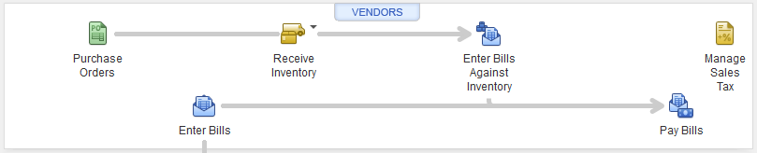

Vendor Name field
Enter a unique name or code for identification
Company Name field
Enter the name you want to appear on invoices & other forms. This will also appear in the Invoice/Bill To box.
Account Settings tab
Accounts selected here will auto-fill the proper fields when you enter vendor bills.
Additional Info tab
Classify vendors so you can send custom communications or determine which types are more profitable.
Adding New Vendors
1) Click on the Vendors button to open the Vendor Center
2) Click New Vendor in the toolbar, then select New Vendor
3) Enter information in the fields for each tab
4) Click Ok

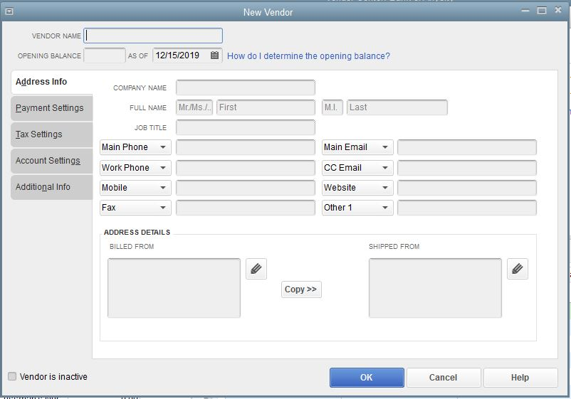

Entering Bills
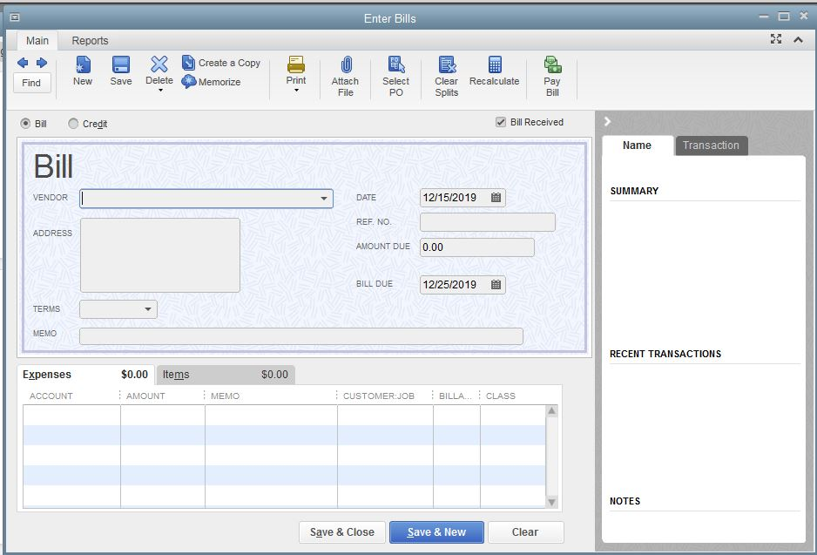
- Click on Enter Bills in the Vendor area
- Enter information in the appropriate fields
- Click Save & Close
Note: Afte entering a Bill, it can be paid immediately by clicking on Write Checks in the Banking area or you can view and pay it later by clicking on Pay Bills and selecting Show All Bills.

