
QuickBooks: All About Customers
The Customer Area (Home Screen)
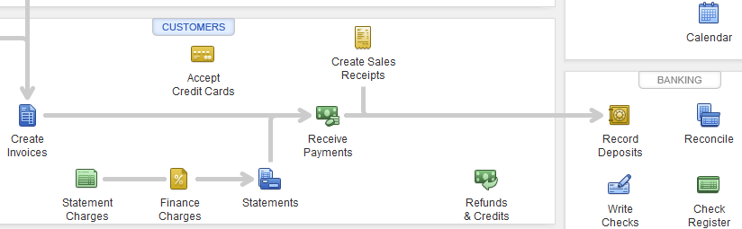

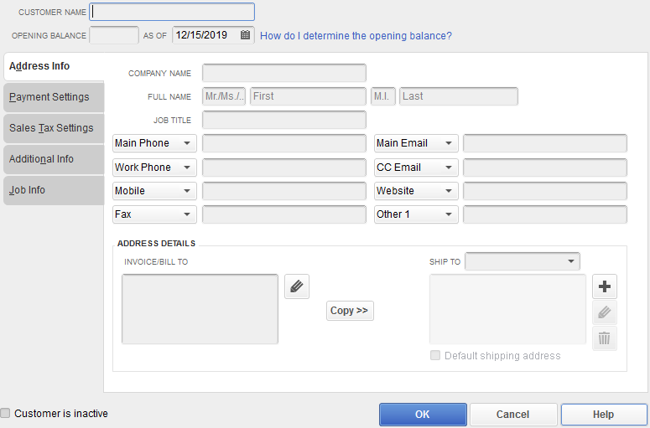
Customer Name field
Enter a unique name or code for identification
Company Name field
Enter the name you want to appear on invoices & other forms. This will also appear in the Invoice/Bill To box.
Sales Tax Settings tab
If sales tax isn’t turned on, the fields will be grayed out.
If the customer pays sales tax, select Tax in the Tax Code drop-down. In Tax Item drop-down, select the tax rate the customer pays.
Adding New Customers
- Click on the Customers button to open the Customer Center
- Click New Customer & Job (toolbar), then select New Customer
- Enter information in the fields for each tab
- Click Ok

Creating an Invoice – Invoices record sales and show an amount due. The required fields if using the Intuit Service Invoice template are below. Remember to Save & Close.
- Customer:Job – Use the drop-down to select the Customer/Job
- Date & Invoice # - These are auto-filled. You may change them if necessary
- Item & Quantity – Use the drop-down to select the Item, then enter a number for quantity

Invoice Templates in QuickBooks – Many companies use QuickBooks’ built-in Invoice templates, but you can create custom templates as well. Available templates depend on the software edition.

.

Intuit Service Invoice
This template doesn’t bother with shipping fields because services are performed, not shipped. It includes fields for the item, quantity, description, rate, amount, tax, and purchase order number.
Intuit Product Invoice
This template is useful if you sell products with or without services. It shows information like the quantity, item code, price for each item, total charge for each item, sales tax, and shipping info—including the ship date, shipping method, and FOB.

Progress Invoice
If you bill customers based on the progress you’ve made on their jobs, use this template, which has columns for your estimates, prior charges, and new totals. This option only appears if you turn on the preference for progress invoicing.

Intuit Professional Invoice
The difference between this template and the Intuit Service Invoice is that this one doesn’t include a P.O. Number field, and the quantity (Qty) column follows the Description column.

Time & Expense Invoice
If you bill customers by the hour, this template is the one to use. It includes columns for hours and an hourly rate, and it calculates the resulting total.

Fixed Fee Invoice
This template drops the quantity and rate fields, since the invoice shows only the total charge. It includes fields for the date, item, description, tax, and purchase order number.

Time & Expense Invoice
If you bill customers by the hour, this template is the one to use. It includes columns for hours and an hourly rate, and it calculates the resulting total.

Receiving Payments
- In Received From, select the customer
- Verify the Date
- In Payment Amount, enter the amount received
- Select the Payment Method and enter any necessary details
- If there are multiple transactions, verify that the amount is being applied to the correct one – a check mark will appear
- Click Save & Close
Making a Deposit – Once funds are received from a customer, they need to be deposited into the QuickBooks bank account
- In the Banking area on the Home Screen, click on Record Deposits. The Deposit window will appear with checks that have been received.
- Click Ok to launch the Make Deposit window
  - Verify the Bank Account and the Date
  - The Memo field defaults to Deposit
- Click on Save and Close

