
Pinterest Basics
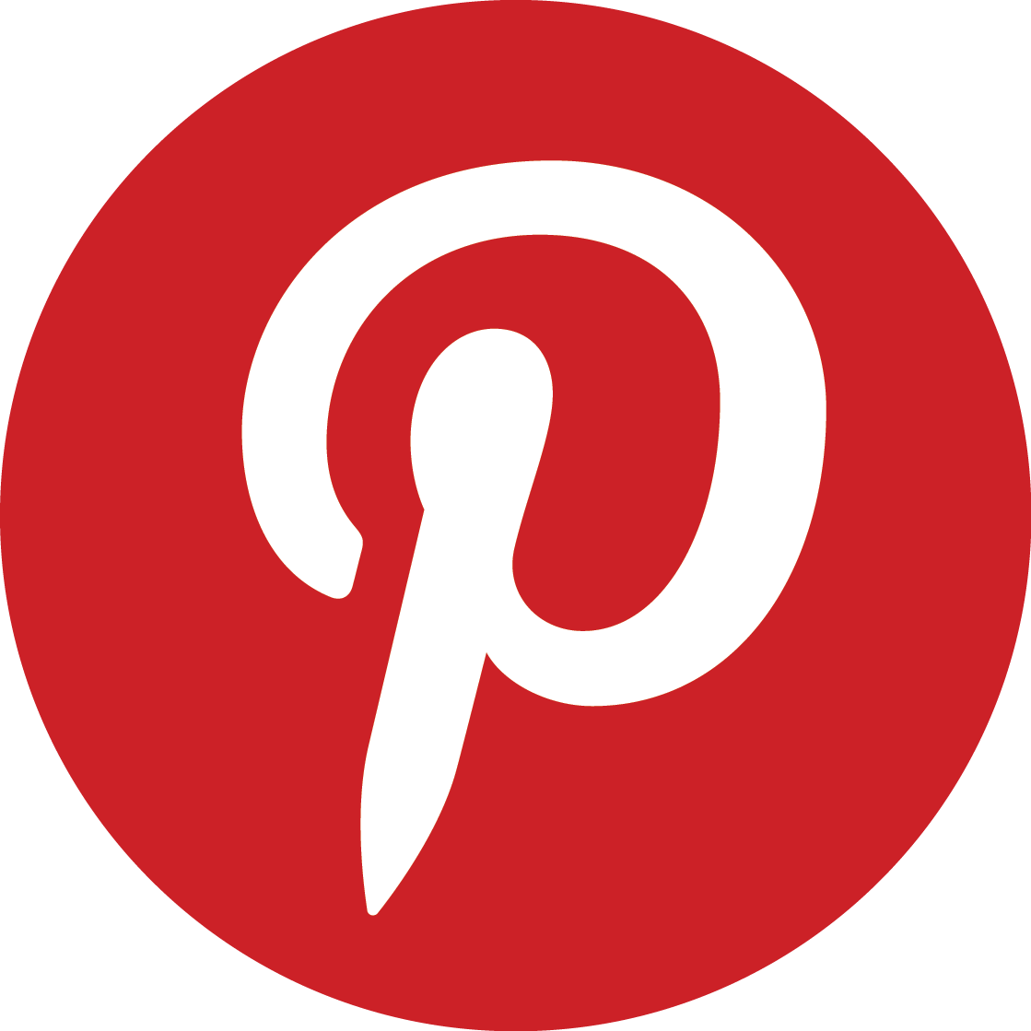
Terminology

Board | A virtual cork board where you can collect and organize pins.
Categories | The selected topics Pinterest divides their pins into to represent major themes
Feed | The main feature of your Homepage which continuously updates with pins
Following | Keeping track of users, boards or interests to influence the pins on your feed
Like | The action used to give quick positive feedback on a pin and adding it to your collection but not saving it to a board
Message | The feature used to have a private conversation with someone.
Notifications | The area on the right side of your home page the provides activity updates
Pin | Links to other websites represented by an image and description
Profile | The page containing everything related to your account, such as boards, pins, followers, those you follow, and any personal information you share
Save | The act of adding a pin to one of your boards from another user.
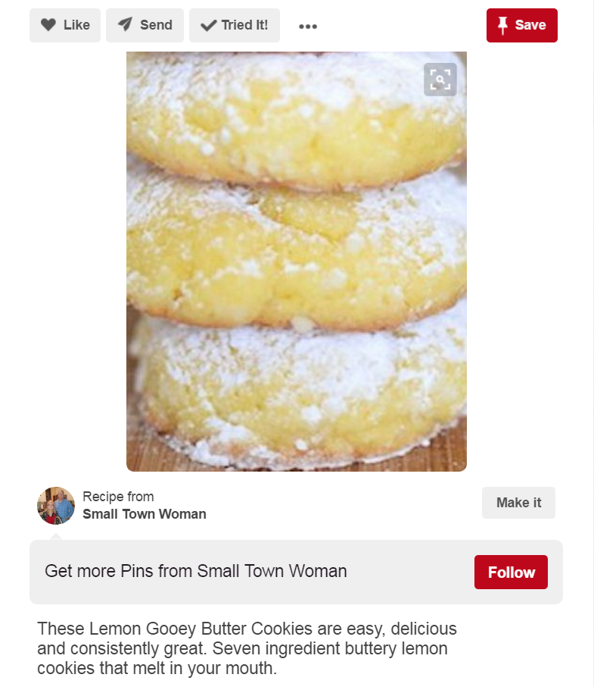
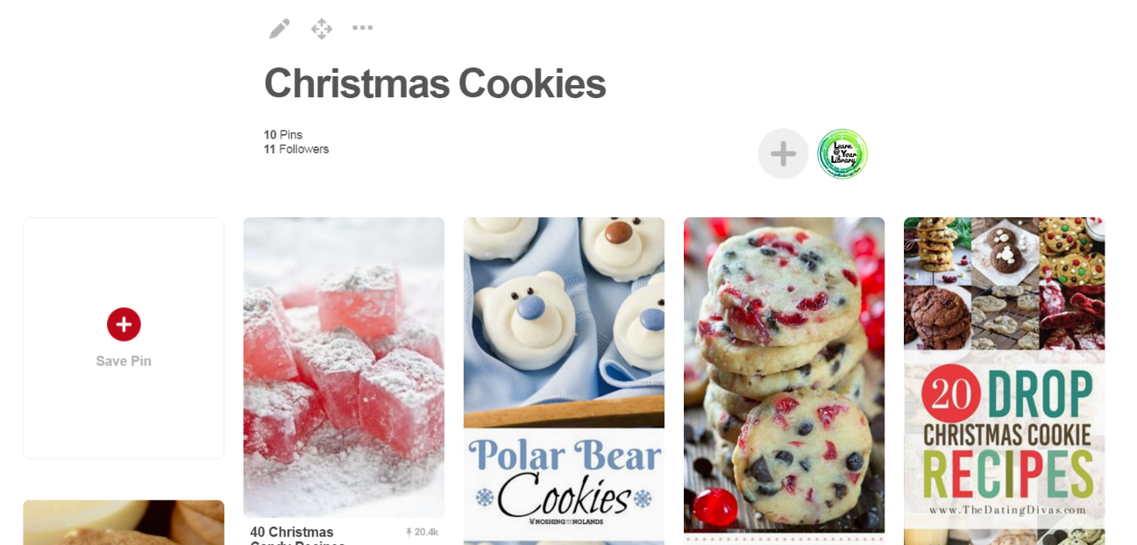
Pin Options:
-Like it
-Send/Share it
-Mark if you’ve tried it
-Save it to a board
-Access the link
Edit a board’s title, description, privacy setting (public vs. secret), collaborators, or delete it
Pins & Boards

The Homepage (Feed)

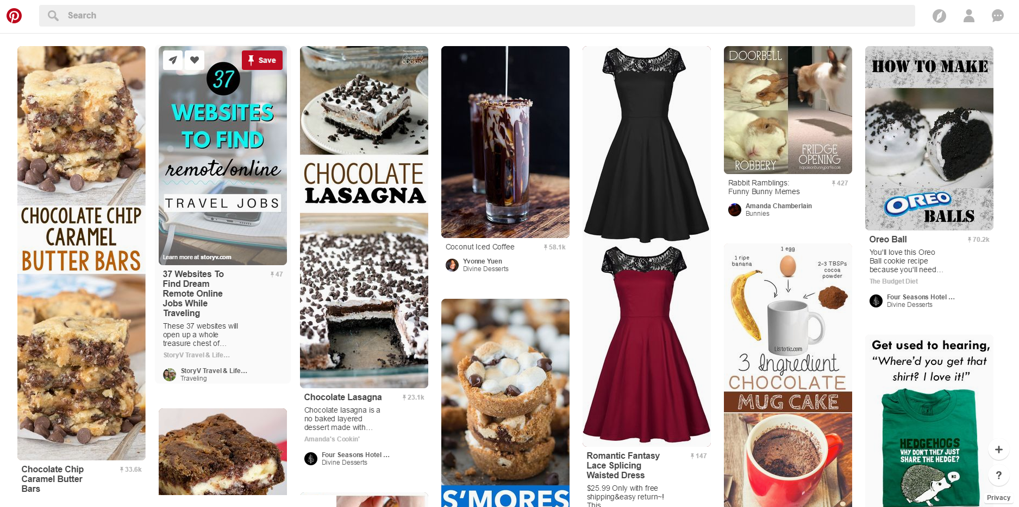
-Categories
-Profile,
-Notifications/Messages
Search box
Home

The homepage is constantly updating with pins related to…
- Pins from fellow pinners and boards you’ve followed
- Interests you follow
- Suggested pins from advertised boards/pinners
Add a new pin & Help

Your Profile

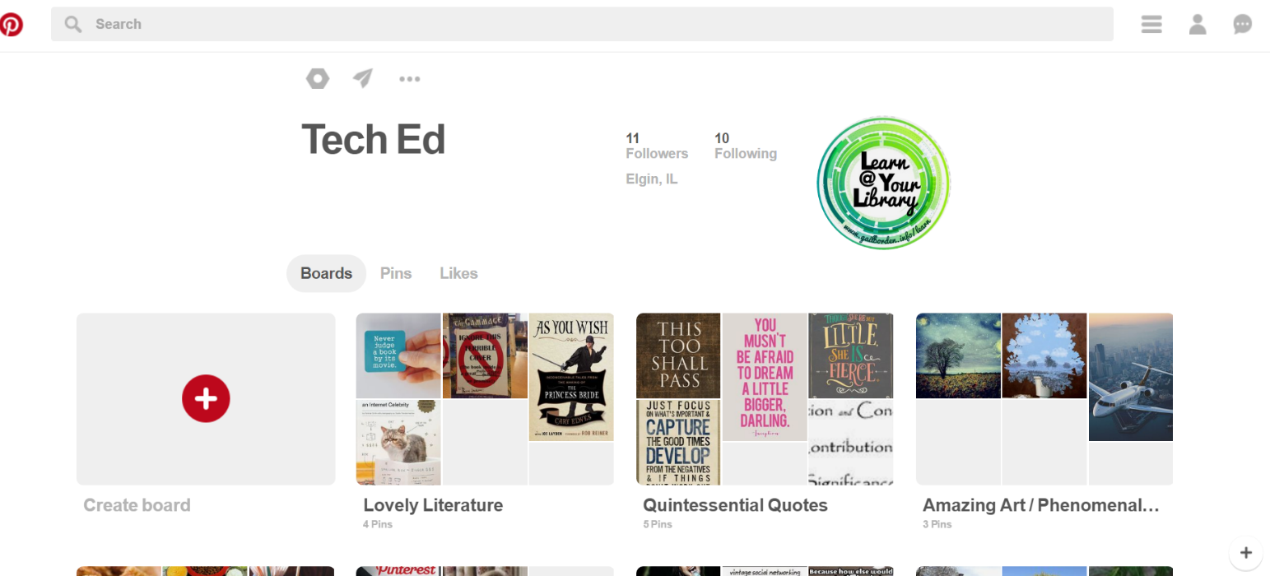
-Settings
-Messaging
-Log-out
Your Boards
Toggle between sections

