
Keyboard & Mouse Basics

Mouse A hand-operated device that allows users to move a cursor around a computer screen

Scroll
Right-Click

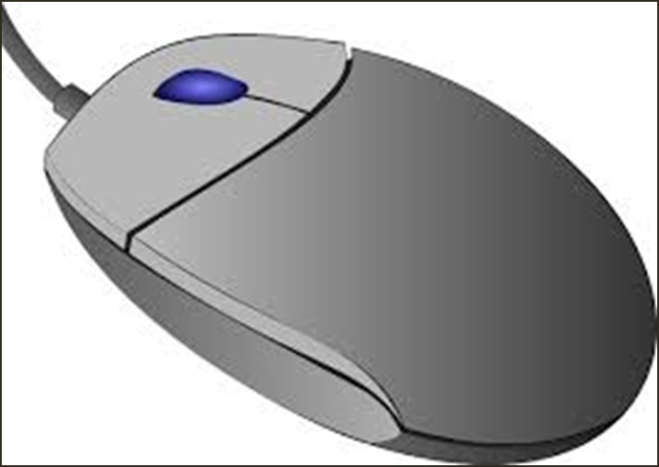
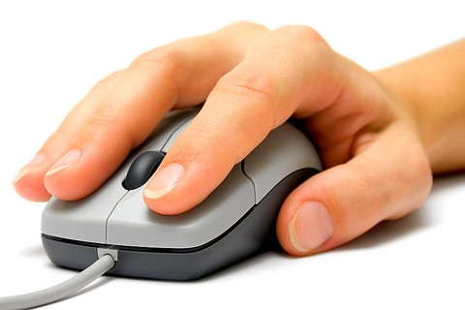

Left-Click

Keyboard A piece of equipment similar to a typewriter that allows users to enter data into a computer
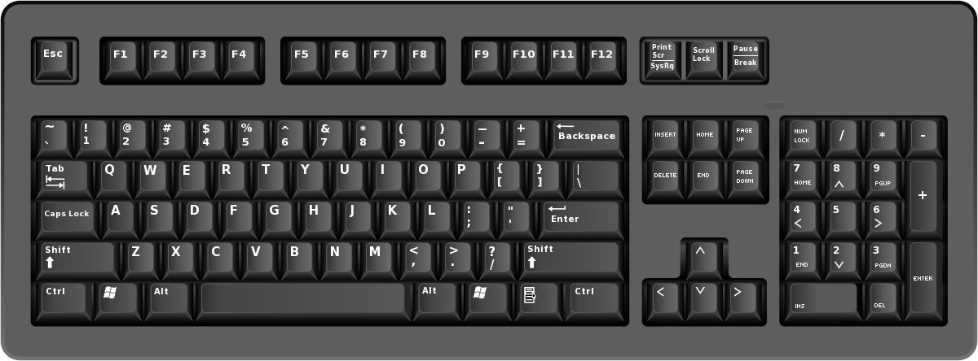
Function Keys
Numeric Keypad
Typing Keys
Navigation & Special Keys

ADDITIONAL KEYBOARD & MOUSE PRACTICE
- Left-click the appropriate icon to open the Internet (Google Chrome, Mozilla Firefox or Internet Explorer).
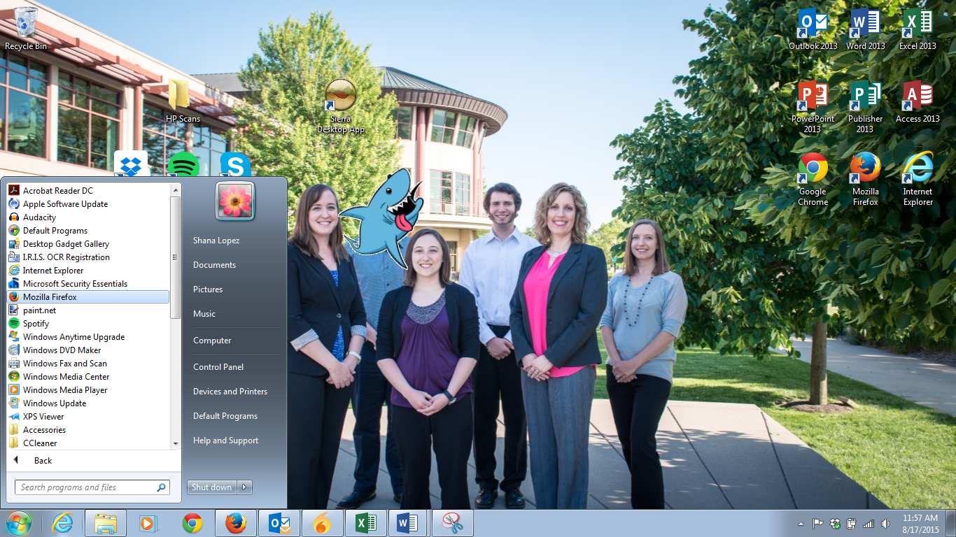
Single left-click on items in the Start Menu or from the task bar to open them.

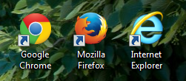
Double left-click on desktop icons to open programs

- Type http://www.gcflearnfree.org/topics into the search box at the top of your screen and press Enter

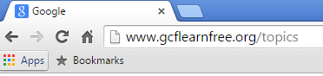
- Left-click on Mouse Tutorial and follow the prompts for more mouse practice or left-click on Typing Tutorial for additional keyboard practice



