
Activity Sheet: Mouse & Keyboard Basics

Activity #1
- Put your hand on the mouse.
- Move the mouse until the white arrow is over the Microsoft Word icon.
- Use your right pointer finger to quickly press the left mouse button two times (double-click)
- After the document opens, use the mouse to click the “x” in the upper right-hand corner.
- Use your right pointer finger to click once on the No button that appears to ask if you want to save your changes.
Activity #2
Use your mouse to open a new Microsoft Word document. Type the following text on four separate lines:
- gailbordenlibrary (lowercase)
- GAILBORDENLIBRARY (uppercase)
- GailBordenLibrary (upper & lowercase)
- G@ailBord+nLibrar; (upper/lowercase & symbols)
Activity #3
Type the following, this time with one character space in between each word:
- gail borden library (lowercase)
- GAIL BORDEN LIBRARY (uppercase)
- Gail Borden Library (upper & lowercase)
- G@ail Bord+n Librar; (upper/lowercase & symbols)
Activity #4
Use the Backspace, Delete or Arrow Keys to make the following changes to your text:
- Capitalize the “g” in “gail” in line one
- Delete the letters “AIL” in “GAIL” in line two
- Delete the word “Library” in line three
- Replace the symbols in “G@ail Bord+n Librar;” with the correct letters
Activity #5
Use the Tab or CapsLock keys to make the following changes to your text:
- Insert 10 spaces between “Gail” and “Borden” in line four
- Type the words, “I LOVE” in front of “Gail Borden” in line three

MOUSE ACTIVITY
- Scroll down the page and left-click on launch activity.
- Log on to the Internet

- Type http://www.gcflearnfree.org/topics into the search box at the top of your screen and press Enter

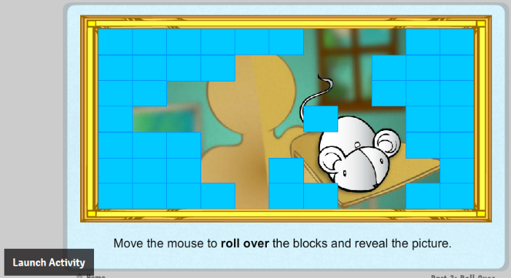
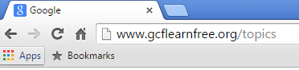

- Left-click on Mouse Tutorial under the Computers section
- Scroll down the page and left-click on Part 1: Holding the Mouse to begin the activity
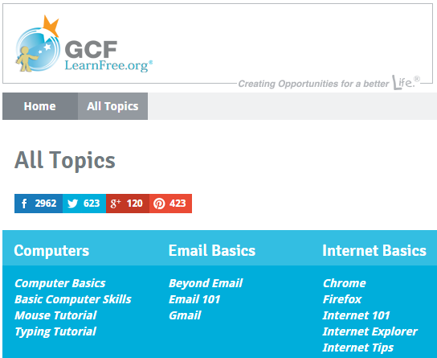

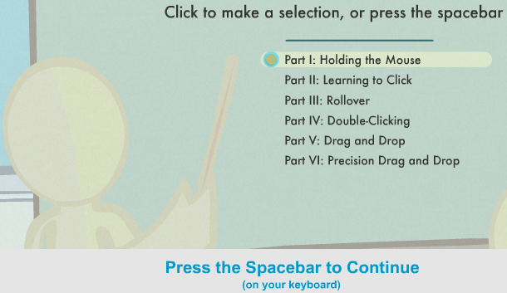

KEYBOARD ACTIVITY
- Log on to the Internet
- Type http://www.gcflearnfree.org/topics into the search box at the top of your screen and press Enter
- Scroll down the screen and left-click on Practice

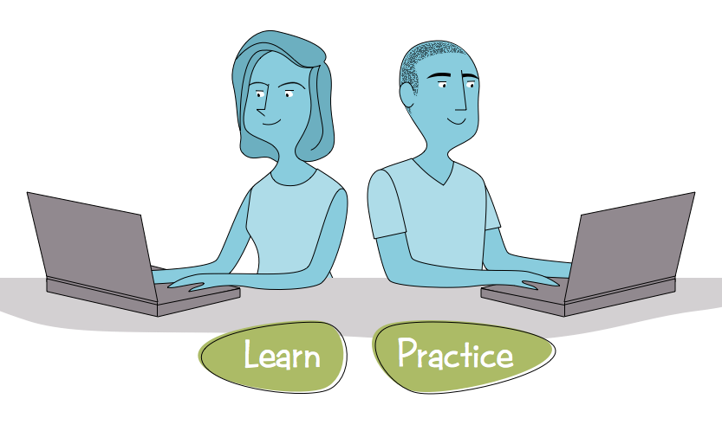

- Left-click on Typing Tutorial under the Computers section

- Scroll down the screen and left-click on Sentences
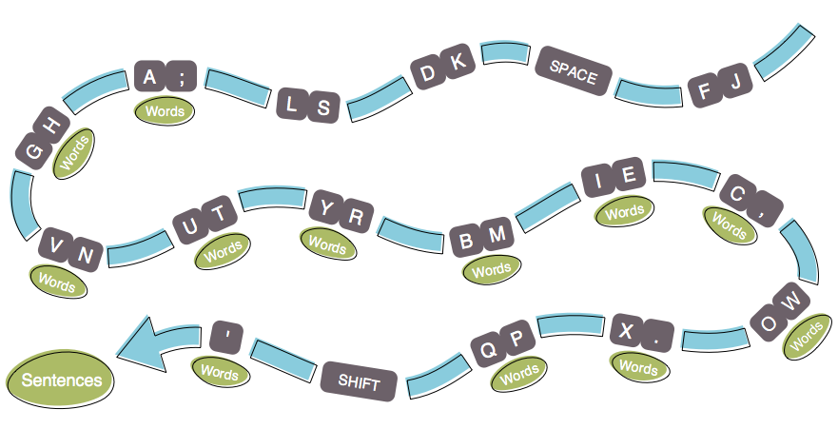

- Type a number in the space provided (Example: 5) and left-click on Start
- Scroll down the page and left-click on launch activity.




