
Learner Activity Sheet:
Mobile Basics—Android

ACTIVITY #1: External Buttons and Touch Gestures
- Locate the button to turn on your phone. Turn your phone on.

- Locate the buttons to turn your phone’s volume up and down. Turn the volume all the way down, then halfway up.

- What do you do if you don’t want your phone to ring? Use the button to silence your phone.

- How do you see all of your apps? _______________________________________________________________

- How do you scroll through a website? ___________________________________________________________

ACTIVITY #2: Common Apps
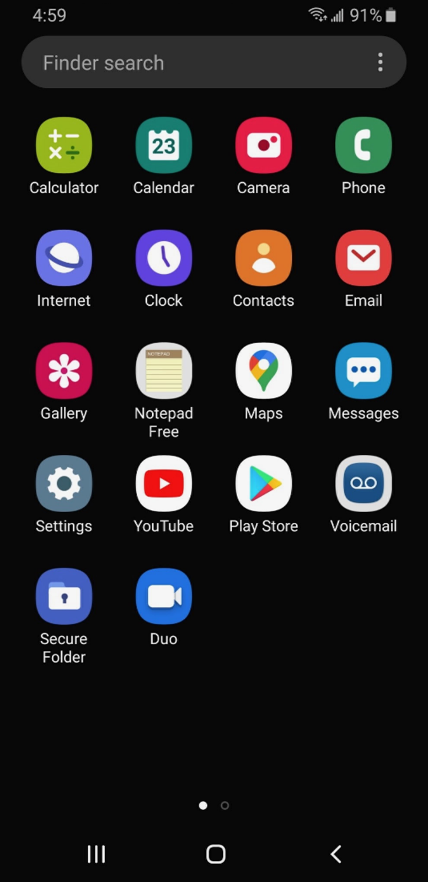
What app do you use to:
- Send an email? ________________________

- Search the web? ______________________

- Send a text? __________________________

- Record a video? _______________________

- Make a phone call? ____________________

How do you get back to the Apps view when you have an app open?
_____________________________________________________________________

Open the camera app and take a picture. Show the instructor the image you took.
Open the browser and search for the PLA Digital Learn website: https://www.digitallearn.org/ Scroll to the link about Accounts and Passwords. Tap the link and show the instructor your screen.

ACTIVITY #3: Getting Connected
Navigate to the available Wi-Fi-Networks screen on your device. Write down what steps you took to get there.

_____________________________________________________________________________________________________________

____________________________________________________________________________________________________________

Write down one of the networks that is secure (if applicable).

____________________________________________________________________________________________________________

Write down one that is public (if applicable).

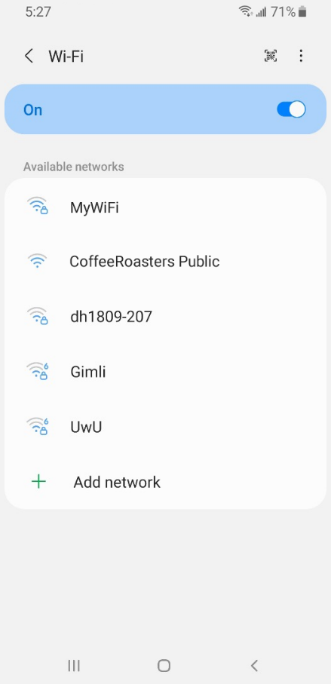
You’re relaxing in a coffee shop. You want to connect to Wi-Fi and do some personal tasks on your smartphone. On your phone, you see this list of Wi-Fi networks. Which would you connect to? Why or why not?

_________________________________________________________________________

_________________________________________________________________________

You want to do some online banking at the coffee shop. Is this a good idea on the Wi-Fi network you’re on? Why or why not?

_________________________________________________________________________

_________________________________________________________________________

ACTIVITY #4: Safety and Security
Which of these apps seems more trusted? How do you know?

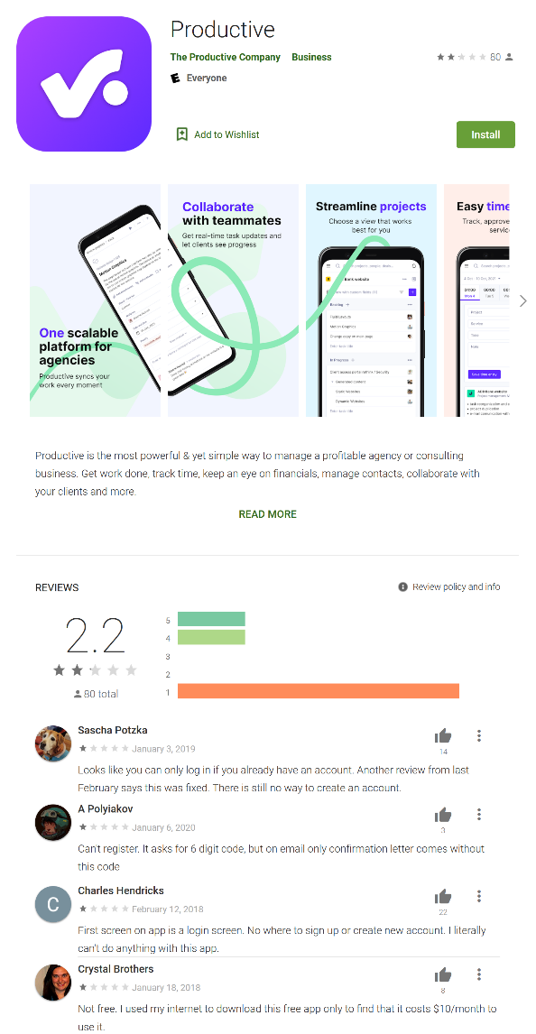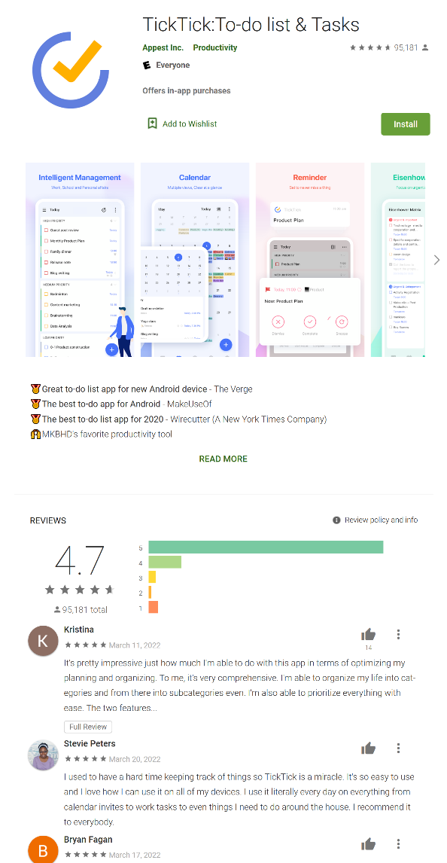

Imagine you’re at work talking with some co-workers. Even though your phone is locked, you receive a notification. What might be a problem in this situation? How could you address this problem?

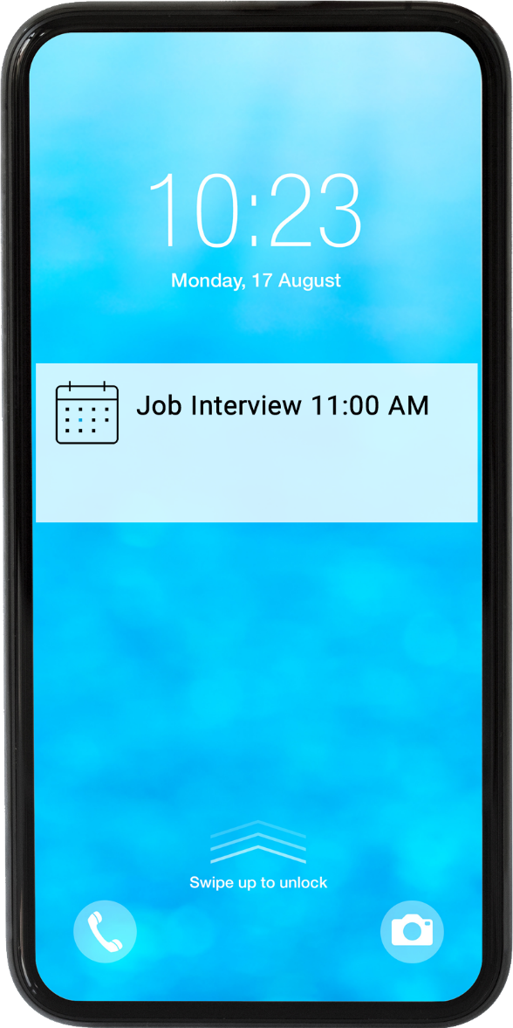

ACTIVITY #5: Practice
Complete the Practice lesson for Using a Mobile Device (Android). You can either open a web browser and complete the activity on your own or follow along with the instructor. You can also complete this lesson on your mobile device.
- In the address bar of the web browser, enter www.digitallearn.org.
- Click on “Using a Mobile Device (Android).”
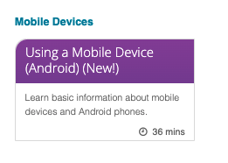
- Scroll down and click on the Practice lesson.


