
Mobile Device Basics—Android Learner Handout

External Buttons and Charging Port

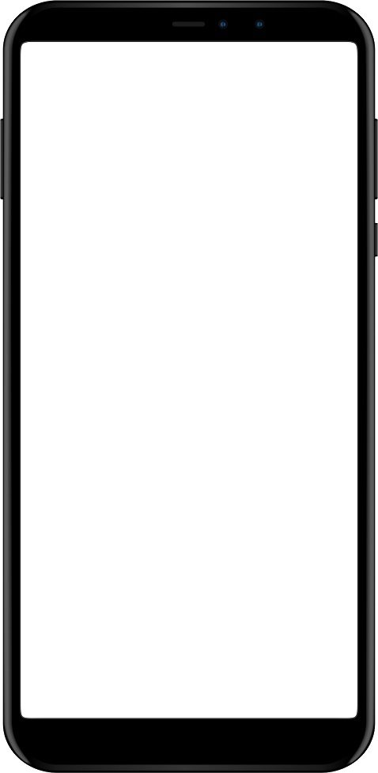
Volume
Ring/Silent Switch
Power Button

Charging Port

Touch Gestures

To control your mobile device, you touch the screen of the device with your finger and use gestures to navigate and perform different functions. There are a few standard gestures that are important to remember.

 | Tap: Use this to activate a control or select something on the screen. For example, you can tap on an app to open it.
 | Tap and Hold: Use this to display a menu of options.
 | Swipe Up and Down: If the text goes beyond one screen, you can scroll up and down by swiping up and down. You will also swipe up from the bottom of the screen to go to the Home screen.
 | Swipe Left and Right: If you want to see what apps are available on your phone, swipe left and right in the App View.

Common Apps

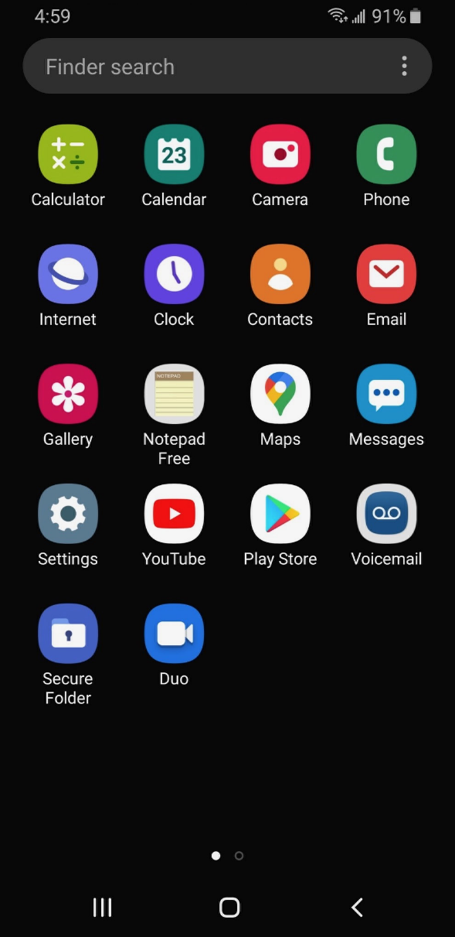
Maps
Messaging
Phone
Email
Play Store
Browser
Camera

Tips for Wi-Fi Security

Follow these tips to keep your information safe when you connect to Wi-Fi.
- Make sure you trust a public network before connecting to it. Do you know who set up the network?
- Try not to send private information over public Wi-Fi networks.
- If you do send personal information, make sure the website is secure and begins with https.
- Set up a password for your home network to block intruders from accessing it.

Locking and Unlocking Your Phone

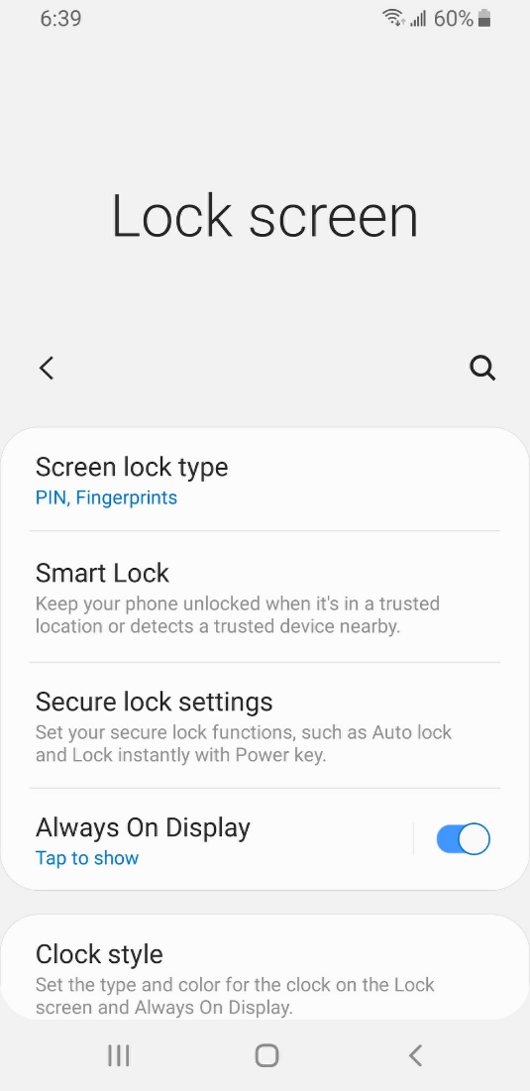
One of the most important things you can do is set a personal identification number (PIN) or passcode to access and use your mobile device. This will help protect the data stored on your device if it is ever lost or stolen. Each time you turn on your device or wake up the screen, you will see a prompt to unlock it.

To set a PIN or passcode, tap Settings. Then look for the option to lock the screen.

You can also use unlock your phone using Face ID, iris scan, or fingerprint. You would need to follow the prompts to store that information in your settings before you can enable this feature.

Please explore these settings and be sure to use one of the approaches to lock your phone to keep your data safe and secure.

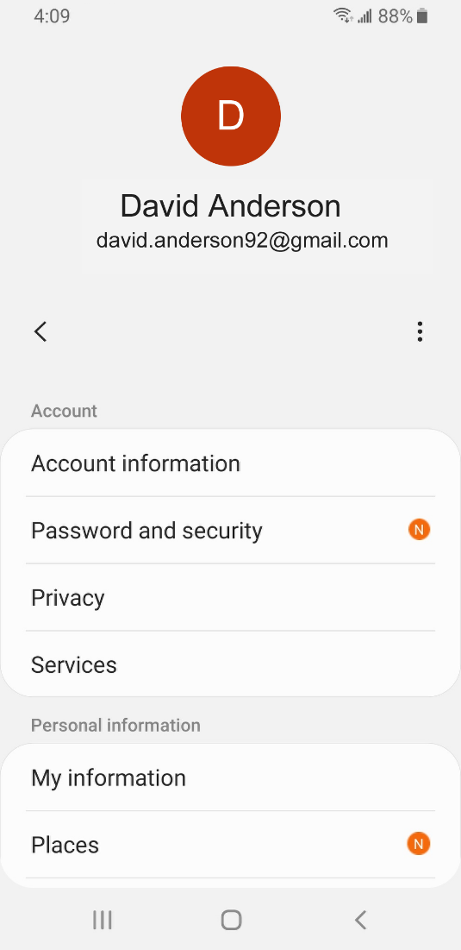
Privacy Settings

Privacy settings are also important for mobile devices. Using your phone’s privacy settings, you can decide which apps have access to information and data stored on your device, such as your location, photos, and microphone.

To access the privacy settings, go to Settings. Then tap the donut icon. Then tap Privacy and follow the prompts.

The way you set your privacy settings may be different depending on the device manufacturer. Because of the variety of Android mobile devices, you may notice slight differences between your device and this example.

Please explore these settings and be sure to set up your phone in ways that keep your data safe and secure.

Accessibility Settings

Accessibility settings on your mobile device can help you customize your phone to meet your visual, physical, motion, or hearing needs. To find the Accessibility features, tap on Settings. Then scroll down the page and tap Accessibility.

Common features to explore include a voice assistant to get spoken guidance to navigate the device without needing to see the screen; changing text size, contrast, and display color of the screen; adjusting audio settings; and enhancing or changing the touch interactions.

Please explore accessibility settings after the workshop to make sure you’re meeting all of your needs.

Security Tips
Here are some security tips to keep you safe when using your mobile device.
- Set a passcode on all of your mobile devices to prevent someone from accessing the information stored on the device if it is lost or stolen.
- Download trusted apps only. You can determine this by reading reviews, ratings, and privacy statements.
- Review the privacy settings on your device. Adjust your settings to control which apps have permission to access your camera, location, microphone, and personal information.
- Adjust your notifications to change how much content will display on the lock screen when messages come in.
- Make sure that you check the apps and operating system are running the most up-to-date versions available, or set these to automatically update.

Learn More
Visit www.digitallearn.org for more courses and to help build skills and confidence using technology.

Today’s training is provided by AT&T and the Public Library Association.

