
LinkedIn Tips & Tricks

REQUESTING ENDORSEMENTS REQUESTING RECOMMENDATIONS
- In the top toolbar, click on the Profile hyperlink and select the Edit Profile option from the drop-down list
- Scroll to the Skills & Endorsements section and click on the icon next to any of the skills listed
- Click on Yes next to the I want to be endorsed option
- Check the box next to the Include me in endorsement suggestions to my connections option
- Check or uncheck the box next to the Send me notifications via email when my connections endorse me option
- Click on the Save button

- Scroll to the Recommendations section of the Profile and click on Ask to be recommended
- On the Recommendations page, select a position in the What you’d like to be recommended for box
- Type a Connection name in the Who do you want to ask box and select the appropriate Connection
- Choose a relationship and position from the drop-down lists in the What’s your relationship? and What was (Connection’s name) position at the time? boxes
- Type a personalized message into the Write your message box
- Click on the Send button

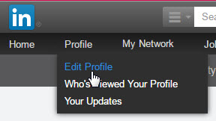
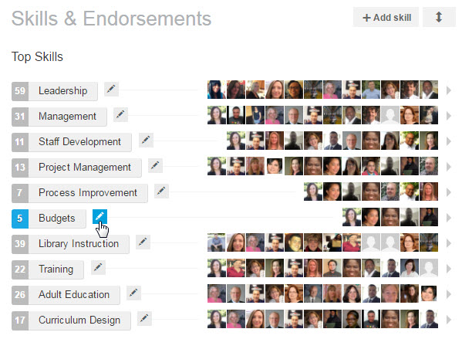
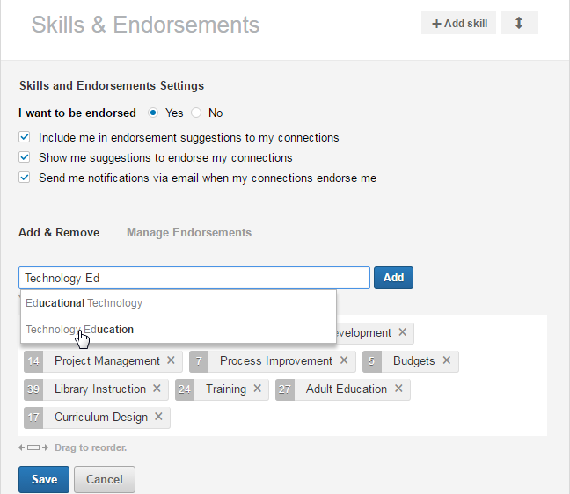
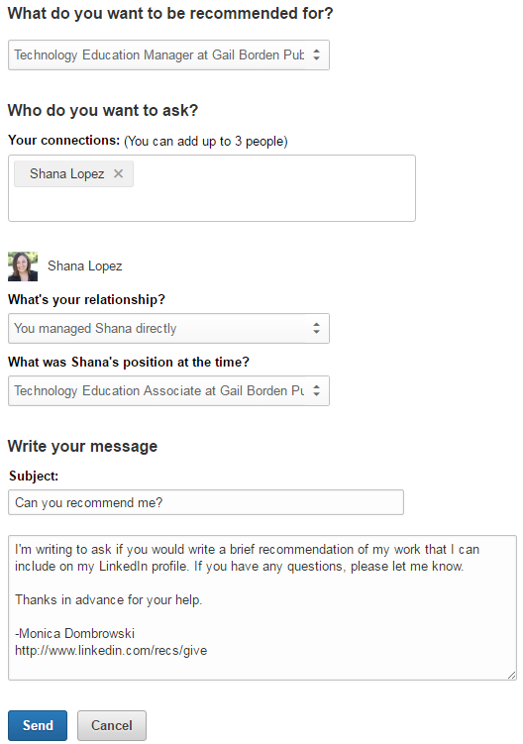

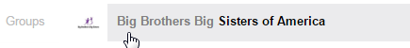
FINDING & JOINING GROUPS
If you know the name of a group you want to join:
- Type the name of the group into the search box and click on the group name when it appears
- Click on the Ask to join button

To browse Groups:
- Click on the Interests hyperlink and select Groups
- Click on the Discover link on the Groups home page
- Click on the Ask to join button to request membership
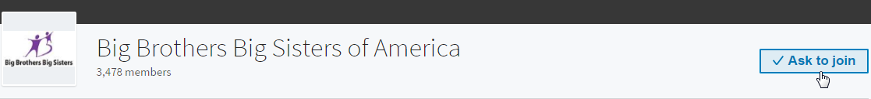

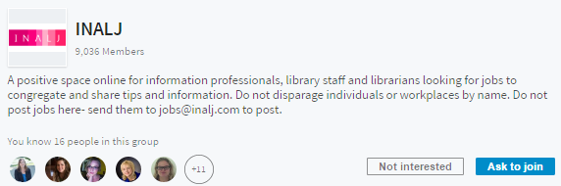
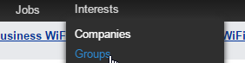

FOLLOWING A COMPANY
- Type the name of the company into the search box and click on the company name when it appears
- Click on the Ask to join button
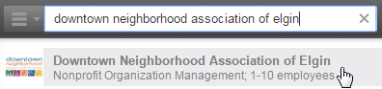
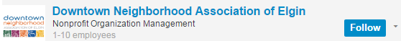

SEARCHING FOR JOBS
- Click on the Jobs hyperlink in the toolbar
- Type the desired keywords into the Job title, keywords, or company name box and enter the city or area into the Location box
- Click on the Search button
- To view a job, click on the View button

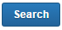
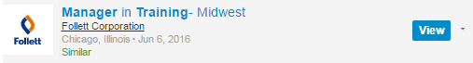

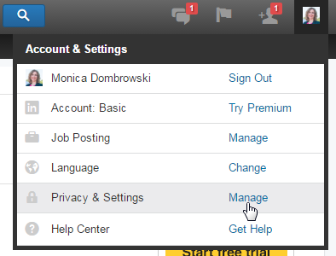
ACCESSING PRIVACY SETTINGS
- Click on your profile picture in the upper toolbar
- Scroll to the Privacy & Settings option in the drop-down list and click on the Manage hyperlink

