
LinkedIn: Getting Started
Search Box
Notifications
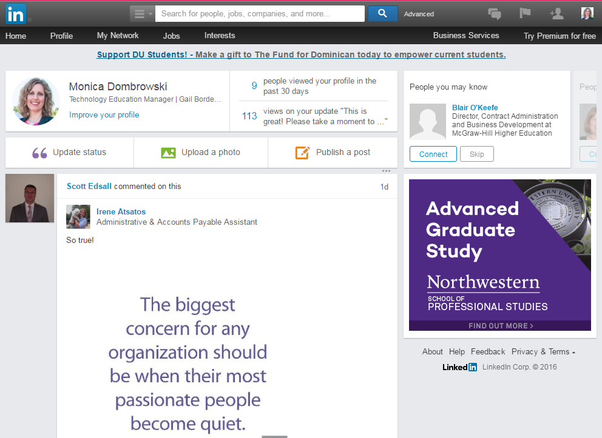
HOMEPAGE

Page links

Update your status, Upload a photo, or Publish a post

Newsfeed

ADDING SECTIONS

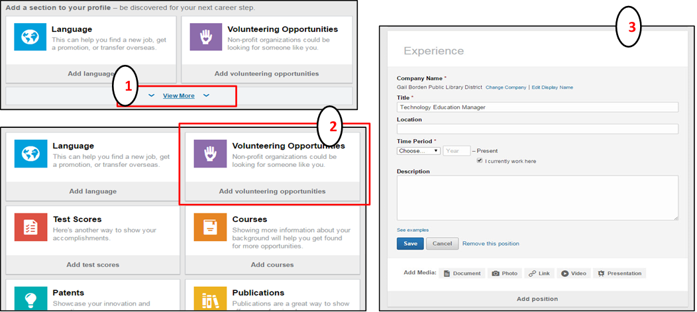

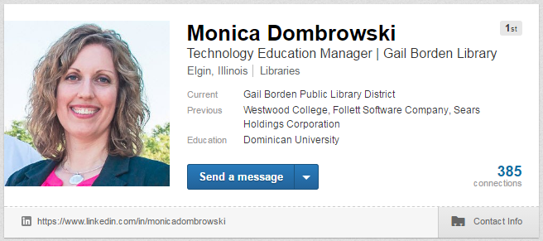
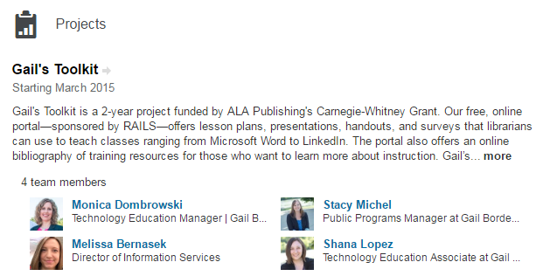
PROFILE SECTIONS

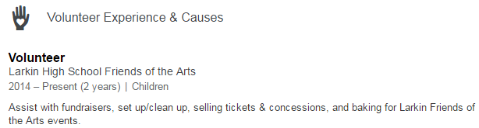

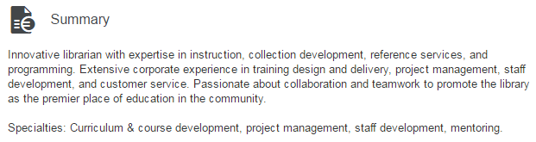



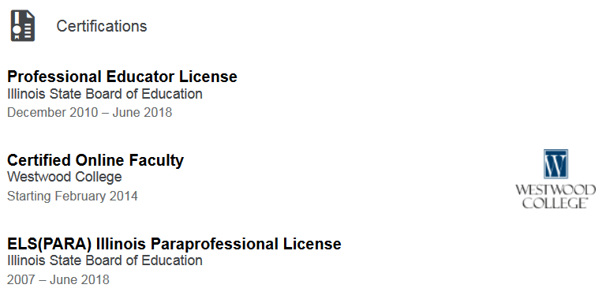
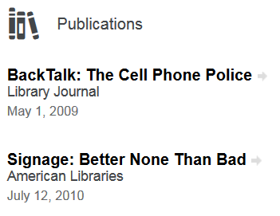
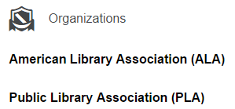

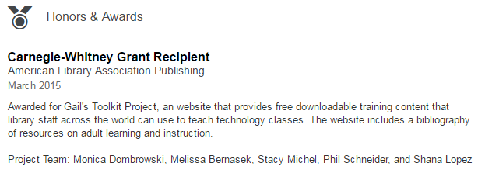

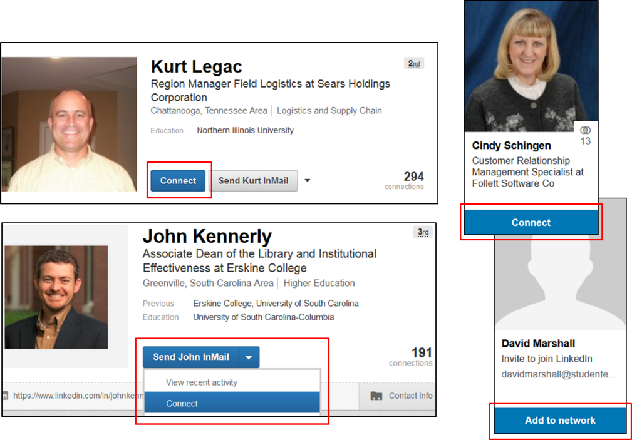
ADDING CONNECTIONS
To Add a Connection:
- Type their name in the Search box and click on
the button
- Click on the Connect button that appears under their picture
OR
- Click on the drop-down menu next to the Send InMail button
- Click on the Connect button

