
LinkedIn Basics

LinkedIn URL: www.linkedin.com

TERMINOLOGY
Connection A person to whom you are directly connected.
Potential Connection A Connection of a Connection.
Recommendation An online paragraph or letter of support written by or for one of your Connections.
Toolbar The stationary navigation bar at the top of each screen. Contains the Search box and links to the Home page, Profile page, My Network, Jobs, Interests, Messages, Notifications, Grow My Network, and Account & Settings.

HOME PAGE
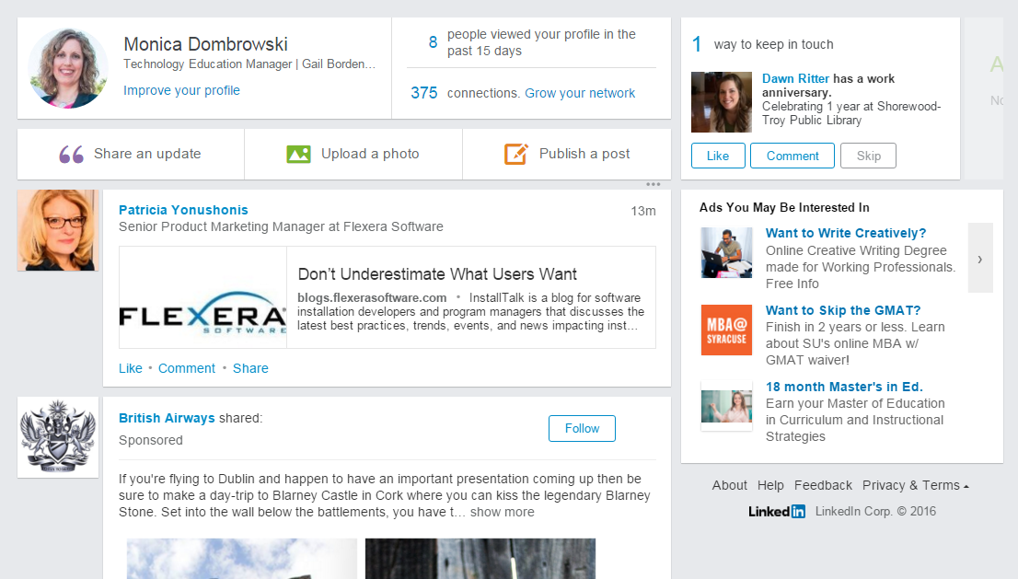

PROFILE PAGE
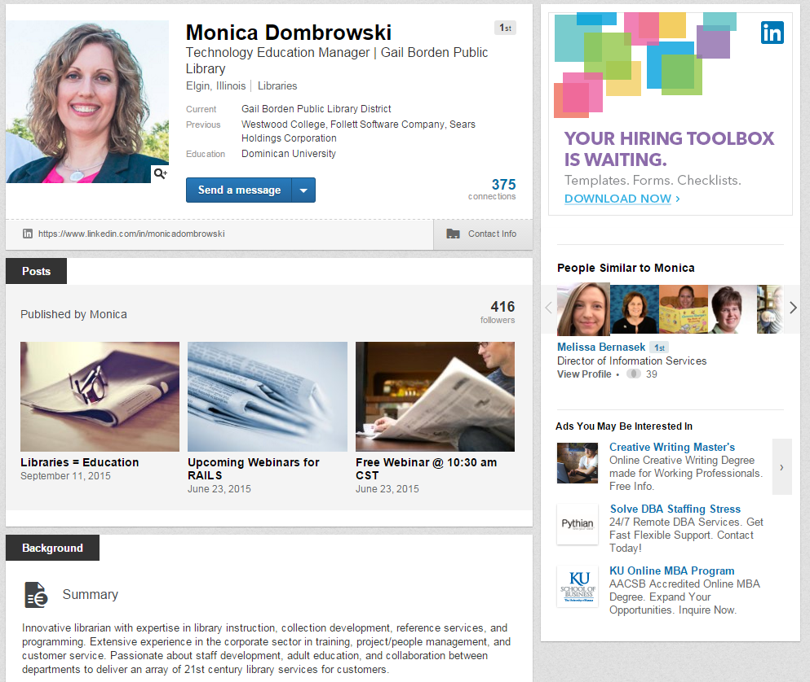

CREATE AN ACCOUNT
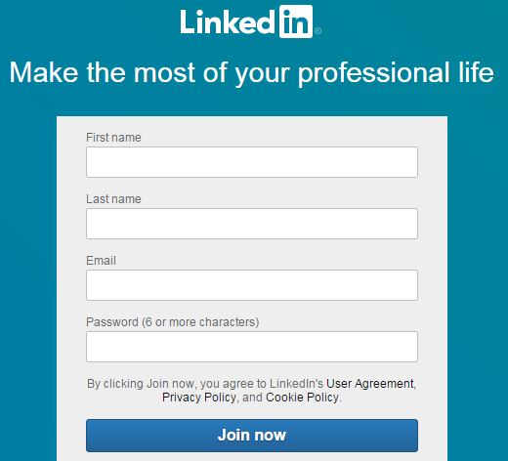
To create an account, type the following pieces of information into their corresponding boxes:
- First name
- Last name
- Email address
- Create a password (6 or more characters) and type it into the Password box.
Note: Be sure to write your password down or email it to yourself for future use
- Click the Join now button at the bottom of the screen and follow the wizard’s directions.

