
Intro to Google Tools

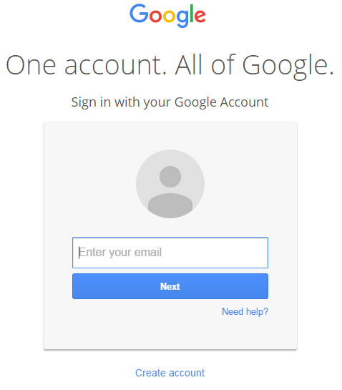
creating a google account
- Open your web browser (preferably Chrome) and go to www.google.com
- Click Sign In and then click Create Account on the next screen
- Fill in the required fields
  - Name (First & Last)
  - Username
  - Password
  - Birthday
  - Gender
  - Security fields
  - Optional cell phone number or current email address for password recovery
- Click Next Step to finish creating your account. You can add a profile photo, explore your options and settings or begin using one of Google’s Apps

Your account works for all of Google’s products, including Gmail. The username you choose will be your new Gmail address.

POPULAR GOOGLE APPLICATIONS



Contacts
Online address book
Gmail
Fast, easy, secure email
Google Chrome
Web browser


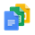

Apps
Office suite of programs
Drive
Cloud storage & sharing
Calendar
Schedule organizer




Hangouts
Chat or video calls
Forms
Build free, online surveys
Google+
Social Networking


For help with any of Google’s Apps, visit https://support.google.com
Sites
Create websites & group wikis

