Internet Basics

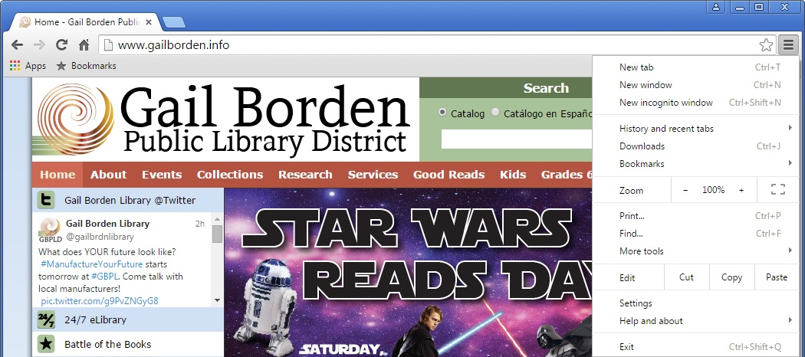
Tabs
Navigation Buttons – Back, Forward, Refresh, Home
Options and Settings
Bookmarks
Address Bar

Address Bar – The box where you type a web address (URL).
Home – This is the website page that will first appear when you open your browser. Search engines, such as Google, can be useful as Homepages.
Back/Forward – Clicking the Back arrow will take you back to the previous page you were on. Forward will return you to the page you were on after you’ve hit the back button.
Refresh – This will re-load the page you are on. Helpful if the page didn’t load properly or if recent updates have been made.
Tab – When you open a browser, you start with one tab which loads your homepage. You can use this tab to visit other websites by entering a URL into the address bar. To visit multiple sites or compare different parts of a website side-by-side, you can open multiple tabs within one browser window and switch back and forth.
Options/Settings – Contains all the settings you need to set up the browser. Includes tools such as Display (zoom, font, themes, etc.), History (previous sites visited), the Print feature and more.
Bookmarks – Save frequents sites you visit as bookmarks so you can quickly access them via the bookmarks toolbar.

USING SEARCH ENGINES (ex: Google)
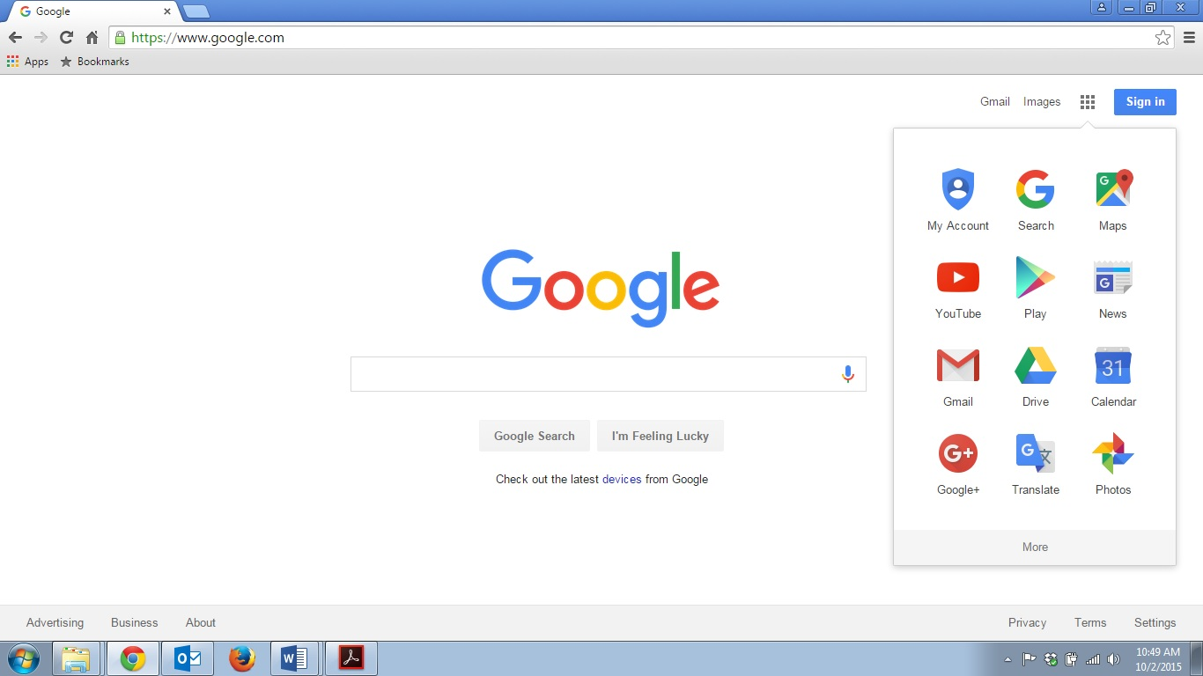
Type in keywords or search terms
Access other Google Tools for more options

TIPS & TRICKS
1. Use quotation marks around a phrase to limit results to the terms inside the quotation marks in that particular order
Ex. “Illinois State Fair” retrieves results with Illinois State Fair in the title but not Iowa State Fair
2. Use connectors AND, OR between keywords to broaden or narrow your search
Ex. Chicago AND events, Chicago AND events OR museums
3. If you aren’t getting an exact match or the results look off, be sure to check for the following:
- Additional pages of results (appearing in number form at the bottom of the page)
- Helpful hints from the Search Engine, like “Also try,” or “Searches related to”
4. Review results carefully before clicking on a link to be sure it is the best match for your needs
5. Try to use websites that begin with an https:// or display a lock icon, for added security
6. Make sure you have current antivirus software installed on your computer
7. Keep your software programs and apps updated to the most current versions
8. Create strong, unique passwords for each website and store them in a secure location (i.e., NOT in a folder labeled “Passwords”). Also, ensure your passwords have at least seven characters, a mix of upper and lowercase letters, and contain both a number and a symbol

