
Learner Activity Sheet: Internet Basics

ACTIVITY #1: Using a Web Browser
Use a web browser or follow along with the instructor to complete the following tasks.

- Use the address bar to go to www.google.com and search for puppies.

- Click the back button. What web page displays? ___________________________________

- Click the forward button. What web page displays? ________________________________

- Click on the homepage. What web page displays? _________________________________

- What icon on the browser would you click to bookmark this page? _______________

ACTIVITY #2: Basic Search
Complete the Practice lesson for Basic Search. You can either open a web browser and complete the activity on your own or follow along with the instructor. To complete the activity on your own:
- In the address bar of the web browser, enter https://www.digitallearn.org
- Click on Basic Search.

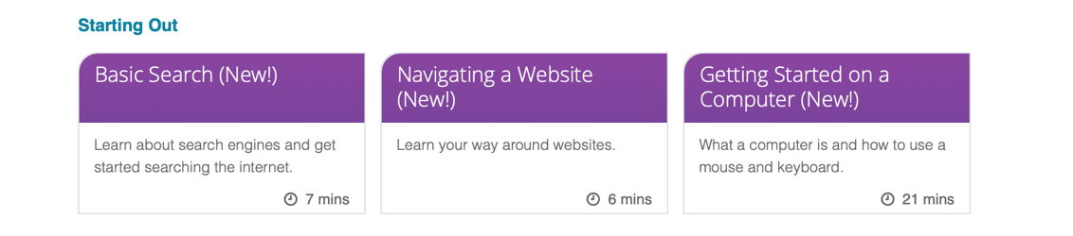
- Click on “Practice.”

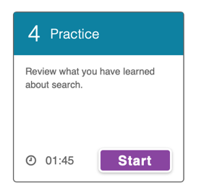

ACTIVITY #3: Advanced Search Techniques—Discussion Only

ACTIVITY #4: Practice
Practice what you’ve learned. Use a web browser to visit https://www.digitallearn.org
and answer the following questions or follow along with the instructor to complete the following tasks.

- How many courses are available? ___________________________________________________
- How many activities are in the Navigating a Website course? _______________________
- What information is available in the footer? _________________________________________
- What links are in the navigation menu? _____________________________________________
- List one resource that is hyperlinked on the web page.______________________________
- Are there ads on the website? If yes, how many? ____________________________________
- Does the website have a search function? ____________________________________________

