
Learner Handout: Internet Basics
Navigation Buttons: Back, Forward, Refresh, Home
Options and Settings
Tabs

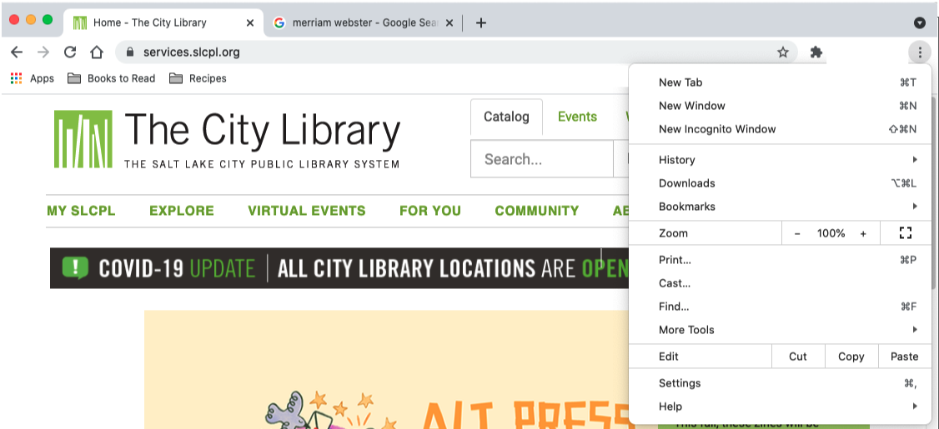
Bookmarks

Search Box

Main Content

Navigation Menu

Address Bar
Parts of a Web Browswer
Browser Window – Is how you view and navigate Web Pages. Within a Browser Window you can have multiple Tabs. You can also have multiple Browser Windows open at the same time.
Web Address – Tells the computer the correct combination of letters, numbers, and/or characters to reach a particular website. It’s like the street address for a Website!
Address Bar – The box where you type a web address (URL). It can also be used to search for information and view content on the Internet.
Home – This is the Website page that first appears when you open your browser. You can select which Web Page you want as your homepage in the web browser’s Settings.
Back/Forward – Clicking the Back button takes you to the previous page you were on. Forward returns you to the page you were on before you hit the back button.
Refresh – This re-loads the page you are on to ensure the web content is up to date or to fix any issues if the page didn’t load properly.
Tab – When you open a browser, you start with one tab which loads your Home Page. You can use this tab to visit other Websites by entering a URL into the Address Bar. To visit multiple sites or compare different Websites side-by-side, you can open multiple tabs within one browser window and switch back and forth.
Options/Settings – Contains all the Settings you need to set up the browser. Includes tools such as Display (zoom, font, themes, etc.), History (previous sites visited), the Print features and more.
Bookmarks – Save sites you visit frequently so you can quickly access them via the bookmarks toolbar.
Internet Terminology
Internet – A system of interconnected global computer networks that allow people to share digital information with one another.
Web – A system of online documents that are linked together, like a spider “web” (hence the term World Wide Web).
Hyperlink – It is an element on the webpage that when clicked takes you to another document on the Internet.
Website – A collection of Web Pages that are linked together that provides information about a particular business, group, organization, or person.
Web Page – An electronic document with text, images, video and other links that is accessed by clicking a Hyperlink from the Results List or Web Page in a Web Browser.
Home Page – The landing page or main page of a Website that provides links and a Search Box to find information on other pages within the Website.
Web Browser – Also known as a Browser Window. It is a program that allows you to view Websites and navigate between them using Hyperlinks.
Cloud – A term used to describe web-based applications and/or files that are stored and accessed on the Internet (usually with a login and password) from a shared, remote server and not on your computer’s hard drive.
Domains (the last few letters of the address after the .) USUALLY gives users an indicator about the type of site they’re visiting. Examples include: .com = commercial business or company; .org = was originally used by non-profits but is now also available to politicians, political parties and online communities.; .gov = government agency and .edu = educational institutions.
Parts of Website
Navigation Menu: A collection of links to the main sections of the Website. Navigation Menus usually appear near the top of the page. Click on these links to browse other sections of the Website.
Search Box: Just like a Search Engine searches the Internet, the Search Box on a Website allows visitors to search for specific information on the Website they are visiting.
Main Content: The big area in the middle of the Web Page that contains most of the unique content. Examples: a story you want to read, a video you want to watch, a recipe you want to bake, etc.
Footer: A collection of links that appears on the bottom of each page and often includes basic information about the website or company including contact information, terms of use, social media links and more.
Sidebar Navigation: A collection of links that allows the user to navigate to information in a particular section of the Website.
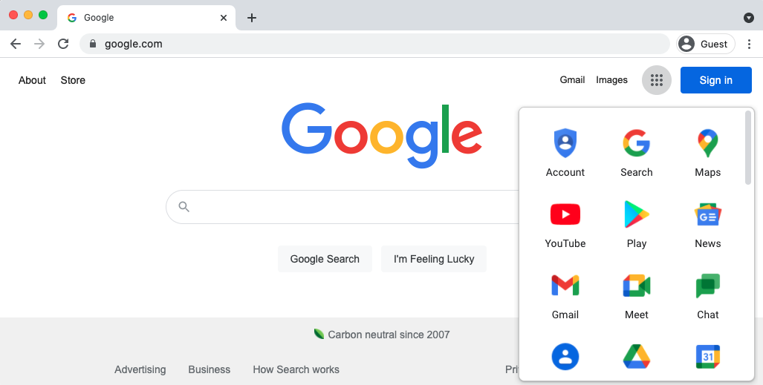
Search Box: Type keywords or search terms
Access other Google tools for more options

Using Search Engines (example: Google)

Search Engine – A Website that allows you to look up information and view content on the Internet. Some examples of commonly used search engines are Bing, Google and Yahoo!

Search Box – Used to enter keywords when the exact address is unknown. Some browsers only have a single “omnibox” that is used to enter both web addresses and keywords (like Google).

Tips & Tricks
Use these tricks to search the Internet like a pro.
- Use quotation marks around a phrase to limit results to the terms inside the quotation marks in that particular order.
- Ex. “Illinois State Fair” retrieves results with Illinois State Fair in the title but not Iowa State Fair
- Use connectors AND, OR between keywords to broaden or narrow your search.
- Ex. Chicago AND events, Chicago AND events OR museums
- If you want to exclude terms from the search results use the (-) minus symbol.
- Ex. Cardinal -baseball
- A search for Chicago Tribune is the same as searching for chicago tribune.
- Search Suggestions: Many Search Engines suggest possible search terms as you type your search in the Search Box.
- Many Web Browsers allow you to search the Internet from the Address Bar. If you see the magnify glass in the Address Bar you can enter your search term in the box to search the Internet.
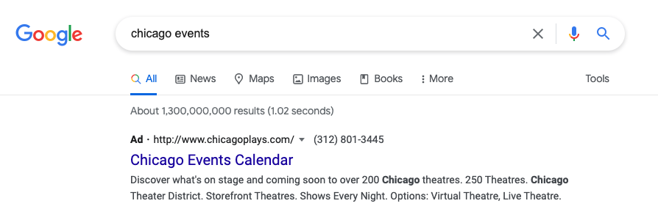

Limit Search To A
Specific Form

Ads in Search Results
- You can search for a specific format including images, music, videos and news. To do this type your search in the search box, submit your search, and then select the type of format you want in the results list.

- Ads in Search Results. Search engines sometimes display ads related to the search result.

- Review results carefully before clicking on a link to be sure it is the best match for your needs.
- If you aren’t getting an exact match or the results look off, be sure to check for the following:
- Additional pages of results (appearing in number form at the bottom of the page)
- Helpful hints from the Search Engine, like “Also try,” or “Searches related to”
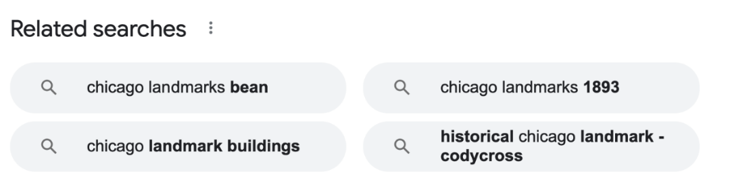
Safety Tips
Here are some tips to ensure that you use the Internet safely.

- Try to use websites that begin with an https:// or display a lock icon, for added security.
- Fake URLS – Sometimes fraudsters create a fake URL as part of an online scam. Check the Website address or URL to make sure you are on the Website you intended to visit. A missing letter, a typo, or grammatical errors can be a sign that the website may be part of a scam.
- Security settings – Check the security settings in your Web Browser to view and set your security preferences.

Learn More
Visit https://www.digitallearn.org for more courses and to help build skills and confidence using technology.

Today’s training is provided by AT&T and Public Library Association.

