
iMovie Basics
Introduction
iMovie is a video editing application available for Mac and iOS.
Getting Started
To launch iMovie:
1. Click the Finder icon on the Dock.
2. Click Applications in the left sidebar.
3. Double-click the iMovie icon from the list of applications on the right.
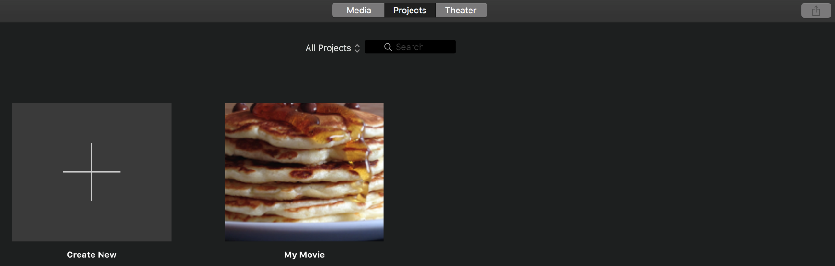
Create a new project by clicking the + sign
Edit an existing project by clicking its thumbnail.
Project Library: contains all existing iMovie Projects.
iMovie Project Library & Home Screen

iMovie Workspace
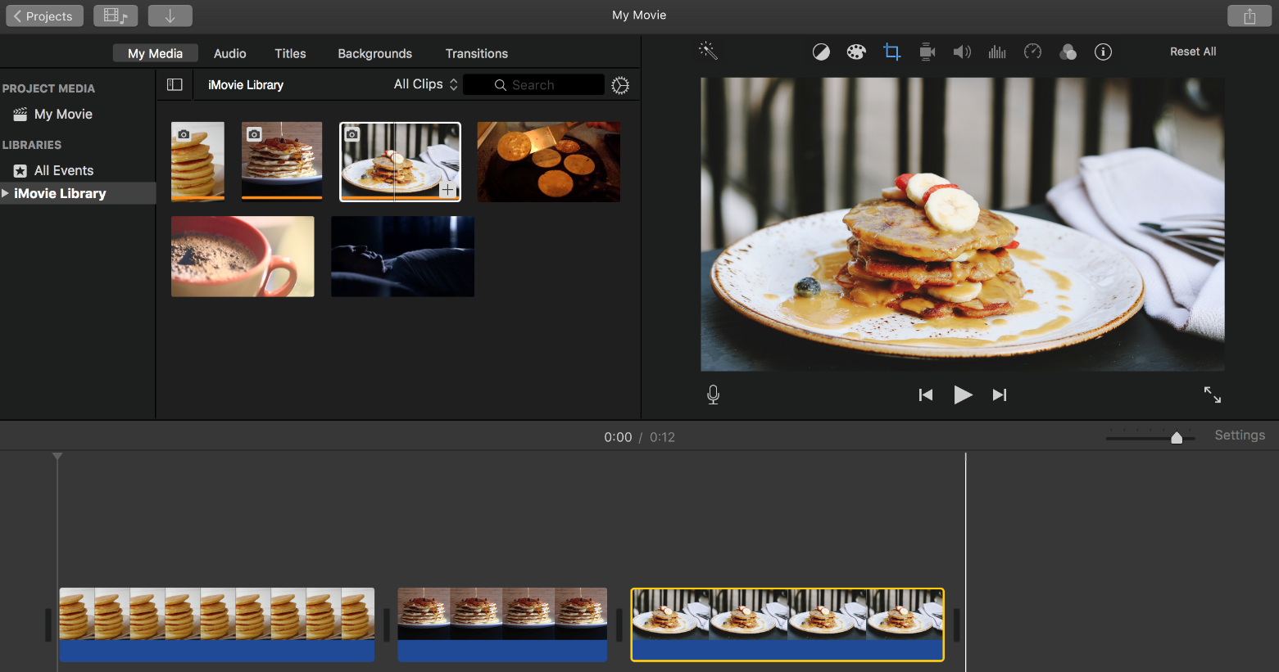
A
B
C
D
E
F
G

(A) Import Button: Imports media into your Library
(B) Libraries: iMovie has five libraries for organization: My Media, Audio, Titles, Background, & Transitions
(C) Library Pane: Contains subfolders for each library
(D) Browser Pane: Displays the content of your selected library
(E) Viewer Pane: Contains info about media selected from the Browser & Timeline. Playback options are here.
(F) Timeline: Workspace for assembling your movie. The vertical white line shows where you are within the Timeline.
(G) Toolbar: Contains editing tools.

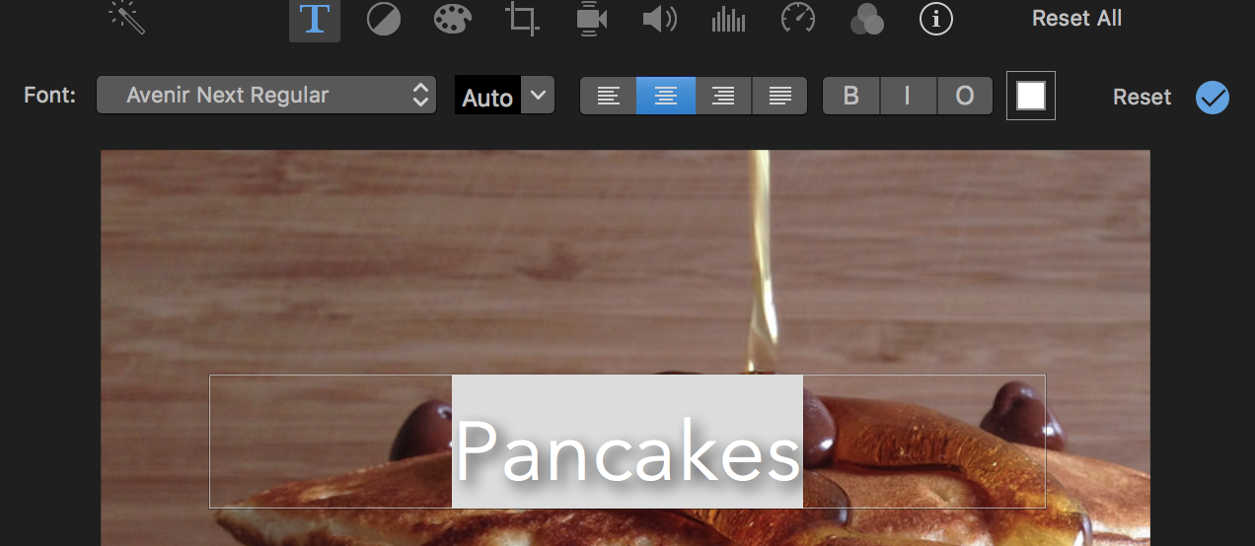
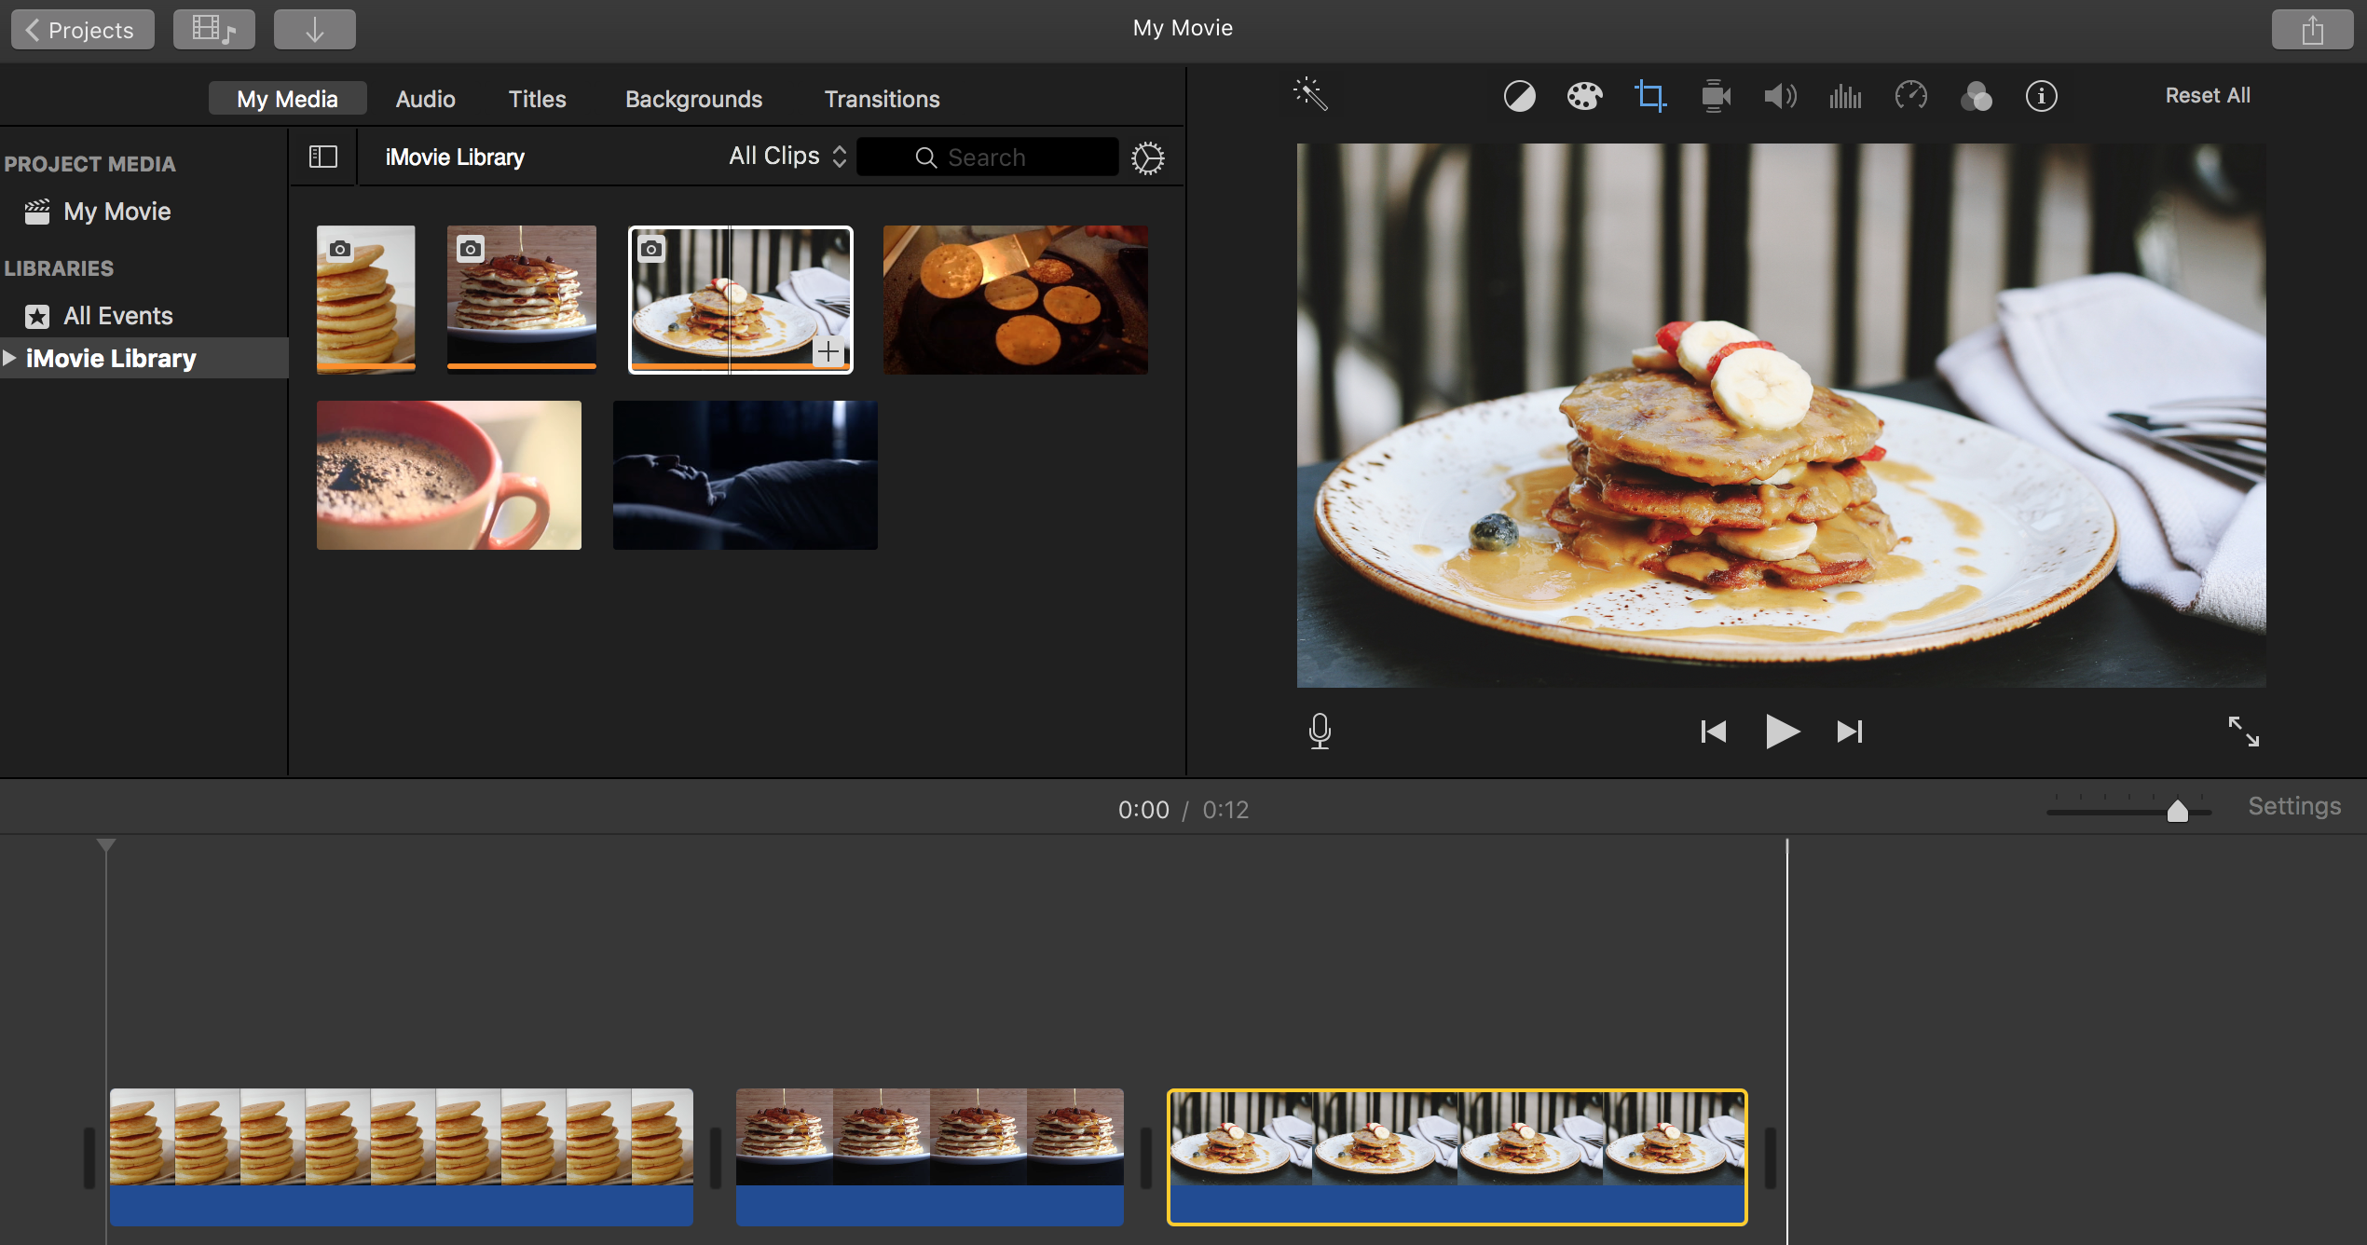
Text Options
Font Styles
Font Size
Text Placement
Font Color
Reset changes
Click here to apply changes
Text Options Toolbar
Bold, Italicize, Outline
Highlight text to make changes.
Toolbar Options
Color Balance
Crop
Volume
Speed
Clip Information
Color Correction
Stabilization
Noise & Reduction Equalizer
Video/Audio Effects

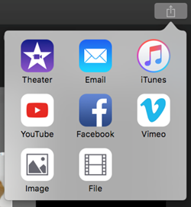
Exporting and Sharing the Finished Project
To share your finished movie:

1. Click the Share Project button in the upper right corner.
2. Click File from the drop down.
3. Name your movie and add a description.
4. Click the Next button.
5. Select a location where you’d like to save your Movie.
6. Click Save.

