
Google Tools: Slides

GOOGLE SLIDES OVERVIEW
Google Slides is an online presentation app that lets you create and format presentations and work with other people.
Access Google Slides via https://slides.google.com

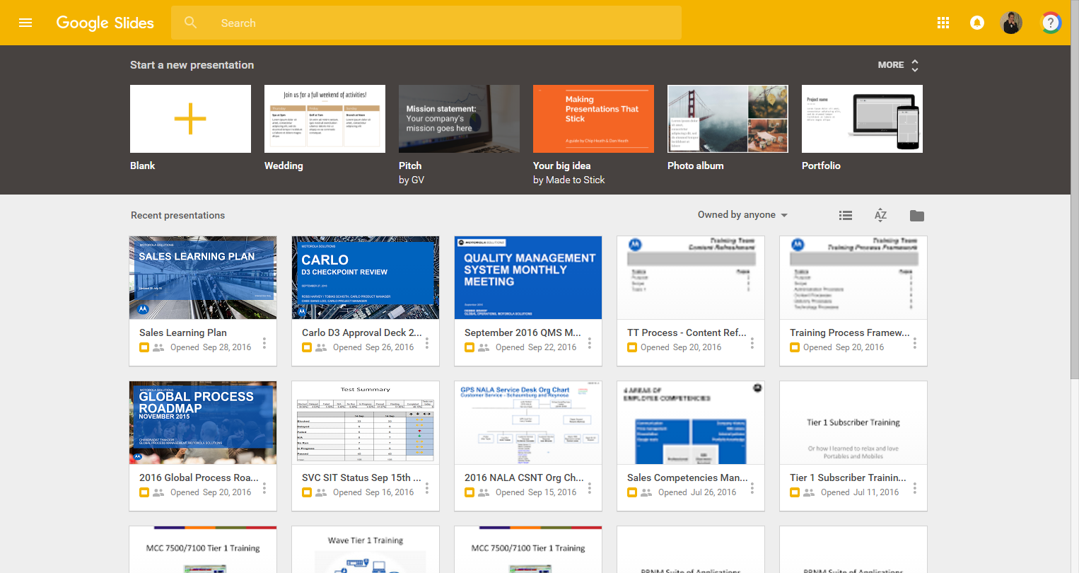
Templates/New Doc
Your files
Search for Files
Display options
File picker

CREATING A NEW PRESENTATION
- Access Google Slides
- Under “Start a new presentation,” click  to begin a new “blank” slide deck or select from an available template
- The new presentation displays
- Edit, format, and/or share your slide presentation
Note: All changes you make within Google Slides are automatically saved in real time.

Google Tools: Slides

EDITING, FORMATTING, AND SHARING PRESENTATION SLIDES

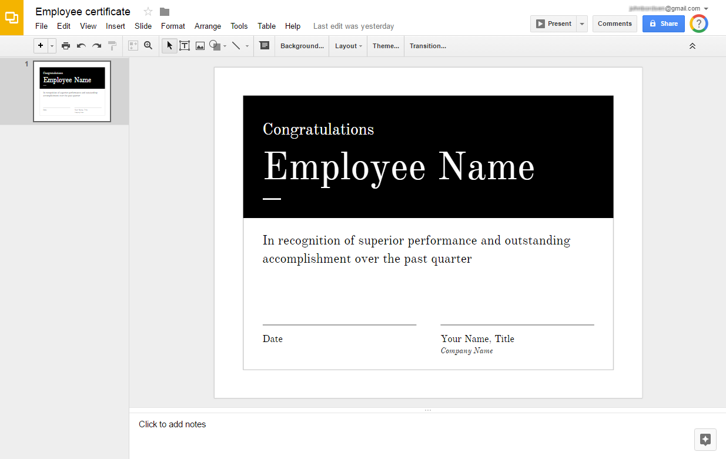
File Name
Slides
home
Menu bar
Present
Share
Tool bar
Slide(s)
Workspace

Navigating Slide Presentations
- Slides home: Return to the Google Slides home screen
- Slide(s): Select from existing slides within your presentation to view and/or modify them
- Workspace: Modify the contents and formatting of a slide within the workspace
- File Name: View or modify the document’s title within the “File Name” field
- Menu Bar: Select from various menu items and corresponding actions/commands
- Tool Bar: Insert, modify, and adjust slides, objects, or other content with various commands
- Present: Launch full screen mode to display your slide presentation
- Share: Provide collaborators or others with access to your slide presentation

