Activity Sheet: Google Slides

ACTIVITY #1
Log-in to your Google account and access Slides
- Open Google Chrome
- Access https://www.google.com/
- Click the Sign In button located in the upper-right corner
- Proceed to log-in with your Google (Gmail) username and password
- Click on the Apps Launcher button in the upper-right corner
- Click on More and then Even more from Google
- Locate and click on Slides (under “Home & Office” apps)

ACTIVITY #2
Create a slide presentation from a template, duplicate the file, and then delete the copy
- Locate the template labeled “Portfolio” and click on it
- Verify the presentation opens in Slides
- Proceed to copy the presentation by selecting File > Make a copy
- Title the document “Training Test” and then click OK
- Delete the new “Training Test” presentation by selecting File > move to trash
- In the pop-up box that displays, click the Go to Slides home screen button

ACTIVITY #3
Create a new presentation
- From the Google Slides home screen, click the option for creating a new blank presentation
- Name the presentation “Library Training” by modifying the file name field
- Select a new theme for the presentation by clicking Themes… on the toolbar
Tip:
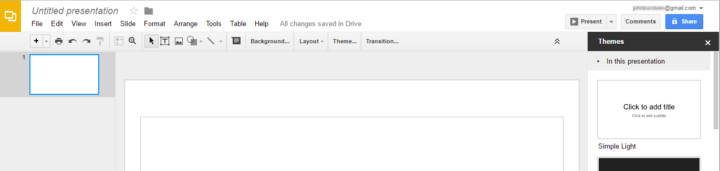
File name field
Themes

ACTIVITY #4
Select a new slide layout
- In your new, blank presentation, click the Layout button on the toolbar to change the layout of Slide 1 from the default to “Section Header”
- In the text box placeholder, type “Google Slides Training” for the title

ACTIVITY #5
Working with slides in your presentation
- Insert two new slides into the presentation
- Type “Modifying Slides” as the title of the first new slide
- Create a duplicate copy of this slide
- Modify the title of the duplicate to “Inserting Objects”
- Title the second blank slide “Working with Slides”
- Drag the “Inserting Objects” below the “Working with Slides” slide
- Delete the slide entitled “Modifying slides”

ACTIVITY #6
Working with slides in your presentation
- From the “Inserting Objects” slide, click on Insert in the toolbar and select Image
- On the Upload tab, click the Choose an Image to Upload button
- In pop-up window, click Classroom from the Navigation Pane on the left-hand side and open the folder corresponding to your computer number
- Select the PF – Google Slides file
- Resize the image, as necessary

ACTIVITY #7
Viewing and sharing a presentation
- Click on the Title slide from the Navigation Pane then click on Present to view your presentation
- Move through the slides and when complete, hit the ESC button to return to the editing screen
- In the upper-right corner, click on the Share button
- Type the instructor’s email address into the “Enter names or email addresses” field
- Select “Can view” from the permissions dropdown
- Optionally, type a short note in the message field (Ex: Check this out!)
- Click on Send

