
Google Tools: Sheets

GOOGLE SHEETS OVERVIEW
Google Sheets is an online spreadsheet application that lets you create, format, and collaborate on spreadsheets with people in real time.
Access Google Sheets via https://sheets.google.com

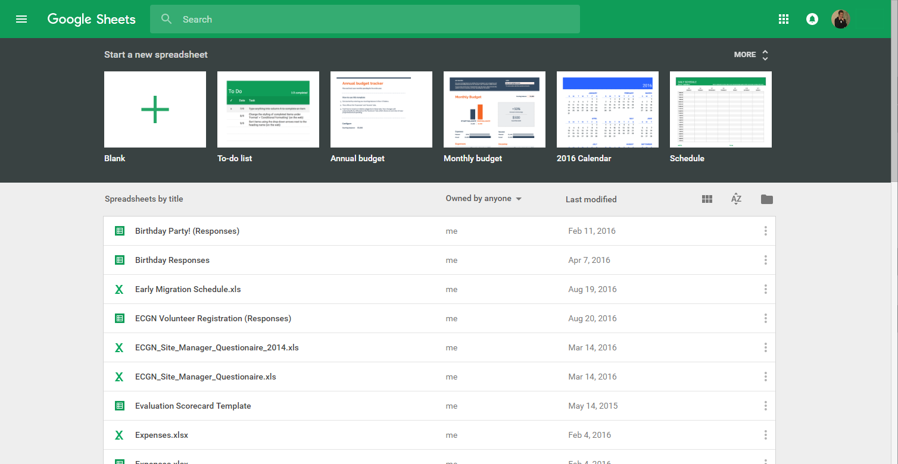
Templates/New Doc
Your Sheets
Search Bar
Display options
File picker

CREATING A NEW SPREADSHEET
- Access Google Sheets
- Under “Start a new document,” click  to begin a new “blank” document or select from an available template
- The new spreadsheet displays
- Edit, format, and/or share your spreadsheet, as needed
Note: All changes you make within Google Sheets are automatically saved in real time.

Google Tools: Sheets

EDITING, FORMATTING, AND SHARING A SPREADSHEET

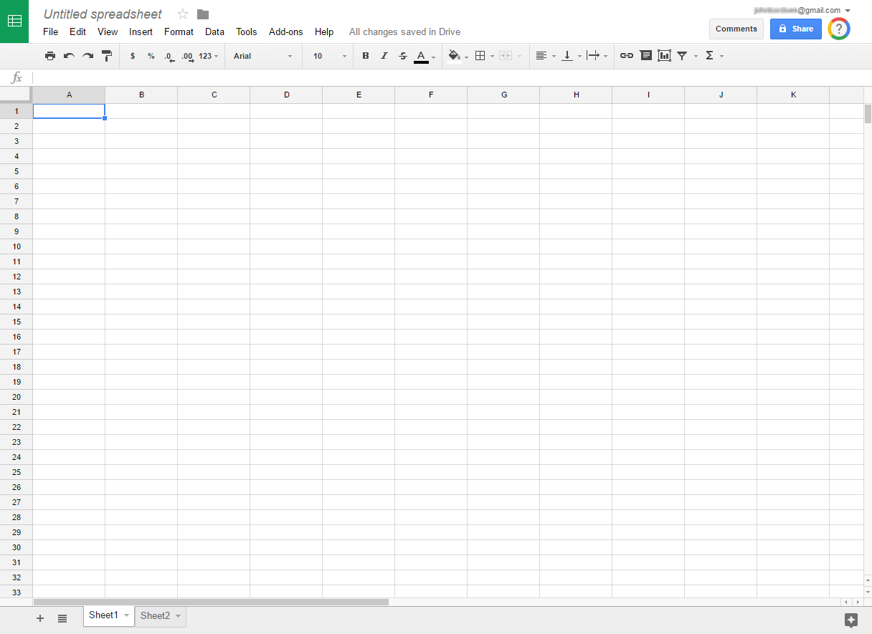
Rename
Sheets home screen
Share
Menu bar
Text formatting
Insert comments, links, functions and more
Cell formatting
Tabs (sheets)

Note: All changes you make within Google Sheets are automatically saved in real time.

