
Google Tools: Forms
GOOGLE FORMS OVERVIEW
A web-based application that allows users to create and share online, interactive questionnaires.

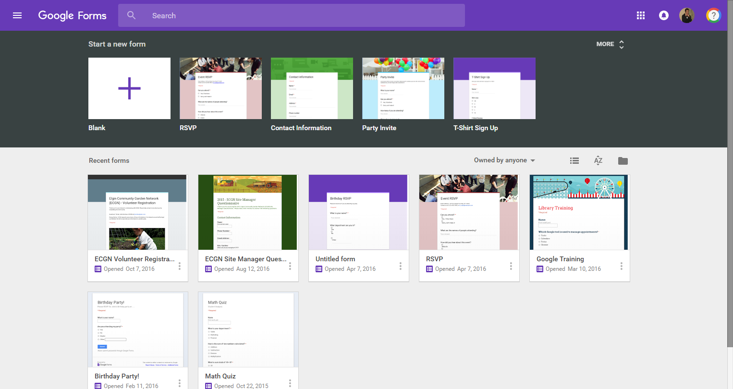
Create a new Form
Your Forms
Search for Docs
Display options
File Picker

CREATING & PUBLISHING A NEW FORM
- In “Start a new form,” click  to begin a new “blank” form or select from an available template
- The new form will appear for you to edit and customize by adding a title, questions, etc.
- Publish or share via the “Send” button in a Form
- Review and manage the response data via the “Responses” tab within a Form

WORKING WITH A FORM

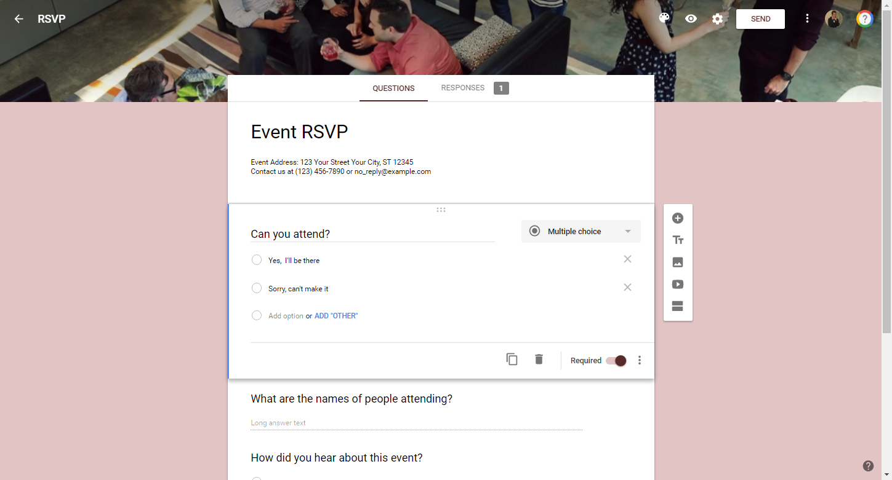
Question(s)
Insert Items
(Ex: Add questions)
Forms home
Form Name
Menu
Preview
Select Theme
Settings
Publish / Share
Form title & description
Edit questions or view response data

INSERTING & MODIFYING QUESTIONS

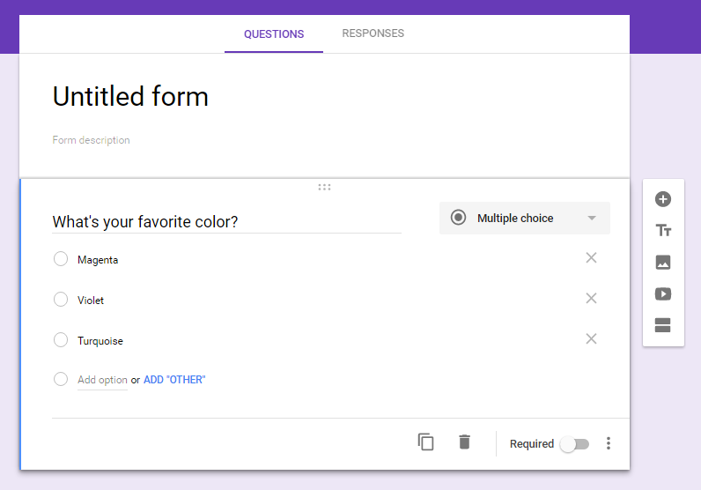
Enter a question
Responses
Add a new response
Select a question type
Add a new question
Miscellaneous options

VIEWING RESPONSES
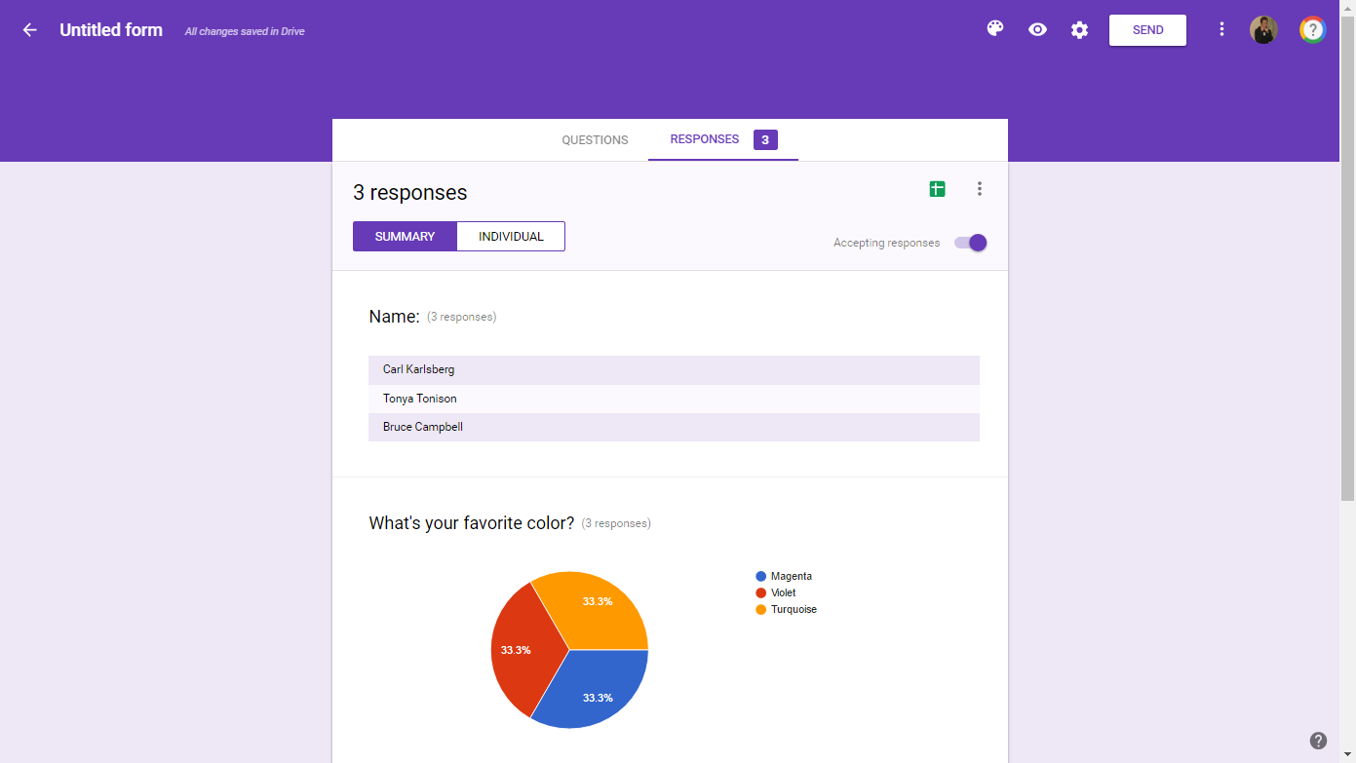
Create a Spreadsheet
Responses tab
Options
Summary or Individual Breakdown

Access Google Forms via https://docs.google.com/forms

