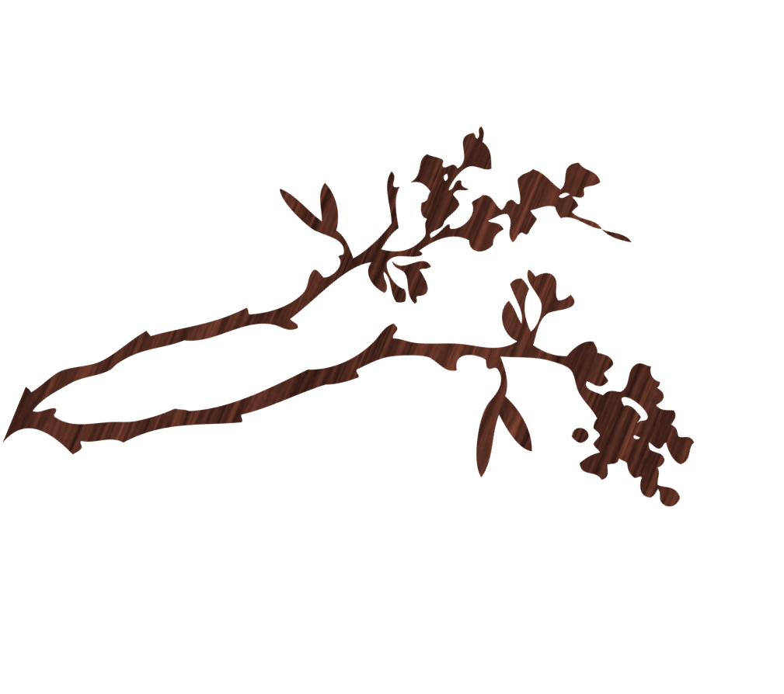
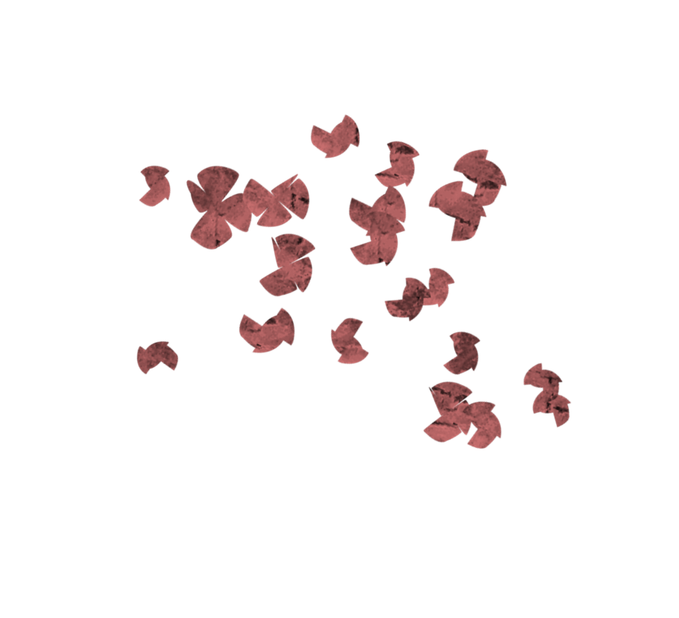
14th Annual
for more information contact: Cherry @ 123-456-7890

Cherry Blossom Day
March 26, 2016

Washington, D.C.
Join us for the 14th Annual Cherry Blossom Day! Prepare to be amazing by a dazzling opening ceremony and parade among other festivities!

