
Google Tools: Drive
NAVIGATING GOOGLE DRIVE
Google Drive is a cloud storage solution that allows you to keep all of your files in one place and access them from any device.
https://drive.google.com

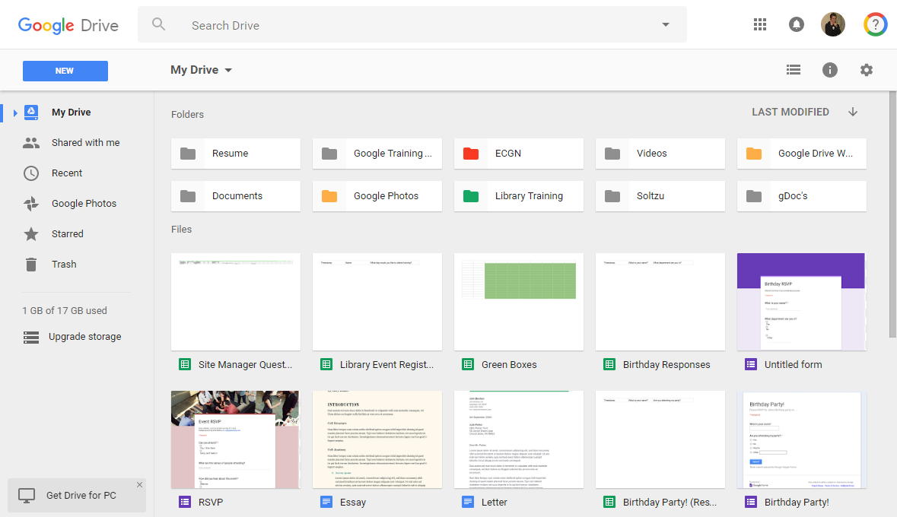
Create or Upload
Navigation Pane
Search Bar
Remaining Storage
Sorting
Settings and Display Options
Folders
Files

UPLOADING AND CREATING FILES IN DRIVE
Backup files from your PC or create a new Google document (Docs, Sheets, or Slides). Google Drive provides 15 GB of free storage; Google documents do not count towards your storage.
Tip! For more information about managing your Gmail Inbox and Contacts, visit https://support.google.com
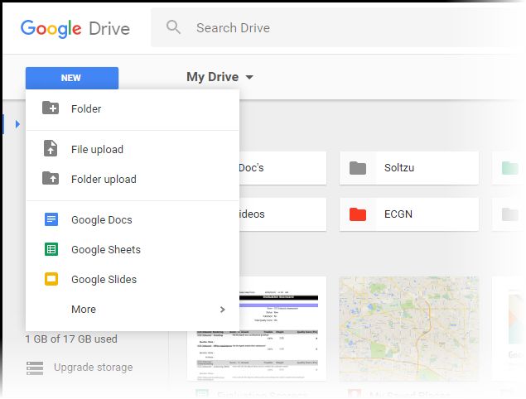
- Access Google Drive
Click NEW to create or upload files and folders
Upload from your PC
Create new Google docs
- Click on the NEW button
- Select desired option
- Folder (to organize files in Drive)
- File upload
- Folder upload
- Google Docs
- Google Sheets
- Google Slides
SHARING A DOCUMENT WITH OTHERS FROM DRIVE
Share documents from Drive with Google or non-Google users.
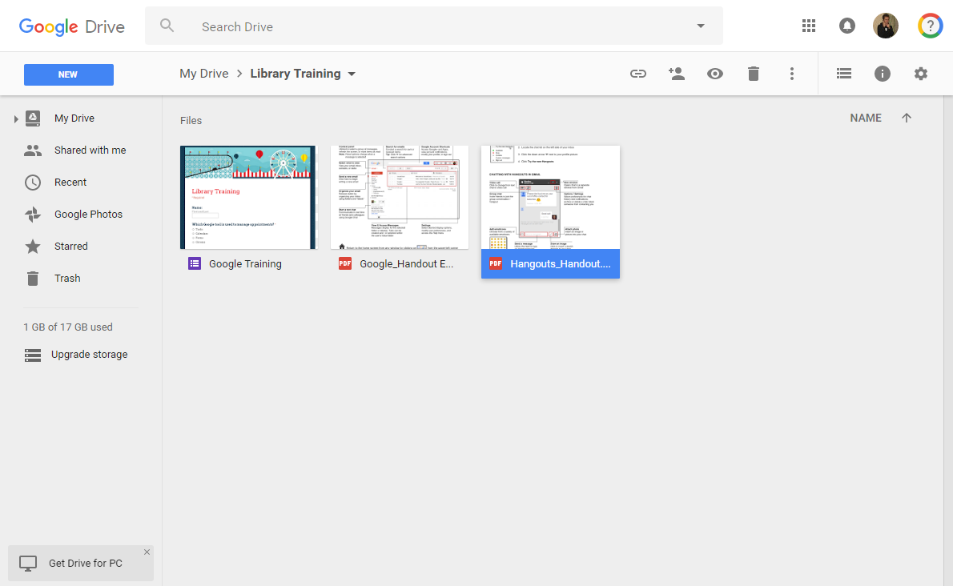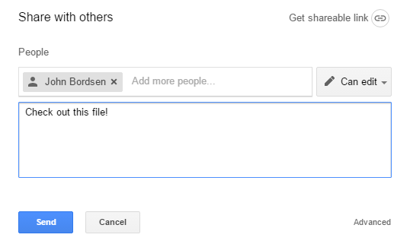
1. Click once on the file
2. Click the share icon
4. Enter recipient(s)
5. Type a message
6. Click on “Send”
3. Select permissions

