
Google Tools: Docs

GOOGLE DOCS OVERVIEW
Google Docs is an online word processor that lets you create and format documents and work with other people.
Access Google Docs via https://docs.google.com

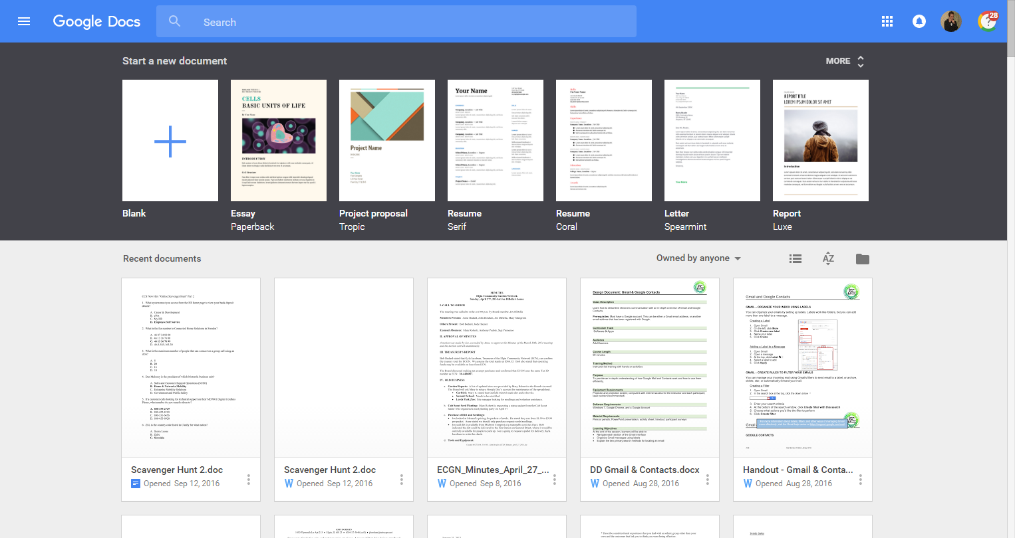
Templates/New Doc
Your Docs
Search for Docs
Display options
File picker

CREATING A NEW DOCUMENT
- Access Google Docs
- Under “Start a new document,” click  to begin a new “blank” document or select from an available template
- The new document displays
- Edit, format, and/or share your document as needed

Google Tools: Docs

EDITING, FORMATTING, AND SHARING A DOCUMENT

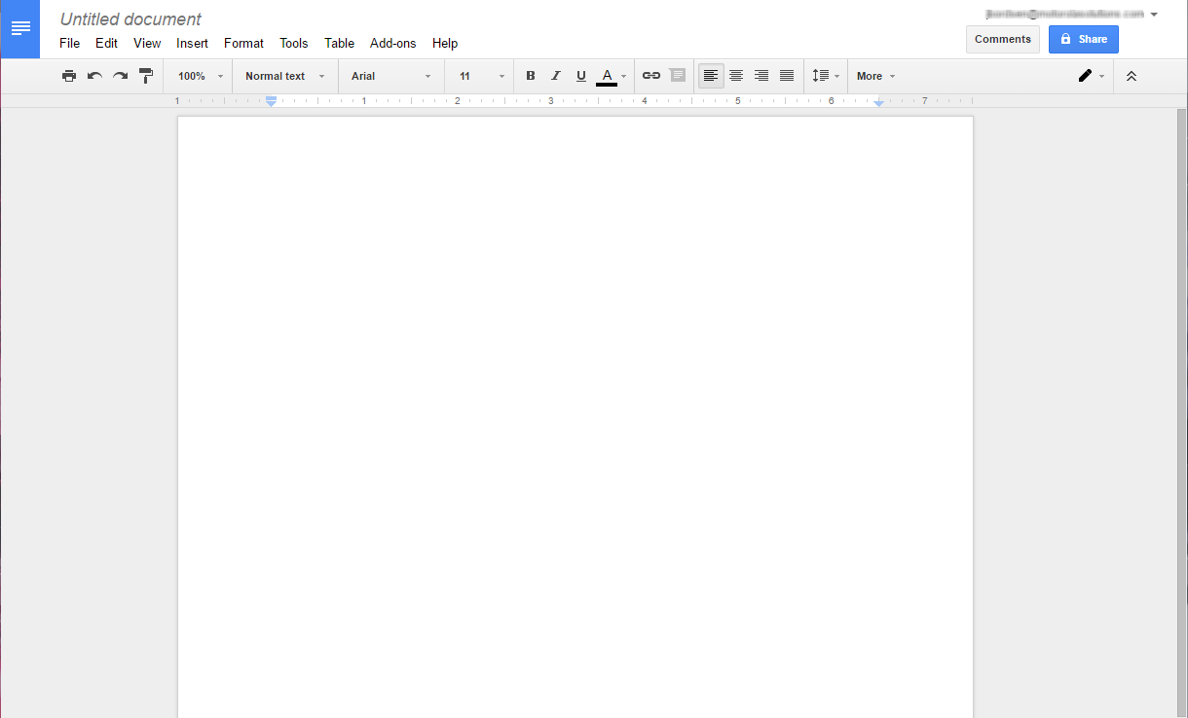
Rename
Docs home screen
Share
Menu bar
Text formatting
Paragraph formatting
All changes to your documents are saved in real time.

