
Google Chrome Web Store

Chrome Web Store - https://chrome.google.com/webstore
The Chrome Web Store offers a variety of free or low-cost options to foster your creativity, enhance productivity and personalize your experience using Google Chrome. Simply Sign-In (using your Google Account), browse, and Add to Chrome.

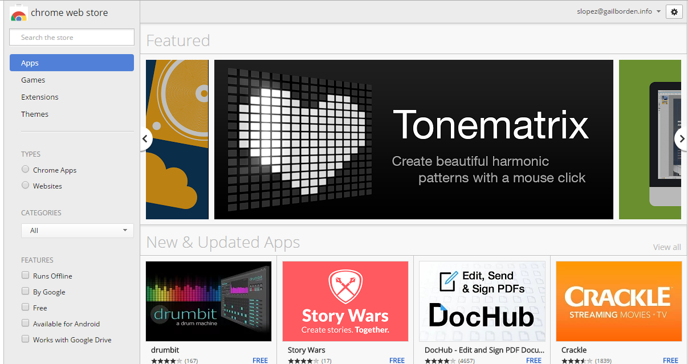

Sign-In
Search & Filter Results
Your Apps
Add to Chrome





What are Extensions?
Extensions add new functionality to the Chrome browser, such as adding a new button to your browser window for capturing screenshots with Clipular! Extensions are often depicted by a jigsaw icon to differentiate them from apps.
What are Apps?
Apps (Applications) are free or low cost programs that can be accessed and run online through your Chrome browser, such as the document processing tool, Google Docs.

Google Chrome (Web Browser)

Download Google Chrome on your PC
- Download the Chrome installer file from www.google.com/chrome/#eula
- If prompted, click Run or Save
- If you chose Save, double-click the installer file to start the installation process
- Start Chrome:
- Windows 7, Vista, & 10: A Chrome window opens once everything is set up
- Windows 8 & 8.1: A welcome dialog appears; click Next to select your default browser.

Sign in to Chrome
When you sign in to the Chrome browser, you can save and sync things like your bookmarks, history, passwords, and other settings to your Google Account, so you can get to them on any device.

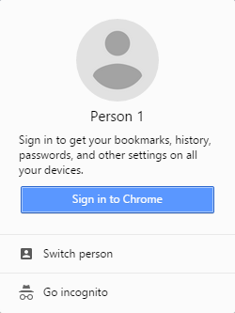
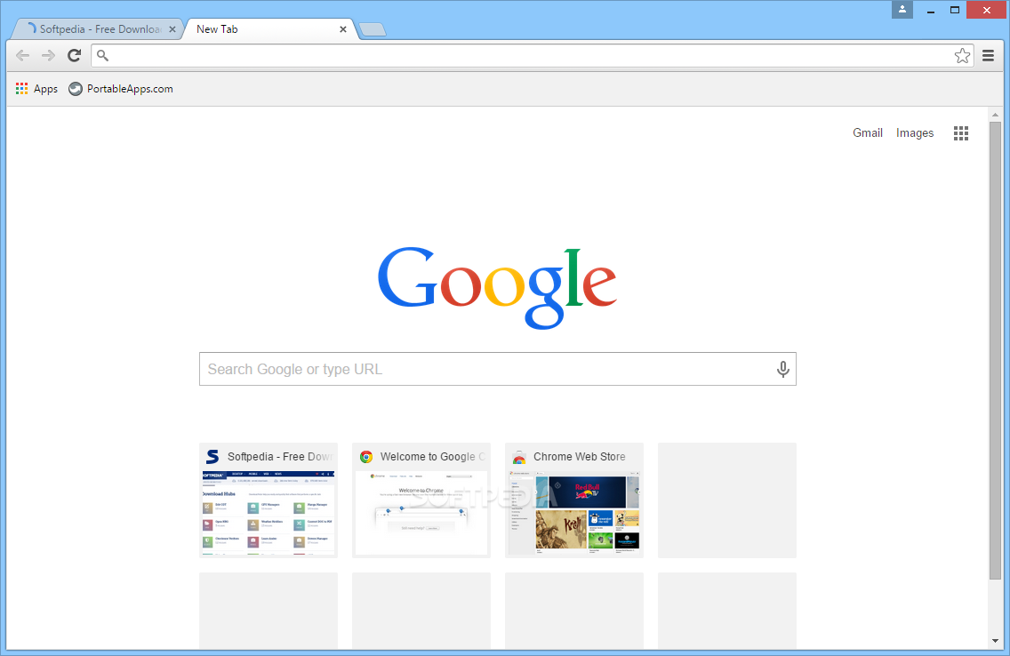
Signing in to Chrome
- Open Google Chrome on your PC
- In the upper right corner of the browser window, click the icon
- Click on Sign in to Chrome
- Sign in with your Gmail log-in credentials

