
Google Tools: Calendar

GOOGLE CALENDAR OVERVIEW
Google Calendar is an online time-management application that lets you track your schedule and share events with other people.
Access Google Calendar via https://calendar.google.com

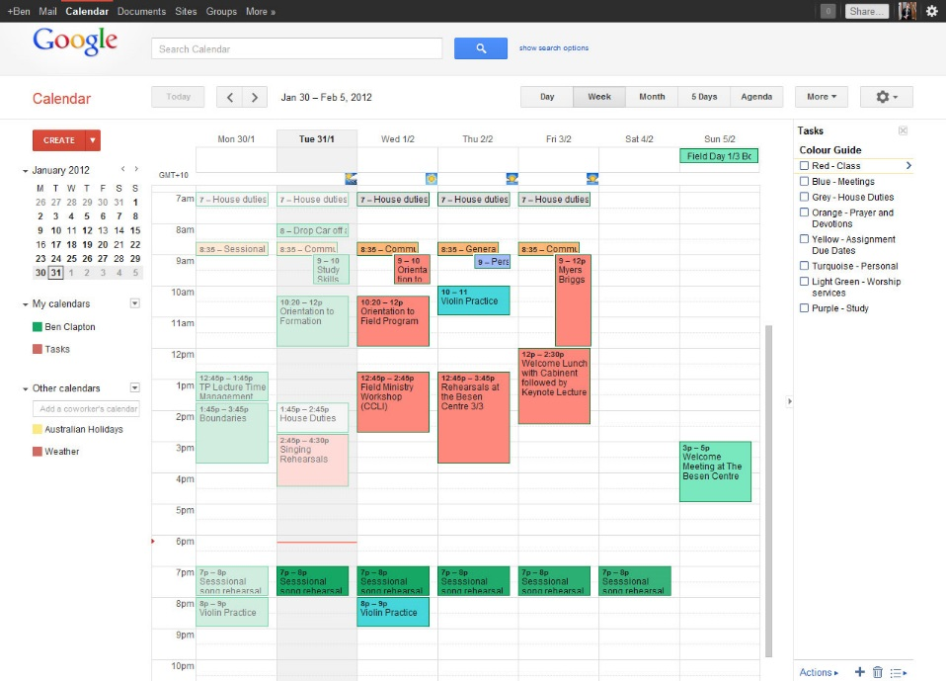
Shared calendars
Personal calendars
Tasks
Display Options
Search bar
Events
Create events
Settings
Print and Refresh page

SHARING A CALENDAR
You can share the main calendar for your account, or another calendar you created.
- Under “My Calendars,” click the down arrow next to the name of the calendar to be shared
- Select Share this calendar
- Under “Share with specific people,” add the email address of the person you want to share with
- Select an option from the “Permission Settings” dropdown
- Click Add this person, if they aren’t already added
- Click Save
Note: The individual you shared with will see the calendar in their “Other calendars” list.
Google Tools: Calendar and Tasks

UTILIZING TASKS IN GOOGLE CALENDAR
Tackle your to-do list with Google Tasks.
- Open Google Calendar (https://calendar.google.com)
- On the left side under "My calendars," click Tasks. Your tasks open on the right.
- Click Add task
- Enter your item
- To include notes and set due dates, click the arrow to edit a task's details
Tasks with due dates will show on your calendar like all-day events.

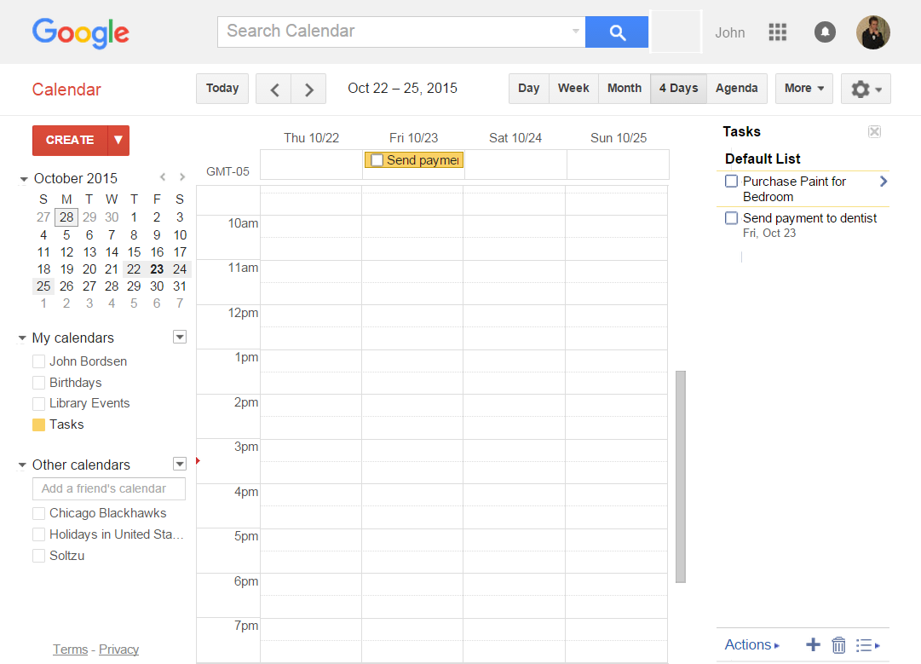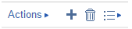
View Tasks in your Calendar
Tasks List
View tasks with an assigned due date
Misc. Actions (create task, delete, print & more)

