Email Basics (Gmail)
Navigation bar
THE GMAIL HOMEPAGE
Search by keyword or sender
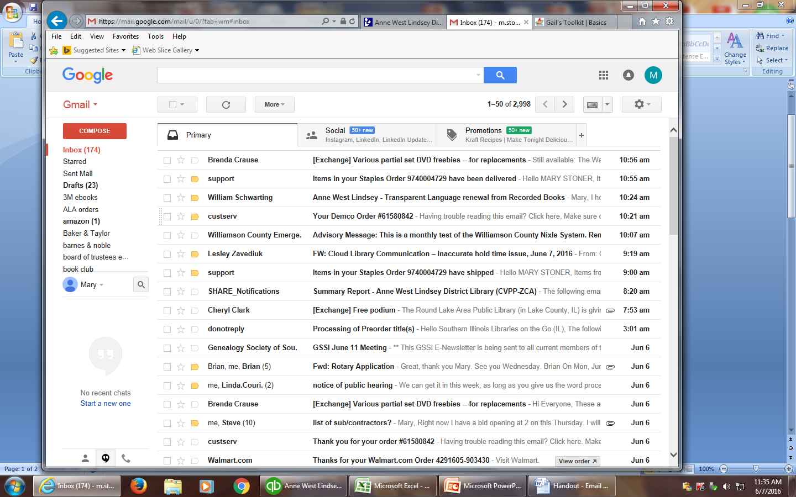
Organize messages with Folders
To create a new folder:
- Click on folder icon
- Scroll down and click on “Create New”
- Press the Enter key

Date sent
Settings
Attachment
Inbox
Compose an email

COMPOSING AND SENDING EMAILS
- Click on (red box) “Compose”
- New message window opens

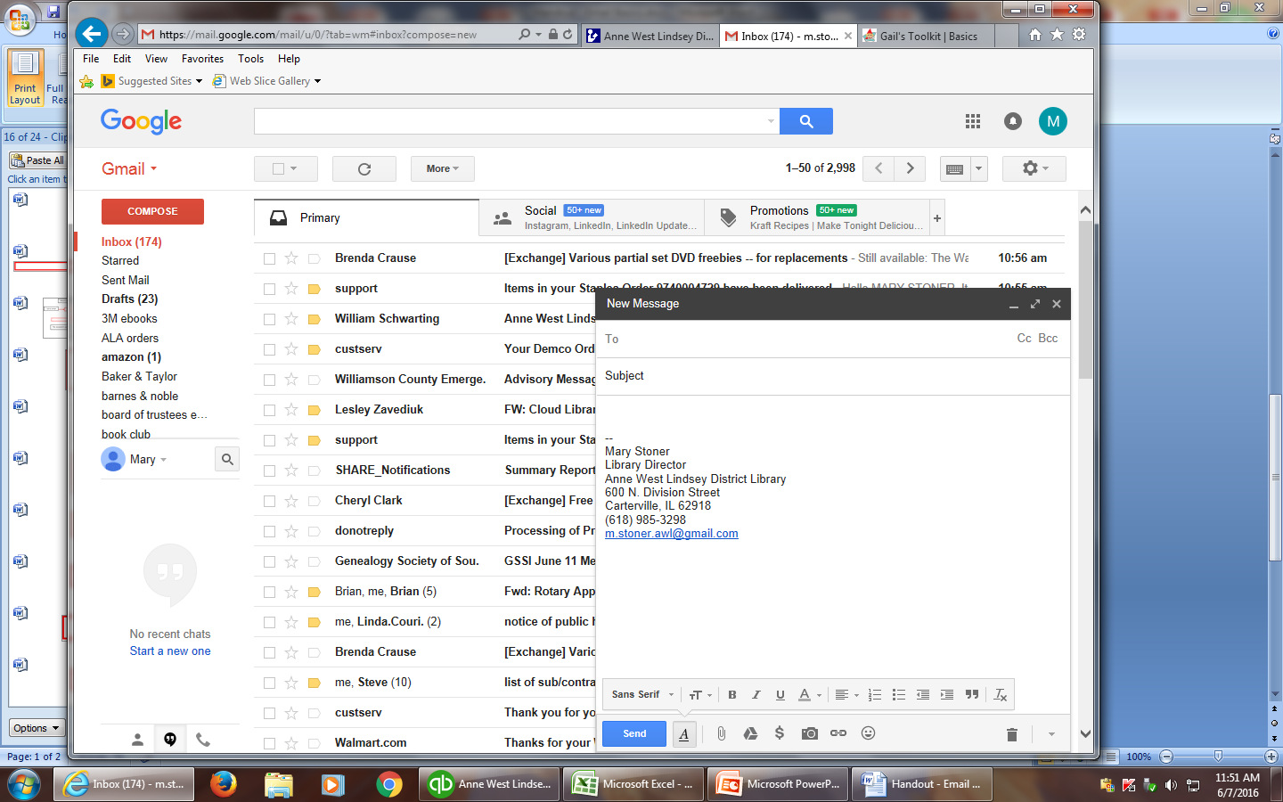
Copy someone on an email
Recipient’s address
Send an email
Cancel/delete an email
Attach a document

Attach a document

ATTACHING A FILE
- Click on paper clip icon
- Browse the computer for the file
- Click on the file
- Click Open
- Type in your message
- Click Send

