
Facebook Basics

TERMINOLOGY

Cover Photo | The large picture at the top of your timeline, above your profile picture. In short, your personal “background”.
Follow | The way you receive news about organizations, groups, celebrities or other Facebook users you’re interested in but not “friends” with.
Friend | People to whom you are connected and with whom you share content.
Group | Close circles of friends that share and keep in touch on Facebook.
Like | The action used to give quick positive feedback on a post or to follow an organization or page.
Message | The method used to have a private conversation with someone.
News Feed | The list of updates visible on your homepage from friends and other Facebook users that you follow.
Profile | The page containing YOUR information on Facebook. Also called your Timeline.
Profile Picture | The picture of you that is visible to other Facebook users and/or the general public (if the appropriate permissions are enabled).
Tag | The action that links a person to a particular picture, place, page, post, or event.
Chat Sidebar | The area on the right side of home page that allows you to what friends are currently online and instant message them. Can be hidden from view.
Timeline | Your personal page on Facebook that is comprised of your photos, updates, likes and other information that tells your story.
Wall | The area on your timeline where you and your friends can post status updates, photos/videos, places you visit and information about significant life events.

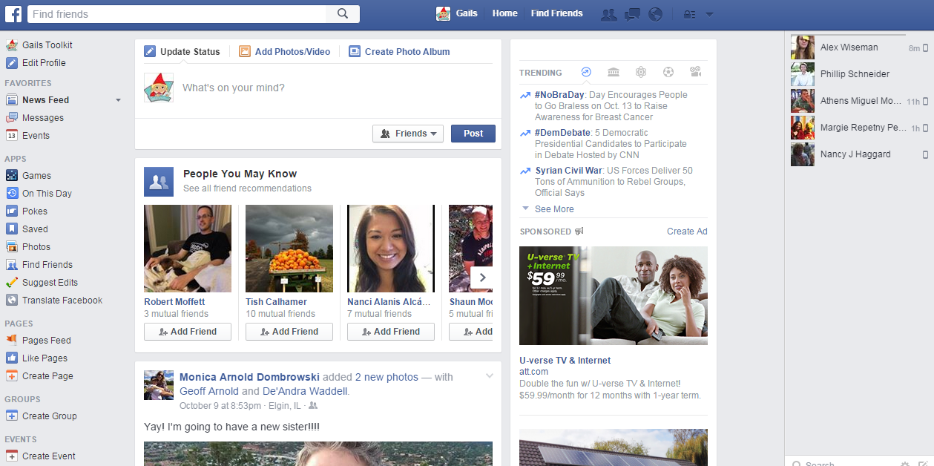
Search for people, places & things
Access Timeline
Friend Requests, Messages, Notifications & Settings
Events
Chat Sidebar
Trending news stories
Post a status
Groups
THE HOMEPAGE / NEWSFEED

YOUR TIMELINE
Access Homepage
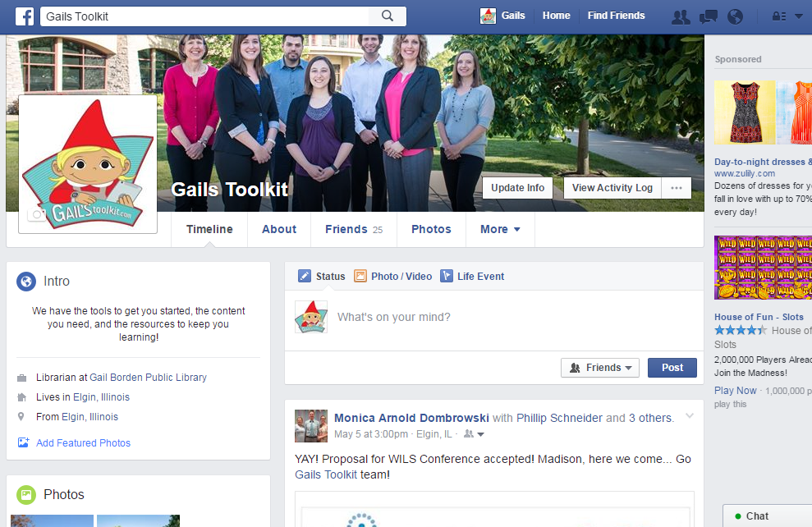

Cover Photo

See personal info, friends & photos
Profile Photo

Post status, life event, photos, etc.

