
Email Basics Example

Search Message

Instructor Note for Live Demonstration: This Email Basics example is used starting on slide 57 in the Volunteer Instructor Guide and PowerPoint presentation and is used in the section about searching for email messages.

Before the class begins, check the account you will use for the workshop and verify this email is in the Draft folder. If this email example is not in the Draft folder, complete the following steps.

- Go to www.gmail.com.
- Log into the account you will use in the workshop. Do not use your personal email account. If available, use an account your organization has for workshops, or consider creating an account for this purpose with leadership approval.
- Click the Compose button to create a new email.
- In the New Message window, copy and paste the following information into the appropriate fields:
  - To: insert <email address of the account you will use in the workshop>
  - Subject: Email Basics Search Example: Upcoming Field Trip
  - Body of email: Copy and paste this graphic into the body of the email:

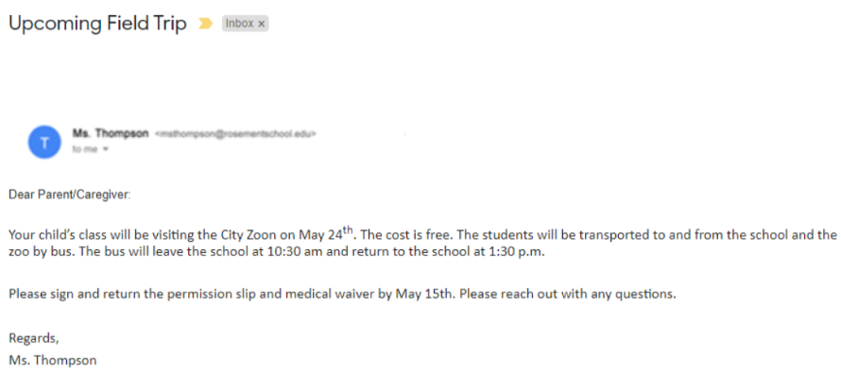
  - Click Send.
  - After you send the email, it will display in the Inbox.
  - Move the email to the Draft folder.
- Use this example for the workshop as indicated on the Instructor Guide and in the PowerPoint presentation.

