Email Basics Example

Welcome New Students

Instructor Note for Live Demonstration: The email basics example starts on slide 27 of the PowerPoint presentation and is also used in the section about opening and replying to email messages.

Before the class, check the account you will use for the workshop and verify that this email is in the Inbox. If this email example is not in the Inbox, please complete the following steps.

- Go to www.gmail.com
- Log in to the account you will use in the workshop. Do not use your personal email account. If available, use an account your organization has for workshops or consider creating an account for this purpose with leadership approval.
- Click the Compose button to create a new email.
- In the New Message window, copy and paste the following information into the appropriate fields:
  - To: insert <email address of the account you will use in the workshop>
  - Subject: Email Basics: Email Example – Welcome Students
  - Body of email: Copy and paste this graphic into the body of the email:
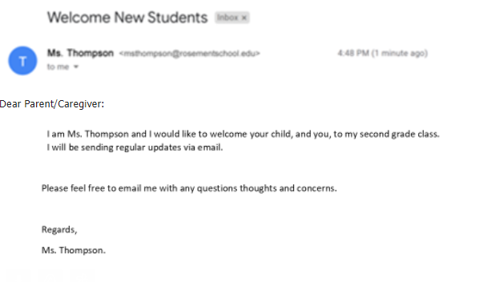
  - Click Send
  - After the email is sent, it will display in the Inbox.
- Use this example for the workshop as indicated in the Instructor Guide and PowerPoint presentation.

