
Learner Activity Sheet: Email Basics

ACTIVITY #1: Your Email Account

Use the computer desktop to answer the following questions.

If you don’t have your own computer, follow along with the instructor.

- Open a web browser and keep it open.
- In the address bar type www.gmail.com.
- Log into your Gmail account.

ACTIVITY #2: Sending New Messages

Use the computer desktop to answer the following questions.

If you don’t have your own computer, follow along with the instructor.

- Open a web browser and go to www.gmail.com.
- Log into your Gmail account if you are not already logged in.
- Compose a new message. Include the following information in the new message:
  - In the To field enter: email address on the slide
  - The Subject: Email Basics
  - In the Body: This is a new message.
  - Click send.
- Where can you find the message you just sent? ____________________________

- Compose a new message. Include the following information in the new message:
  - Your email address.
  - The Subject: Email Basics: What I Learned
  - In the Body: Write one new thing you learned about using email in today’s workshop.
  - Click Send.
Note: If you would like to send an email to a family member or friend, here is an example of an email you could send:
  - In the To field enter: email address of the person you are emailing
  - The Subject: Email Basics Test
  - Body: “Hi! I’m attending an email workshop course and just learned how to send an email. Woo hoo! I look forward to communicating over email in the future. Please note my email address.”

ACTIVITY #3: Searching and Deleting Email

Use the computer desktop to answer the following questions.

If you don’t have your own computer, follow along with the instructor.

- Open the web browser.
- Log into your email account.

- Open the email with the Subject: “Email Basics: What I Learned.”
- Add a label to the email called Email Basics.
- Create a folder called Workshops.
- Move the “Email Basics: What I Learned” email to the Workshops folder.
- Open the Sent folder.
- Delete the email with the subject “Email Basics: What I Learned.”
- Log out of your account.

ACTIVITY #4: Practice
Complete the Practice lesson for Basic Search. You can either open a web browser and complete the activity on your own or follow along with the instructor.

To complete the activity on your own:
- In the address bar of the web browser, enter https://www.digitallearn.org/.
- Click on “Intro to Email 2: Beyond the Basics.”
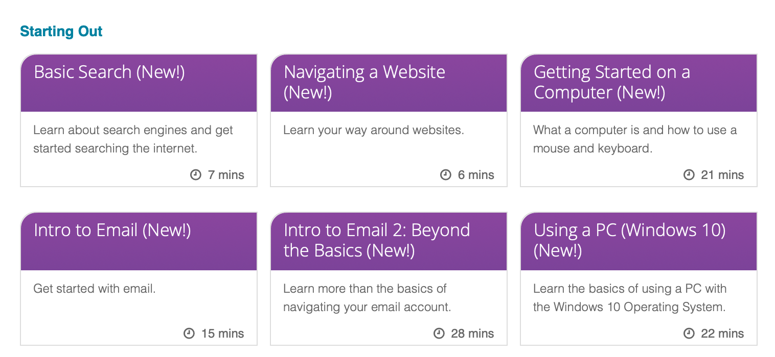
- Click on “Practice.”



