Learner Handout: Email Basics
Email is a way to send mail digitally through the internet.
Creating a Username
- Usernames must be unique, so it may be hard to find something not already taken.
- You may need to add numbers or other identifying factors to it.
- Select a username that is appropriate to share with anyone you may give your email to, such as your child’s teacher or an employer.
- Enter your name and create a password for your account.
- My email address is: ___________________________________________
- My password is: _______________________________________________

Tips for Strong Passwords
- Don’t share your password with others. Passwords should be kept private.
- Gmail requires a password that is a minimum of eight characters.
- It should not be easy to guess, like “password” or “123456.”
- Don’t include personal information, like your address or name.
- Don’t use the same password on multiple accounts and websites.
- Make the password longer. The best defense is length.
- Use short phrases like “cowshelpmakecheese.”

Inbox

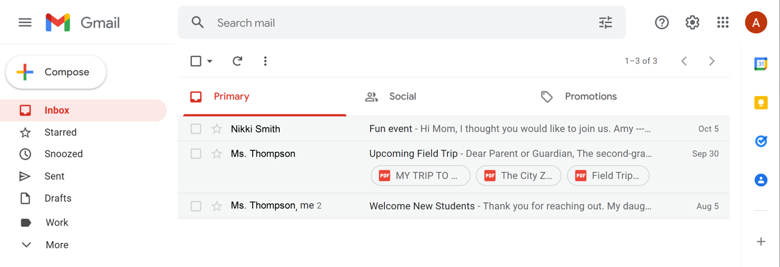

Search: Look for specific messages using the search box.
Compose: Create an email to send to another person or people.
Menu: Allows you to switch between folders that organize your email messages.
Inbox: Where your email is received.
Sent: Where you find the message you have sent.
Draft: A saved copy of an email that you have not completed. You can edit it later and send it.
Trash: Where deleted emails are stored temporarily—usually for about 30 days—and then deleted permanently.
Spam: Unwanted online communication.
Log Out: Sign out of your account when you are finished so no one else can access it.

Messages

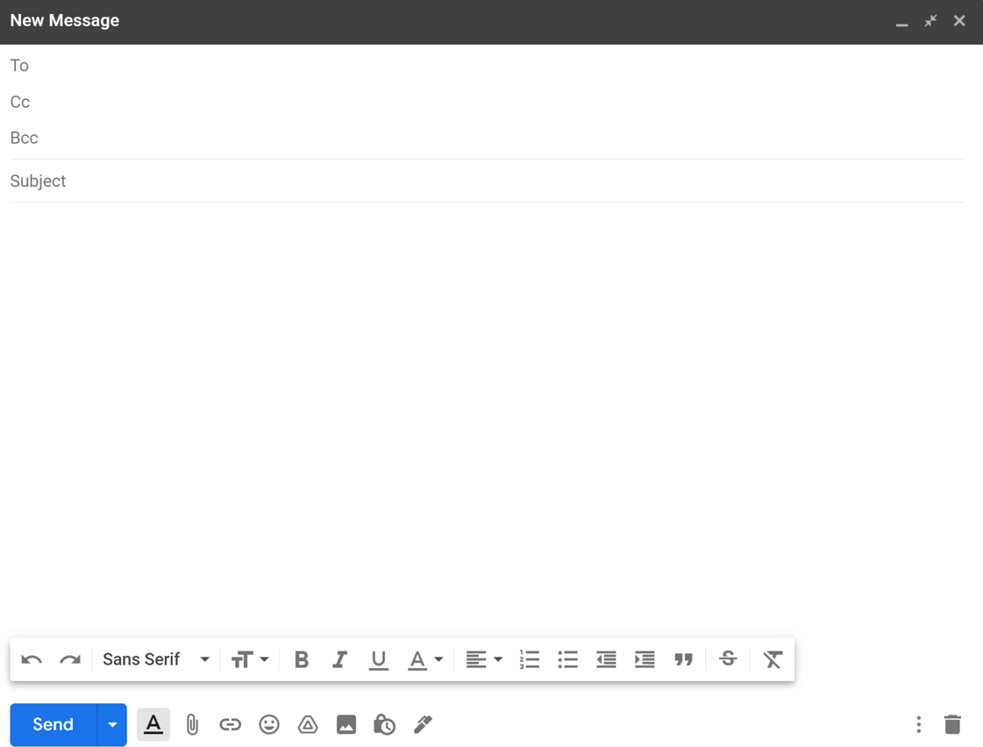
To: The email address(es) of the person or people you are sending the message to.
CC: Carbon Copy.
BCC: Blind Carbon Copy. The people receiving the email can’t see who is inside the BCC field.
Subject: Lets the person know what the message is about.
Body: The message you’re sending.
Attachment : Files included as part of the email.

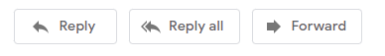
Reply: Email goes only to the person who sent the message.
Reply All: Sends the email to everyone who received the message.
Forward: Sends an existing email to another person.

Learn More
Visit https://www.digitallearn.org/ for more courses and to help build skills and confidence using technology.

Today’s training is provided by AT&T and the Public Library Association.

