eBay Basics

TERMINOLOGY

Place Bid The amount you are willing to pay for an item during an auction. The highest bid wins.

Best Offer The amount you propose to pay for an item offered which the seller can then accept, counter, or decline.

Buy it Now Allows you to purchase an item immediately at a specified price from the seller. Similar procedure to other online shopping sites, like Amazon.

Watching A way to keep watch on an item you are interested in purchasing without placing a bid or making an offer.

PayPal The log-in service that partners with shopping sites like eBay to allow you to safely and securely pay for online purchases.

My eBay Your account section on eBay where you’ll find all your personal information such as current items you’re bidding on, past purchases, watch list, messages, etc.

Notification The bell icon in the top right corner of the screen alerting you to any changes in your activity, such as being out bid on an item, an auction ending, message, etc.

Shopping Cart The holding place for one or more items you intend to purchase. This feature applies to the Buy it Now items.

BIDDING STRATEGIES

- Bid the highest price plus $1 from the beginning to keep an edge on the competition
- Be aware of the auction countdown time. Sometimes you may have to enter a counter offer in the last few seconds if you are outbid.
- Create a watch list that contains multiples of the same item, then bid on the item ending soonest. If the price gets too high, move on to the next item ending soonest.
- If you have any questions about an item, ask the seller. If something doesn’t seem right, don’t bid on the item.
- Check a seller’s feedback from previous buyers. Most sellers are genuine in product description and send the item specified, on time. As with any online site though, beware of potential scams if a deal appears too good to be true or a seller will not respond to inquiries.

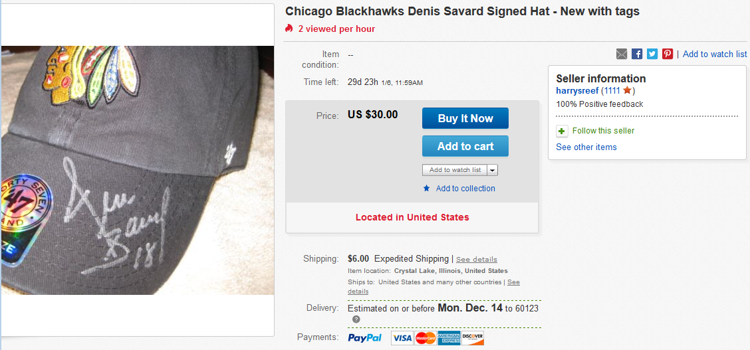
ITEM ADS
Time left to purchase or bid on item
Pricing information
Shipping Information

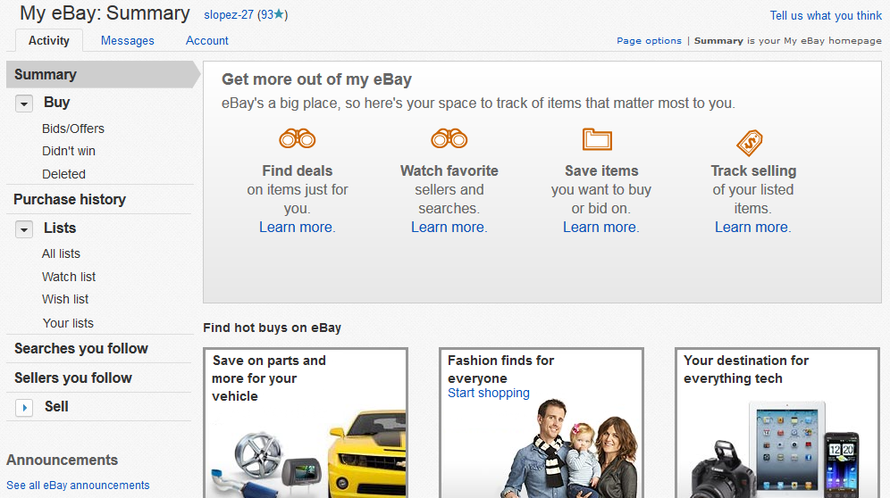
Navigation bar visible on all pages
Notifications & Shopping Cart
View Activity, Messages, & Account info
Your activity (bids, purchases, watch list, saved searches, etc.)
MY EBAY

